SOS Education Meeting Notes – 9/18/13
6th Quarterly SOS Education Forum

The theme for this meeting is audience engagement.

Panelists: Hilary Peddicord of NOAA Boulder, Robert Morris of Clark Planetarium, Toshi Komatsu of Lawrence Hall of Science, Maurice Henderson of Goddard and Annette Brickley of Ocean Explorium.

Attendees: Sarah Waters (Thunder Bay), Sara Lee Chubb (Alaska State Museum), Robert Morris (Clark Planetarium), Jami Sunkel (Space Foundation), Abbey Spargo (Ocean Explorium), Sue Wu (OMSI) Sharon Lamkin (Science Central), Isabel Gaoteote (American Samoa) Shilpi Gupta (NOAA), Abbie Diaz (NOAA), Jeff Mucklin, Harriet Smith (NOAA), Dave Blumenstock (Denver Museum), Robin Ramsey (Boonshoft Museum of Discovery), Nick Wilde (NOAA Boulder), Eric Hackathorn (NOAA Boulder), Jessica Beebe (NASA)

A few updates from NOAA Boulder:
- SOS Collaborative Users Network Workshop – June 10-12 St. Paul, MN – “Anthropocene: Exploring the role of SOS in illuminating humanity as the driving agent of global change”
- Please complete the surveymonkey for your contributions to the workshop content by 3/17 (look for the email that was sent on 3/5)
- NASA MAVEN – Invisible Mars – SOS Educator’s workshop held June 8-9 St Paul, MN (contact Hilary if you are interested – and she can send info)
- SOS 4.2 release due out ~ May 1st
- Thanks for completing your questionnaire! It’s very useful information.
- As always, if your sphere isn’t working, please email us at sos.gsd@noaa.gov

Featured Presentations
*****Audience Response Systems – clickers overview by Hilary Peddicord

What you need – Clickers are purchased as a unit, with remotes, receiver, software and carrying case. They run between $1000 - $1500 for 30 remotes. Currently in order to use clickers with SOS you will need to have either separate screens or an extra projector + an extra PC. Software is PP compatible.

Why use them?
- They work as an equalizer – shy folks who like to take time for cognition are given a method for being heard
- Maintains attention
- Promote active audience engagement
- Promote discussion and collaboration among audience
- Check for understanding
- Can be used as formative and summative assessment tool

What to ask – Do’s
- Relate directly to learning goals
- Utilize known misconceptions
- Bookend questions
- Add thought provoking (no right answer)
Don’ts
- Focus on what they don’t know
- Write useless & poorly worded q’s
- Use too many. 2-4 questions for 30 min

Example question using misconceptions –
Whose job is it to find solutions for climate change?
- Scientists
- Policy makers – both state & federal
- Economists
- Mine
- All of the above

Example question thought provoking –
Is the greenhouse effect bad for the Earth?
- Yes
- No
- I don’t know

Recommended Reading -
“Clickers in the Classroom- How to Enhance Science Teaching Using Classroom Response Systems” By: Douglas Duncan (FISKE Planetarium)

*****Programming, successes and challenges of iclickers at Clark Planetarium by Rob Morris
Programs:
- Programs are 15-20 minutes long, allowing for 10 minutes to change audiences and handle iclickers
  - 15-20 minutes is longest that kids (6th grade on down) can seem to sit for.
- 7-8 presentations per day
- Subjects range from climate and weather to astronomy topics
  - Grades kindergarten up to 9th grade are covered
Successes:
- First year goal of 5000 student experiences
  - Hit 30,000 by May and expect similar numbers this year
- Teachers love seeing the kids actually express what they know
- Students love to anonymously express their answers, and see that they mean something by watching the graph change
- Allows presenters to sculpt presentation to the specific needs of the audience, based on their knowledge level
- Teachers are booking field trip visits for just SOS, even if there is availability in the Dome or IMAX
- Presenters have really taken charge of the presentations, looking for ways to improve them, have a sense of ownership of the program
Challenges
- Questions must have 5 possible answers (with iClickers), no option for fewer
- Kids are hard on the clickers
  - Get dirty very quickly
    - Requires frequent cleaning and sanitizing, especially during flu season
  - Removing batteries & covers
    - Presenters have to spend time putting everything back together each day
  - Changing frequency
    - Rare, but occasionally happens, requiring someone to reset it
- Battery Life
  - On for several hours continuously due to kids “fiddling” with them between questions
    - 200 hours of battery life * 4 hours per day = 2 months until replacement
  - Cost of batteries
    - Alkaline vs. Rechargeable
  - Proper disposal of dead batteries

Q/A – Question: Do you think in the end that clickers are worth it? Do you think they enhance the experience?
Answer: Absolutely. We find that our programs are very well attended and the audience engagement is much higher with clickers.

Contact info: RMorris@slco.org

Annette Brickley: abrickley@oceanexplorium.org

*****Creating Compelling Stories – Toshi Komatsu from Lawrence Hall of Science talks about what he learned and is implementing from the book: “Connection: Hollywood Storytelling Meets Critical Thinking” by Randy Olson.

Check out Toshi’s Prezi presentation: http://prezi.com/kd0qjpmb_7i_/creating-compelling-stories-with-wsp-v1/?utm_campaign=share&utm_medium=copy

In order to know what story you are planning to tell. You need to break down your message into first, one word, then, one sentence then, one paragraph. Tie them together an fill in the blanks.

Toshi plans to use the message delivered in the book to encourage his SOS docents to plan their presentations using this method.

Contact Info: tkomatsu@berkeley.edu

*****NESO - a.k.a. NEO + Space Science Data = Interactive display and analysis tool for accessing near real-time data on SOS Maurice Henderson of NASA Goddard & Annette Brickley of Ocean Explorium

Annette: Ocean Explorium has been in NESO development for 2 years and has brought in teachers and students in workshops and daily practice, to use and give feedback on the tool. Teachers and students love it. It’s great especially for older students – in finding relationships between different types of data and analyzing it.

OE brought in 2 Master teachers over 3 evenings (3.5 hours each) bringing examples from their classrooms have used NESO for:
- Scaffolding data analysis with students/Aligning with science & math standards
- Defining a research question/Examples from the classroom
- Presentation of research (using NESO) and sharing of lesson plan

Maurice: Full release of new NESO application for SOS coming 3/31/14
In the new release:
- Enriched library handling high resolution content
  - NEO library of virtually all NASA Earth Observing missions
  - NASA missions at full resolution over the lifetime
  - NASA WorldView imagery
  - Planetary and moon maps
  - Milky Way Galaxy all sky maps
  - Google Maps
- NASA Data Librarian
- Time series
- Animations for SOS playlist
- Selectable color table
- PDF of analysis
Next Release:
- New math and graphing package
- Sharing widget
- Cross-platform continuity of analysis

Demo Example using NESO – All sky map, zoomed into the red giant star Betelgeuse: The following pdf’s can be generated by the NESO “analysis”
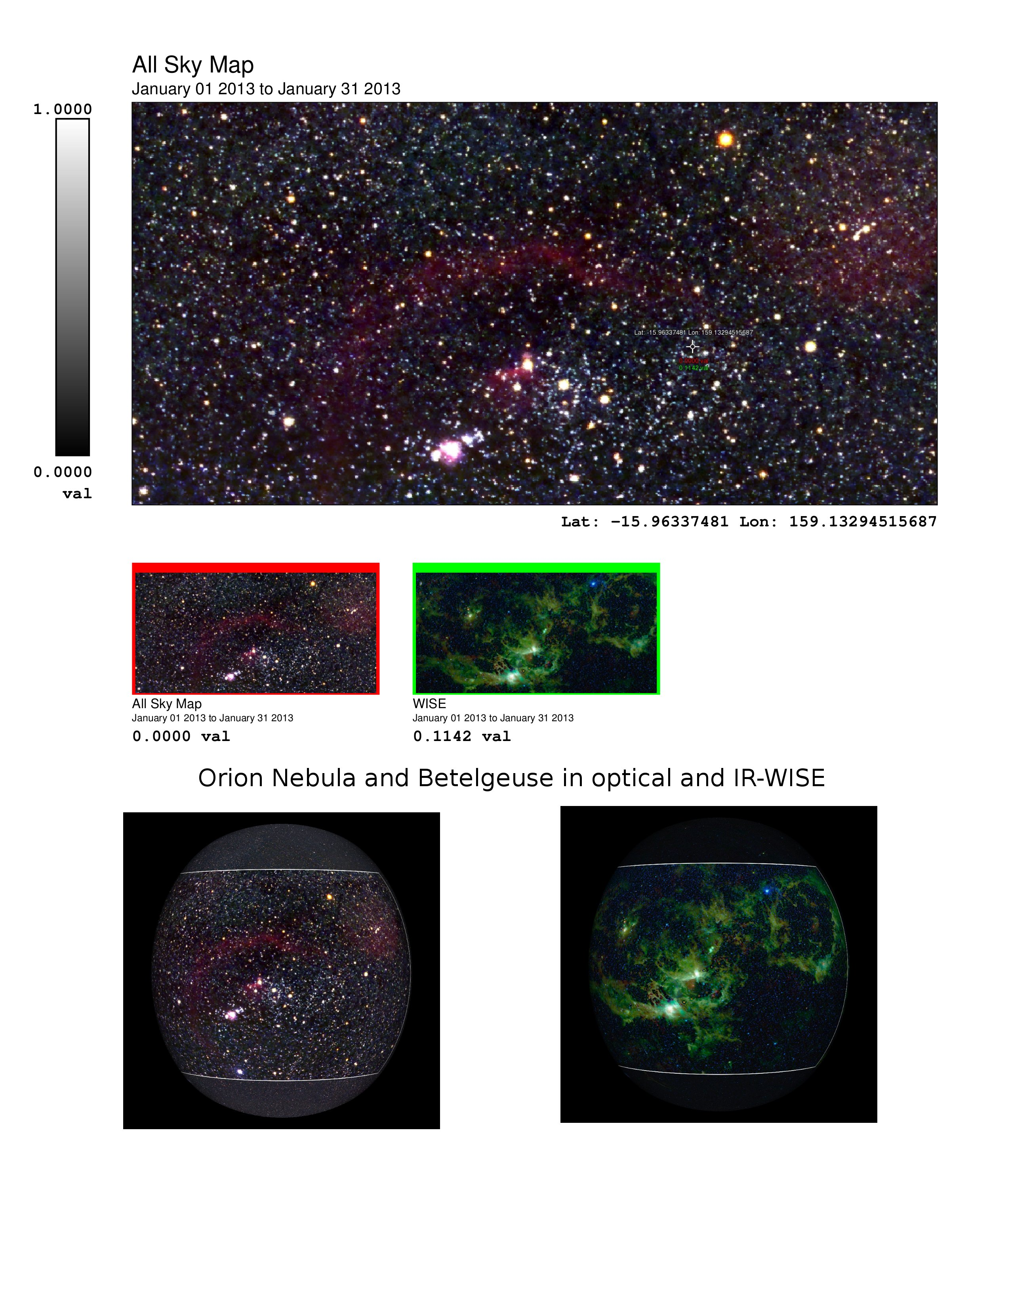

Demo example using NESO of probing and graphing global temperature
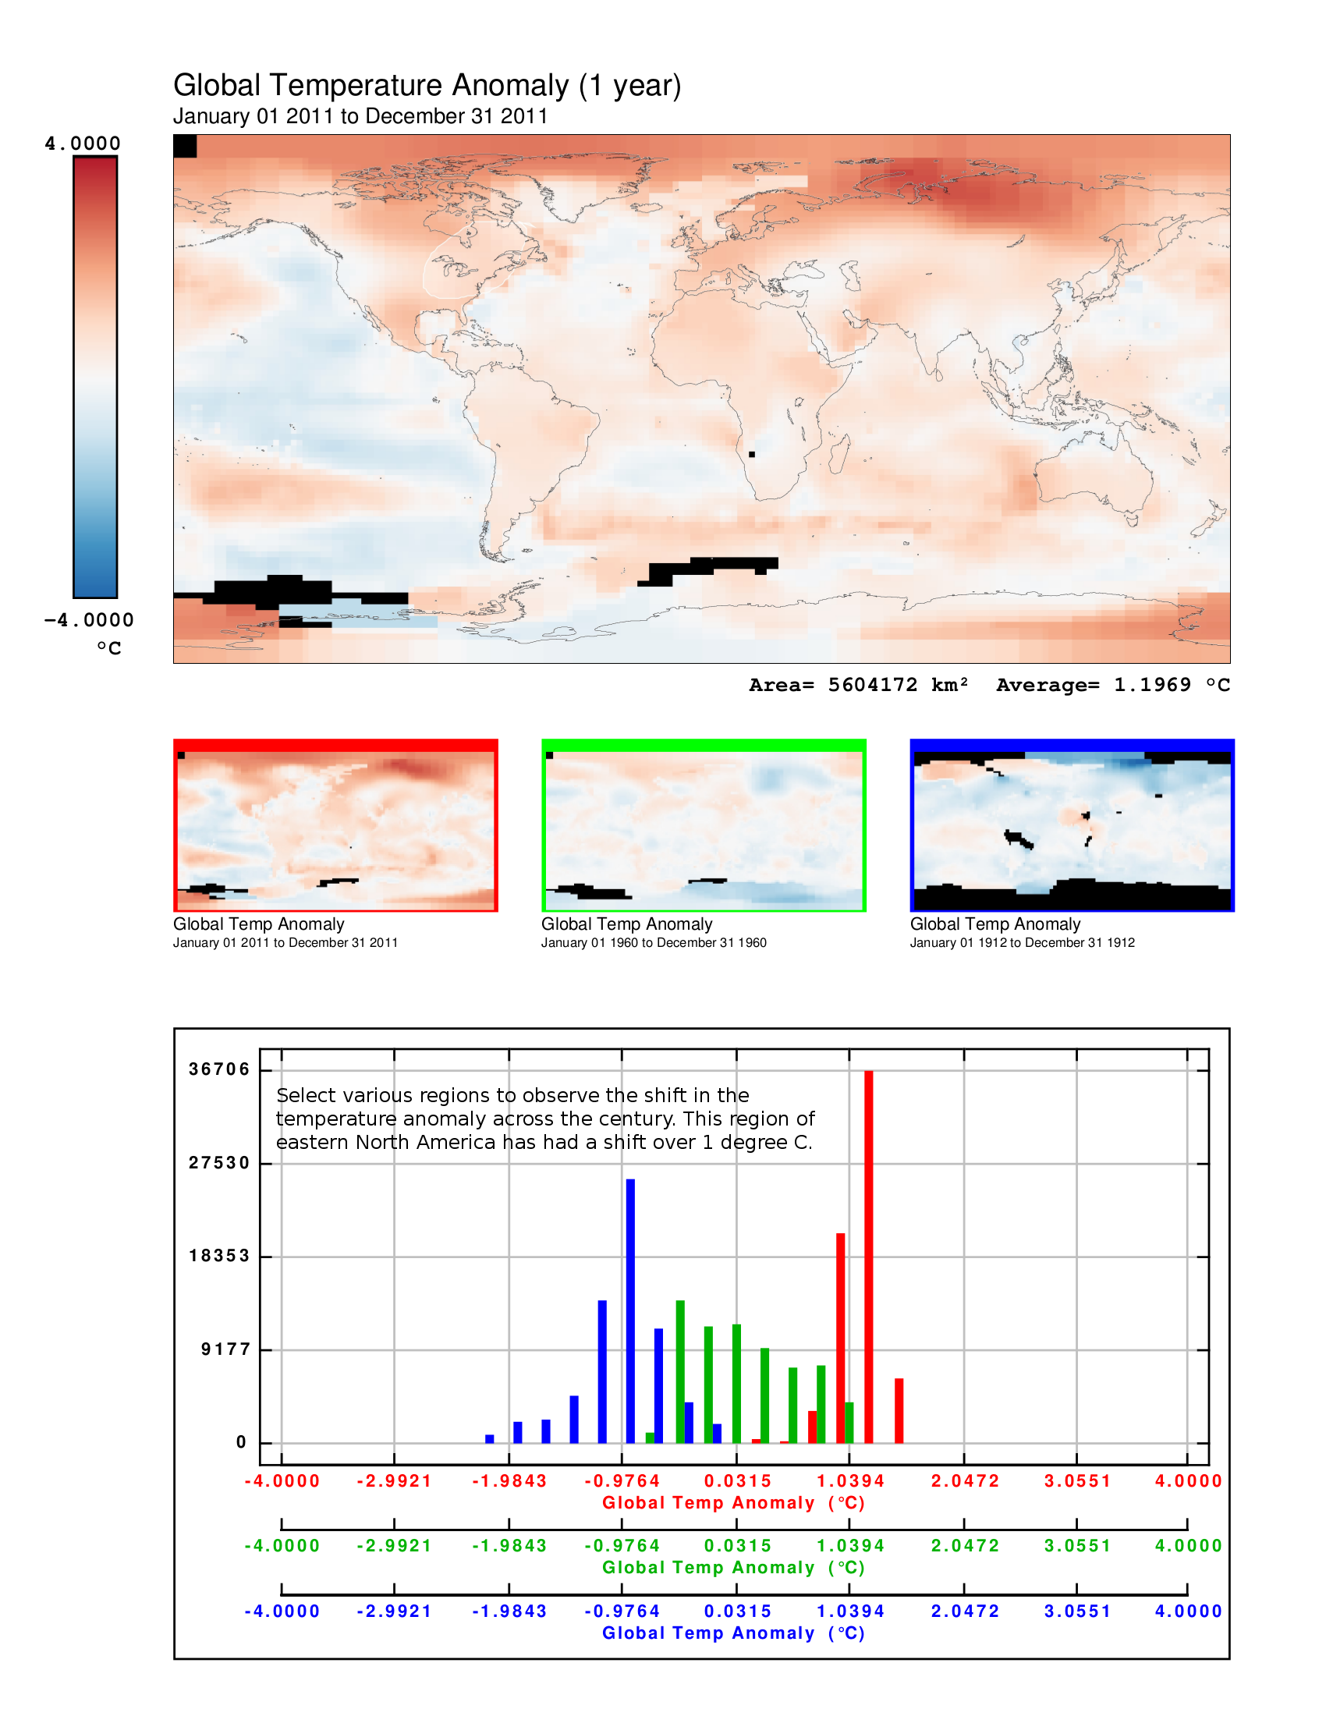

Demo example using NESO of zooming using google on the sphere and graphing
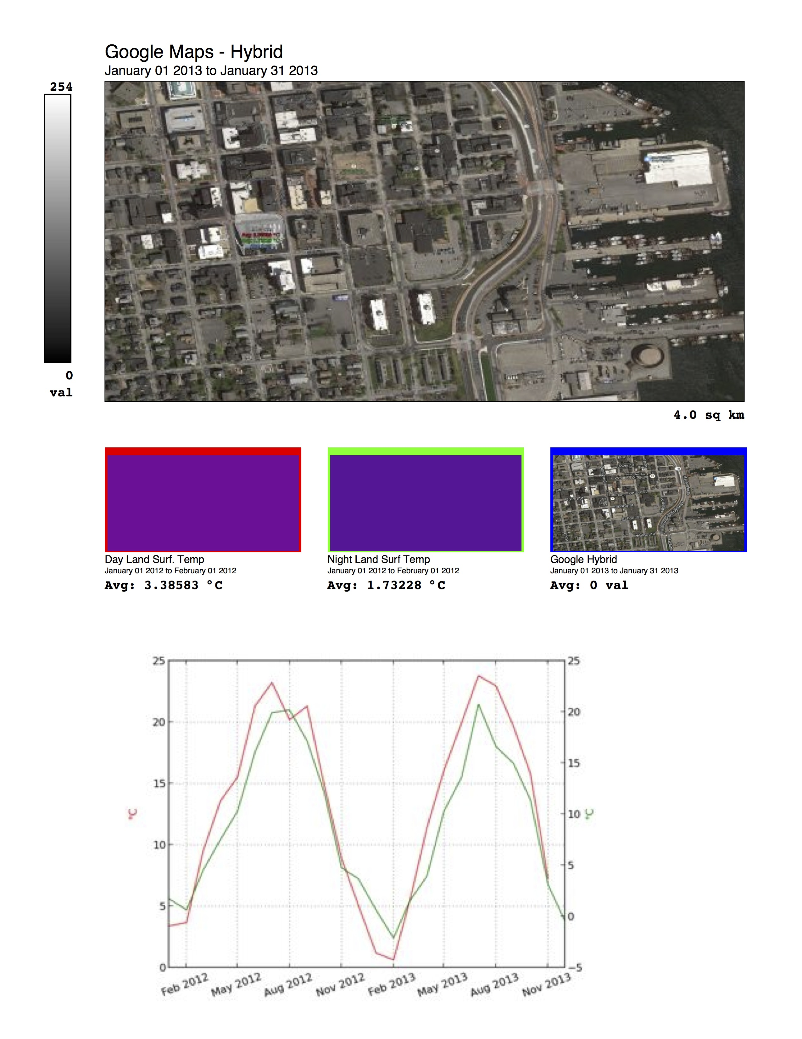
Support Plans for Teachers:
- NASA Data Librarian will support new data request
  - e.g. Soci-economic, political, and census
- New England Educators producing lesson plans
  - Global Land Surface Temperature
  - Bathymetry/Sea Surface Temp/NPP
- News articles with NESO data analysis
  - Brazilian Droughts 2005, 2010, 2014
  - Australia: Drop in Global Sea Level
- NASA educators outreach to museums

Survey plans for evaluating community needs and desires
- We will contact each site
  - Installation and operation?
  - Value of NESO in your institution?
  - Specific needs?
  - Informal Education support ?
  - Approach to serve formal educators?
- Seek to establish citizen scientist programs
  - Support science literacy discussions
  - Social media role
- Feedback to shape next release

Contact info: Maurice Henderson
NASA Goddard
301-614-5672
Maurice.henderson@nasa.gov

Next meeting slated for June! See you then.

