Playlist Clip # | Thumbnail | Clip Title | Objective / Script / Actions  3 literacy concepts to be covered: life in extreme environments, volcanoes at plate boundaries, new technologies to explore, ocean is largely unexplored
1 | 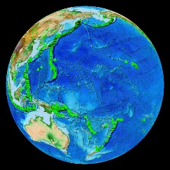 | Volcano Locations Globally | Objective: Introduce volcanoes  - Welcome…orient to SOS, how it works, etc.  - Have any of you ever seen or visited a volcano?  - Did you know there are more than 1500 known volcanoes here on Earth? This image shows all of the known volcanoes, both present and based on historical evidence. But did you know that most volcanoes are underwater, deep in the ocean, and remain to be discovered?
2 | 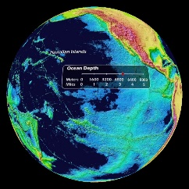 | Ocean Drain | Objective: Introduce deep sea floor, first map  - We’re going to explore the deep seafloor. For us, using Science on a Sphere, it’s easy. We can simply drain the water out of the ocean to see what’s there. But that’s only due to the hard work of many scientists over the past 50 years.
3 | 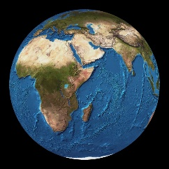 | Etopo2: Earth Topography and Bathymetry  (more like orig. map) | - First map of the entire seafloor was published in 1977 by Marie Tharp and Bruce Heezen with data collected using echo sounders (see http://blogs.agu.org/georneys/2010/12/24/a-famous-ocean-floor-map/).
4 |  | Volcano Locations Globally | Objective: Patterns, location of volcanoes around the Earth, relate land volcanoes to underwater volc.  - Let’s go back to the map showing us the locations of volcanoes around the world as green triangles.  - Imagine you are on the team of scientists back in 1977. What patterns do you see as you observe the locations of volcanoes? Can you locate some of the volcanoes you know about? (Hawaii, Pinatubo, Iceland)  - Spin globe around so everyone is able to see the entire globe. Pause for answers. Annotate with drawing tool or by dropping an icon.  - Many of the volcanoes that we’re familiar with are hotspots. Hot spots under a moving plate create island chains like Hawaii and the Galapagos.  - But volcanoes are found underwater as well and some of these volcanoes also have hydrothermal vents where warm water is venting from the sea floor.  - Let’s go to Hawaii and look for the newest volcano in the chain of Hawaiian islands, Loihi (loh-ee-hee).  - Option: drop Jason icon at location
5 | 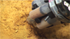 | Vent Site Loihi movie | Objective: Hot spot volcano  - Play  - Pause when the bullseye starts to show location to orient audience. Rotate sphere.  - Pause at the end of the dive graphic (1200m) and rotate for all to see.  - Loihi’s summit hasn’t pushed above the ocean surface yet. It is underwater 1200 meters, or about ¾ of a mile, down. Warm fluids are venting from the summit, at hydrothermal vents.  - The orange color you see on the rocks is because these fluids contain iron. While iron is normally black, when it rusts, as you know, it turns orange. Here, the iron is an energy source for a special type of microbe - iron-oxidizing bacteria. The bacteria grow into rust-colored microbial mats, like a carpet on the seafloor.  - Pause during suction sampling.  - Scientists collect microbial mats using a suction sampler held by Jason’s manipulator arm. These bacteria are being studied to better understand the iron cycle in the ocean. Just like you learn about the rock cycle or water cycle, oceanographers are working to understand similar yet more specific cycles in the ocean.  - Pause at SEM  - This image is a close up of the microbial mats, taken with a scanning electron microscope. The width of the entire image is approx. width of human hair 60-80 µm.  - Stop before credits if desired
6a |  | Vent and Volcano Locations Globally | Objective: Underwater volcanoes are found along plate boundaries.  - Where else might we discover volcanoes underwater?  - See the large number of volcanoes that circle the Pacific Ocean? [Option: annotate w/red pen]  - This is called the Ring of Fire. And the Ring of Fire extends underwater, following the plate boundary of the great Pacific Plate.  - Play animation.  - The stars show where over 200 deep-sea vents have been discovered since 1977. They are called vents because warm water is venting up out of the seafloor. If the site is volcanic, there may also be lava and gases erupting from the seafloor.  - Pause animation at 2011, spin globe around so everyone is able to see the entire globe.  - As you learned from our visit to Loihi, deep sea vents form in places where there is volcanic activity.  - What pattern do you see here for other vent locations?  - Deep sea vent locations closely follow the Earth’s plate boundaries.
6b, c | 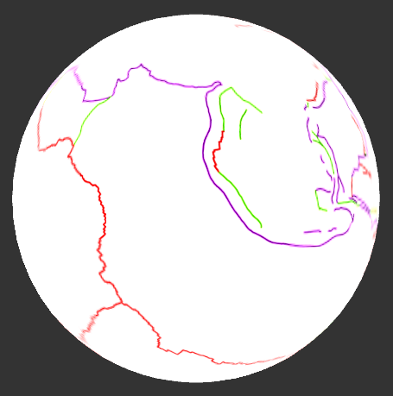 | Overlay – Tectonic Plate Boundaries – Colored  Overlay- Plate names | - PRESS AND HOLD to create overlays  - As we add to our data, we bring in an image which shows us the different types of plate boundaries- divergent in red, convergent in purple, and transform in green.  - Where do you see many of the hydrothermal vents marked by the red stars?  - Pause.  - A divergent (red) boundary is where two plates are moving apart and new seafloor is being created as magma rises to fill the space. Divergent boundaries create the Mid-oceanic ridge, which appears like a baseball seam that wraps around the entire globe. If you observe carefully, can you see how most of the vent stars line up on the red plate boundaries?  - Zoom into Juan de Fuca Ridge  - Let’s go see what one of these vents is like. We are going to travel to the Axial Seamount, a vent site located along a red, divergent boundary in the eastern Pacific Ocean  - Option: drop Jason icon
7 | 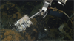 | Vent Site Axial movie | Objective: divergent boundary vent  - Play  - Pause to show location and rotate sphere  - We’ll dive to 1500 meters, about a mile down.  - Pause and rotate sphere.  - Axial Seamount is located on the mid-ocean ridge, the baseball seam around the entire globe where new crust is formed.  - Here, hydrothermal vents are being studied over time as part of an underwater observatory. Tubeworms thrive in this extreme environment, where hot vent fluids and cold seawater mix.  - In 2011 a volcanic eruption paved over the vent sites, and new vents had formed. Some spewed microbes like the snowblower vent shown here.  - Scientists put instruments at the new vents to take fluid samples over the next year.  - When they returned to recover their instruments, they saw microbial mats. Animals had colonized the vents, and covered their instruments.  - Pause while the intake sampler is held to point out the small animals on it
8a  8b, c |  | Vent and Volcano Locations Globally  Overlay Plate boundaries color  Overlay Plate names | - PRESS AND HOLD to create overlays  - In our tour thus far, we’ve seen a vent on a hotspot and a vent on a spreading, divergent boundary.  - Can you find any vent sites along a purple, convergent boundary?  - Let's explore one in the western Pacific. Here, the Pacific Plate is colliding with and dipping under the Australian plate.  - Option: drop Jason icon
9 |  | Vent Site Mata movie | Objective: convergent boundary vent  - This is a site called West Mata, where one of the first underwater volcanic eruptions ever observed was recorded as it was happening.  - Pause to show location and rotate sphere  - We’ll dive to 1200 meters, about ¾ mile down.  - Pause and rotate sphere.  - Listen as scientists discovered the eruption as it happened.  - Wait  - At nearby sites that were not erupting, animals such as these barnacles and snails were thriving. Would these animals colonize the West Mata site?  - Three years later, the volcano was no longer erupting, but warm fluids poured out of the hydrothermal vents and the site had indeed been colonized by a community of specialized organisms, adapted to live off of the vent fluids and vent bacteria. The shrimp were thriving.  - The ROV’s manipulator arm is holding a net to sample shrimp so scientists can learn more about where they may have come from to colonize the vent.  - It is possible that these shrimp came from nearby, or maybe from faraway. Scientists are studying the potential for hydrothermal vent animals to disperse long distances in their early life stages in the plankton.
10a  10b, c | 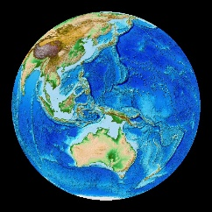 | Vent Locations Globally  Overlay Plate boundaries color  Overlay Plate names | Objective: Review plate boundaries and vent locations, continuing exploration, areas unexplored  - PRESS AND HOLD to create overlay  - In our short journey, we explored 3 different hydrothermal vents, each created by a different process associated with plate tectonics or plate movement.  - (Loihi- hot spot, Axial- divergent, West Mata- convergent)  - But as we look at where vents have been explored, do you see places where YOU think there might be some hydrothermal vents that have not yet been discovered?  - Where would you plan your expedition of discovery?
11 | 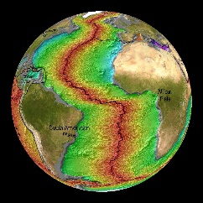 | Vents and Volcanoes on Age of Seafloor | - When you look at those plate boundaries, now colored in this way to show the age of the seafloor (red is youngest and green to blue are older), do you see a dynamic Earth, hidden beneath the ocean, full of geologic activity as well as unique forms of life?  - Rotate/tilt sphere to show Mid-oceanic Ridge remaining to be explored

