Playlist Clip # | Thumbnail | Clip Title | Objective / Script / Actions  3 literacy concepts to be covered: chemosynthesis, Earth’s connected systems (esp. rock, water, life), ocean is largely unexplored
1 |  | Blue Marble 23 degree tilt | Intro to presenter and SOS  Preset pen color to red; select icon.
2 | 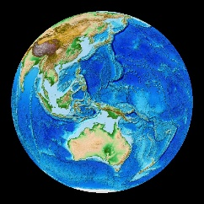 | Etopo 1 | Objective: Introducing deep sea exploration—first expedition to vents with Alvin in 1977, geologists  - In this image, we can see the sea floor. It’s full of mountains and valleys and ridges just like the Earth’s surface above sea level. Only it wasn’t easy to figure that out.  - We didn’t have a good map of the seafloor until 1977, the same year the submarine Alvin, discovered something brand new.  - Alvin is a submersible that can carry a pilot and two scientists to 4500m or 2.7miles deep.  - In 1977, geologists used Alvin to examine volcanic areas and areas along the Mid Oceanic Ridge where they believed new seafloor was being created.
3 | 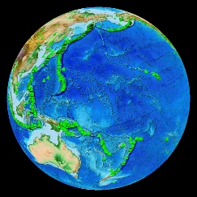 | Volcano Locations Globally | - The green triangles that I’ve added to the image show the location of over 1500 known volcanoes. What pattern do you see in the location of these volcanoes?  - Wait [edges of continents, ridge]  - The geologists, back in 1977, used this pattern and other information to decide where to look underwater for volcanic activity.  - I’ll bet you can see some places you’d like to look.  - For more than 5 years, a team of marine geologists and geochemists had been searching deep sea plate boundaries for theorized hydrothermal vents.
4 | 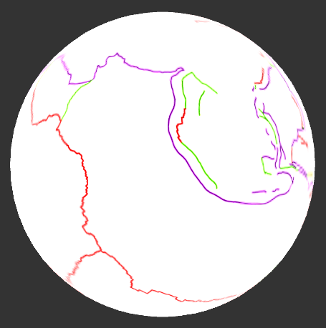 | Overlay- Tectonic Plates - Colored | Objective: First vent discovery 1977- Galapagos Rift  - Overlay Tectonic Plates - Colored  - This image shows the plate boundaries in red, purple, and green.  - The scientists were using the latest in technology to look for warm water percolating from the sea floor. For days they measured the water temperature and took pictures of the dark and barren sea floor.  - But after much persistence, they found spikes in the water temperature.  - The area where they were searching was near the Galapagos Islands- called the Galapagos Rift.  - Option: annotate, point and drop target icon, or Alvin icon
5 | 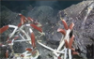 | Vent Site Galapagos Rift movie  Still shots of clams and worms  Video footage  Zoomed in image | - Pause when the bullseye starts to show location if necessary.  - Let’s dive down to see what it was like. We’re going down to 2500m or 1 ½ miles.  - These first images are some of the original photos taken by scientists in Alvin in 1977 and 1979.  - Pause on still photos  - They saw thriving communities of giant clams and never-before-seen worms, the size of their arms. They called the worms, Riftia, named after the location, the Galapagos Rift.  - Their next time back, they would need to add biologists to the team. (for details, see divediscover.whoi.edu, Vent CD, timeline)  - Play  - Scientists continue to explore this region and the animals that live there. The movies were taken at a vent along the Rift, discovered in 2011 (Tempus Fugit).  - Watch/wait  - The Riftia worms have been observed spawning.  - Here you see a close-up of Riftia, showing the feather-like plume which pulls the chemicals from the water to supply the bacteria living inside the worm.
6 | 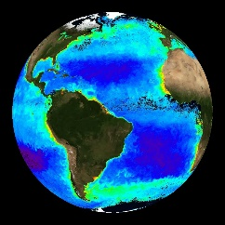 | SeaWIFS Ocean Color | Objective: Contrast life with sunlight and without (photo vs chemo)  - Let’s go back to looking at some of the life on Earth that we know and understand well.  - This image shows us the lush green plants on land as well as algae and single-celled phytoplankton in our oceans.  - You’re watching a seasonal pattern of change in these life forms, a pattern which depends on the amount of sunlight.  - The plants, algae, and phytoplankton all share a common process for converting sunlight into food energy.  - What is this process called? (photosynthesis)  - [photo- meaning light, synthesis- meaning to produce through a reaction]
7 |  | Black ball | - Imagine for a moment, life in the deep ocean. The organisms found at the Galapagos Rift vents live in complete darkness.  - Yet, despite having no access to sunlight and very limited food-fall from the ocean’s surface organisms supported by the sun’s energy, the worms, clams, and other vent organisms are thriving.  - Life without Sunlight—an exciting topic to explore in more detail.
8 |  | Vent Discoveries Animation (black background) | - Since 1977, scientists have found over 200 more vents using human-occupied, remotely-operated and autonomous vehicles. The red stars show the discoveries of these vents all around the world, from 1977 until 2011.  - Watch time stamp. Pause animation to stop loop at 2011.  - What kind of a pattern do you see that reveals the location of these vent systems?  - Spin sphere and allow time for audience to come up with ideas of where they are found.
9a |  | Vent and Volcano Locations Globally | - PRESS AND HOLD to overlay (retains sphere orientation)  - The boundary of volcanoes that circles the Pacific Ocean is known as the Ring of Fire. The hydrothermal vents that have been discovered around the Pacific Ocean also create a ring of fire, only this one is under water, on the deep sea floor.  - Option: Annotate, drawing ring of fire with red pen. Spin globe around so everyone is able to see the entire globe
9b | 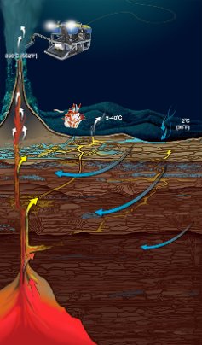 | Vent Cross Section | - PRESS AND HOLD to overlay  - At each of these hydrothermal vent locations, seawater percolates downward into the cracks and is heated by molten rock deep beneath the seafloor. This water can get as hot as 750F or 400C, 4x hotter than the boiling point of water.  - This superheated water rises and flows out of the vent opening, carrying with it dissolved metals and chemical energy. One of the key compounds is hydrogen sulfide, the same substance that gives rotten eggs or swamp mud a putrid smell.
10 |  | Vent Locations Globally on ETOPO1 | Objective: connected systems- similar organisms across oceans/regions  - At all of these vent locations, the organisms found there possess many similar characteristics, depending on chemosynthetic bacteria for energy. But species are also unique within geographic regions.
11 | 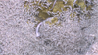 | Vent Site Mid-Cayman Rise movie  Shrimp clustering  Temp probe w/shrimp  Diving bubbles  Black smoker | - Pause when the bullseye starts to show location to orient audience if necessary  - Let’s travel to the Mid Cayman Rise, a plate boundary in the Caribbean Sea where scientists recently explored, using a remotely operated vehicle. (2011-present)  - Pause at the end of the dive graphic and rotate for all to see if necessary.  - This is the ROV on site. Do you see the shimmering vent fluid indicating hot chemically rich water?  - These shrimp are clustering together-- They are trying to get into the best position for the bacteria that live on their bodies.  - The bacteria need access to the vent fluids which contain the compounds they use to make food. Similar to how a plant makes food by photosynthesis, these special bacteria make food by a process we call “chemosynthesis”.  - The food made by the bacteria is what feeds the shrimp; though scientists must still hypothesize about whether the shrimp eat the bacteria or have a more symbiotic relationship.  - Pause during the shrimp temperature probe  - Here you see a temperature probe or thermometer held by the ROV arm.  - How are these shrimp able to live in here?  - Wait.  - They actually live in the fluids that have begun to mix with cool seawater, the water where they are living is around 60C or 140F, hot but not too hot to survive.  - Near this location, we can dive even deeper—down to 5000m. This is the deepest and almost the hottest site yet explored. We still see some shrimp, but not nearly as many.  - I just want to remind you, that the only reason we can see these organisms and black smoker chimneys is due to the light from the ROV.
12 |  | Vent Locations Globally on ETOPO1 | - We are now going to travel to the Mariana Back-Arc, a plate boundary in the western Pacific Ocean  - Annotate site, drop target icon or Jason.  - This vent is located in U.S. waters off of Guam in the Mariana Trench Marine National Monument. You might recognize the name, Mariana Trench as the deepest part of the ocean reaching down to nearly 11,000 m or 6.9 miles deep.  - Option: Overlay plate boundaries. Zoom into Mariana. Explain the Arc and Back-Arc of convergent boundary. See http://en.wikipedia.org/wiki/Back-arc_basin
13 |  | Vent Site Mariana Back-Arc  movie  Snails, crabs  Smoker | - Pause when the bullseye starts to show location to orient audience if necessary  - On this dive, we’ll go to 3000 m or 2 miles deep.  - Pause at the end of the dive graphic and rotate for all to see if necessary  - One of the vents is named Snail, for the many snails that live there. You can also see crabs and shrimp.  - Like the tubeworms and shrimp shown earlier, these snails also get their food from bacteria that are using chemical energy from the vent fluids for chemosynthesis.  - Wait  - Nearby is a high temperature vent, a black smoker called Archaean. The animals that you see are supported by a food web based on vent bacteria and other invisible microbes, called Archaea, giving the site its name.  - Like the bacteria, Archaea are a single-celled organism using the chemical energy spewing from the vent, only they are much more heat tolerant than bacteria and can live inside the smokers in temperatures higher than 100 C (the boiling point of water)!
14 |  | Vent Locations Globally on ETOPO1 | Objective: connected systems, ocean is largely unexplored  - In our short journey, we explored 3 different hydrothermal vents;  - each with similar, yet different organisms;  - all rich, thriving chemosynthetic communities, living without sunlight;  - all demonstrating the connected cycles of rock, water, and life.
15 | 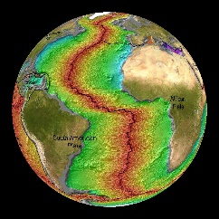 | Vents and Volcanoes on Age of the Seafloor | - I’ve added one more dataset—the Age of the Seafloor. The youngest parts of the seafloor are in red with older parts shown in green to blue or purple.  - As you look, do you see areas of the ocean that are largely unexplored?  - Where will we find more deep-sea vents and discover new life?  - There are likely a thousand more hydrothermal vents and communities to be discovered.  - This is the frontier for our next generation’s ocean explorers.

