The overall goal is to paint a story about why shark conservation is important based on what we know about shark migration patterns and fishing regulations. The story includes:
- the research questions and researcher;
- biological facts about these sharks;
- the actual migration data for the three sharks;
- shark migration relative to the Gulf Stream and Mid-Atlantic Ridge;
- species diversity and shark feeding;
- an info-graphic on shark conservation
- a composite still image of all three shark tracks
- Optional Ocean in Motion

 | Visual | Script | Transition/Play notes
1 | Pip overlay with image of Greg Skomal, logos of partners, sharks | The shark tracking data belong to Dr. Greg Skomal from the Massachusetts Division of Marine Fisheries. The goal of this research was to gain a better understanding of the ecology and life history of the great white shark in the North Atlantic. Previously, white sharks were only known to inhabit coastal waters from Newfoundland to the Gulf of Mexico. What little we knew about them came from infrequent encounters by fishermen. However, with improved satellite tracking technology, scientists can now effectively observe great whites on a consistent basis. White sharks were once thought to be a predominantly shallow, coastal species, but we now know otherwise. Tags, which are attached to the shark’s dorsal fin, are designed to send a signal to a satellite when the fin is above the surface >1min. The satellite would then calculate and transmit the position of the shark to the researcher (Skomal et al). These tags transmit ~4y on the shark. | rotation on
2 | 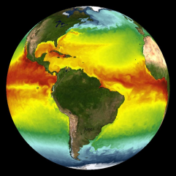 | In this image, we see ocean surface temperatures represented as colors, changing with season (generated by a NASA computer model). While the coldest areas (blue) remain at the poles and the warmest areas (red) remain at the Equator, watch how the warm water spreads northward from the equator during the spring and summer. You can see it cool again in the fall and winter. Ocean currents are also visible, such as the Gulf Stream, which transports warm water from the Gulf of Mexico up the east coast. Along the edges of stronger currents, ocean eddies (small whirlpools) peel off, mixing and dispersing the temperature gradients.  As you will see, the 3 white shark tracks I’ll show you stay in waters in the red, yellow and green shades. As the seasons change, they follow the temperatures best suited for them.  White sharks are part of a family of sharks called Lamnidae, or Mackerel Sharks. This group of sharks is endothermic, which means they are able to regulate their body temperature so it can be several degrees above that of the water. They’re one of the few warm-blooded species of fish. The sharks are following the warming water as it expands into northern latitudes. Endothermy allows these sharks to explore/remain in cooler water than ectothermic species; not only in two dimensions, but also vertically. (Skomal, pers. comm.)
3 | 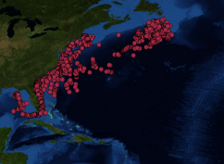  Shark Katharine  Shark tracks are layered on Blue Marble with topo/bathy but can be layered over others. | Katharine, a shark tagged in late August of 2013, showed a predominately coastal migration. She moved south from her tagging location off Cape Cod to the southeastern US and, by the beginning of the summer, 2014, she entered the Gulf of Mexico before swimming back up the east coast by late July of that year, returning to Cape Cod by October. She then followed a similar pattern as she did the previous winter, leaving Cape Cod around mid December. She went along the coast as before, but didn’t go to the Gulf this time. Katharine is interesting because she was predominantly coastal, which was historically thought to be the distribution of this species. Nonetheless, she still made a couple of large excursions out into oceanic waters. | slice image 4x- Atl Oce  After shark reaches New England, fast forward through the rest of the track until she starts to migrate into the open ocean.
4 | 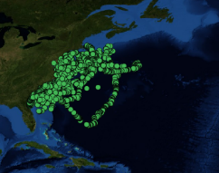  Shark Mary Lee | Mary Lee was tagged in mid September of 2012, and, like Katharine, spent a lot of time moving up and down the east coast. She particularly favored an area off the coast of Georgia, but Mary Lee also made large migrations offshore. She would regularly journey into oceanic waters from January through late March or early April. Mary Lee’s migration pattern was generally repeated throughout the time she was tracked. | slice image 4x- Atl Oce  -fast forward through the rest of Mary Lee’s track to speed up presentation.
5 | 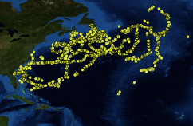  Shark Lydia | Lydia, who was tagged off Florida in March of 2013, is perhaps the most interesting shark in the study. She spent large amounts of time in oceanic waters and traveled farther east than any other shark observed. What makes her so special is that she is giving us an entirely new perspective on great whites in the North Atlantic. We once thought that they were predominantly a coastal species, but Lydia is indicating that they may be more widespread, spending large amounts of time offshore in deeper water.  Like many other migratory species, sharks have a sixth sense that allows them to detect changes in the magnetic field. As you see Lydia move south, perhaps Lydia is using her sense to follow the Mid-Atlantic Ridge, a divergent plate boundary along which reversals in the Earth’s magnetic field have been preserved in bands.  We lose track of Lydia for little over a year. Remember, these satellite tags only work if the shark’s fin is at the surface of the water for a minute or longer.  In addition to SPOT tags, Dr. Skomal placed tags that were able to record light, pressure, and temperature. These data showed that when the white sharks were in the open ocean, they were oscillating up and down in the water column-- they would start at the surface, dive down, spend a considerable amount of time at depth, and then swim back to the surface before repeating the process again. Dr. Skomal believes this behavior might be associated with feeding on deep sea fish and squid in these open ocean environments. | slice image 4x- Atl Oce  -once Lydia’s track reaches MAR  -fast forward through the rest of Lydia’s track -she only appeared infrequently a few more times before her tag popped off  Note: Light, pressure, and temp come from a separate tag called a Pop-up Archival Satellite Transmitting (PSAT) tag that were placed on Lydia and 25 other white sharks.
6 | 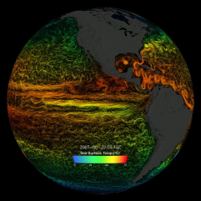  Sea Surface Currents and Temperature (grey land) | What do you think the swirls are that you now see?  Focus on the North Atlantic Ocean, and the strong current that we have running through it, the Gulf Stream. To better understand where the sharks are going, we should also examine the ocean currents that some sharks appear to follow.  Each of the 3 sharks we’ve seen interacts with the Gulf Stream at some point. To remind you, Katharine followed the coast from Florida to Newfoundland. Mary Lee followed went from Georgia to Cape Cod before heading out around Bermuda. Lydia tracked from Florida all the way to where it dumps out in the Central North Atlantic, before following the Mid-Atlantic ridge south. While it seems plausible, there is not a lot of evidence that these sharks are actually using the Gulf Stream to move. The coastal, shelf-oriented movements are well inside the western margin of the Stream and the oceanic movements are south or east of the Stream. (Skomal, pers. comm.) Further research and evidence will certainly give us more knowledge of their movement patterns. | give audience a chance to observe image and key  slice image 4x- Atl Oce  Note: These coastal movements are not really associated with the Gulf Stream because they are inshore of the Stream. Although some of the oceanic movements appear to be in the Stream.
7 | 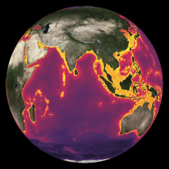  Fisheries Species Richness | This image shows species diversity around the world. Warm colors, like yellow and orange indicate high numbers of species or high diversity, and cool colors like purple and black indicated low diversity. In the Atlantic, all along the coasts, you see high diversity. As you can see by the lighter colored areas, the coastline of the East coast is highly productive with abundant fisheries resources. This in-turn supports a wide range of ocean predators. At the top of the food chain is the great white shark. So along their migration, our sharks have plenty of opportunities to find prey. It has been thought that when they journey away from the coast, there is considerably less prey. However, there are “hot spots” so to speak throughout the Atlantic, and if you remember Lydia’s migration route, she may be following these hot spots, though that would be tough to prove. Notice that brighter line going through the middle of the North Atlantic? That’s along the Mid-Atlantic Ridge that Lydia followed. For any species, migration is driven by food or reproduction, a pattern we likely see here in the behavior of these 3 sharks. | slice image 4x- Atl Oce
8  _  9 | 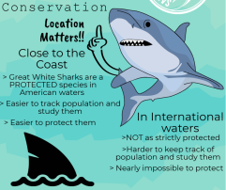  Shark Conservation Infograph: pip with all 3 sharks---------------------Alt dataset:  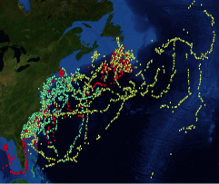  3 sharks composite | This image shows all of the tracks of the three sharks over four years. Katharine red, Mary Lee green, and Lydia yellow. White sharks in the Western North Atlantic spend a large amount of time along the coast. But they also spend a large amount of time in the open ocean.  Great white sharks have been federally protected* in US waters since 1997. Since that time, we’ve been able to study their migratory ranges, life history, and observe that their populations are on the rise. But with this research, we’ve learned that sharks are highly migratory, and when spending large amounts of time in international waters, they’re under considerable threat. In international waters there are no strict laws or regulations protecting these sharks and they are under threat from long-lines, nets, commercial fisheries, and illegal finning operations.  *see additional notes below table | rotating  *fishing ban, NMFS  Alternately may just choose to show composite image of all 3 shark tracks together to summarize and add personal conservation message.
10 | 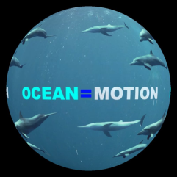  Ocean in Motion movie | The final part of the presentation is a movie about the health and state of the ocean and how we need to start changing things to preserve and protect the ocean and its resources for future generations. | optional play for late visitors or those with further questions

Additional talking points:
So why is all of this information important? Besides allowing us to peek into the secret lives of the Atlantic great white, it also shows us that we need to work even harder to protect them. In the Atlantic, white sharks have been a prohibited species in federal waters since 1997. While a sharp population decline of white sharks follows after the movie, Jaws (1975), the decline is actually associated with the dramatic expansion of commercial fisheries targeting sharks in general. We’ve only recently begun learning the truth about white sharks. Their populations are slow to recover, and even though they are protected in American waters, they don’t have the same level of protection in the open ocean. As we can see from these three sharks, they frequently go into unprotected areas.
All sharks, not just great whites, need protection. They are essential to our ecosystems and are a keystone predator, meaning they provide a service to the environment that is critical to the health of their habitat. Sharks regularly eat the weak individuals in a population and keep other species in balance. Yes, sharks can be scary, but they very rarely interact with humans. They’d rather mind their own business than hunt humans. In fact, people cause more harm to sharks than sharks do to people. They’ve been on this planet for over 400 million years, they were here before and after the dinosaurs. But in the last 50 years, they have been overfished to the point where they now need our help to survive.
So what can you do to help great whites and other sharks? You can do research on websites like Atlantic White Shark Conservancy and become informed about these amazing fish. You could also research other reputable websites like the NOAA Highly Migratory Species Division. Then you could educate others on the situation these sharks face when they journey out into the open oceans, away from the protection of the coast. And finally you can reach out to local and state officials and try to bring about change in policies that may still endanger these and other threatened species.
References:
Curtis, T. H. et al. Seasonal distribution and historic trends in abundance of white sharks, Carcharodon carcharias, in the western North Atlantic Ocean. PLOS One9 (2014).
Skomal, G., Braun, C., Chisholm, J. & Thorrold, S. Movements of the White Shark Carcharodon carcharias in the North Atlantic Ocean. Marine Ecology Progress Series 580, 1–16 (2017).
Gaube, P., Braun, C.D., Lawson, G.L., McGillicuddy, D.J., Penna, A.D., Skomal, G.B., Fischer, C.A., & Thorrold, S.R. (2018). Mesoscale eddies influence the movements of mature female white sharks in the Gulf Stream and Sargasso Sea. Scientific Reports 8: 7363 (2018).
Thank you to Dr. Greg Skomal and his agency, the Massachusetts Division of Marine Fisheries, for funding and personnel. For the tracking of these three fish, Ocearch provided the SPOT tags, ship and tagging platform, as well as satellite time. Thank you to the partnership of the University of Massachusetts Dartmouth with the Buttonwood Park Zoo for supporting the undergraduate internship of Tighe Ratcliffe and the technical support of Annette Brickley, STEMming the Gaps Consulting.

