Dataset | Script
Blue Marble  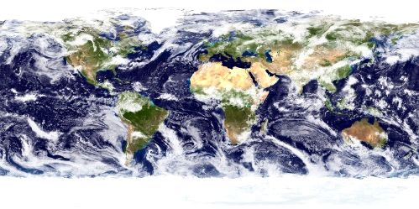 | Hello, I'm ____________ from NOAA, the National Oceanic and Atmospheric Administration.  Welcome to Science On a Sphere. We use this global visualization technology developed by NOAA, along with our network of spheres at over 120 museums and science centers worldwide, to...
Clouds (colorized) - Real-time  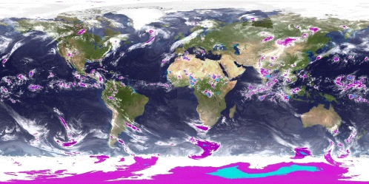 | ...engage viewers with real-time data like today's weather, cutting-edge research models, and other animations showing how dynamic our planet is.  We can look at earth as if we were floating in space, but even better, the invisible is made visible through the art and science of visualization.
Anthropocene  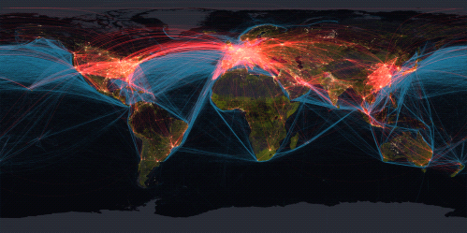 | Here we see an industrialized view of our planet.  We can see Earth as if it were nighttime all around the world so we can see the lights that are visible from space. These lights are a proxy for where most humans live and the economic affluence of those people.  Notice that there are concentrations of populations along the coasts and rivers.  The red lines represent 87,000 flights in a day connecting cities and cultures all around the world.  Moving from our highways in the sky to our highways in the ocean, we see the paths of 3500 commercial vessels over the course of a year, shown here in blue, representing only 10% of the total ocean shipping traffic  And in green, we see the world's roads, used by over a billion motor vehicles.  This colorful globe gives us a sense of how interconnected we are, but also how much energy we use, and the cumulative impact we have on the planet.  With Science on a Sphere we can see that the human footprint is everywhere.

Sea Surface Temperature NOAA Model (with vegetation)  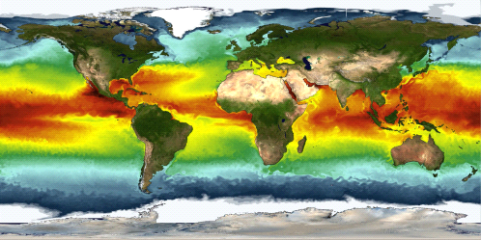 | Let's peel away this heavily industrialized view of our planet to reveal the beauty of the dynamic ocean. Here we are watching an animation of the ocean's surface temperature through a model.  The colored temperature gradients also reveal ocean currents. You can see seasonal changes and major areas of mixing.  Notice how it is truly one world ocean with interconnected basins.  The ocean is constantly moving - transporting colder water from higher latitudes towards the equator and pushing warmer water poleward from the equator.
Marine Debris  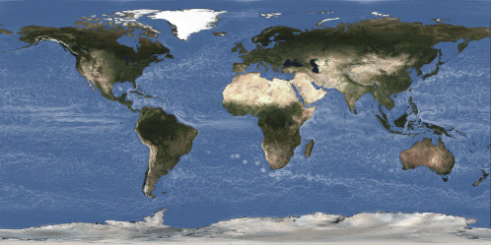  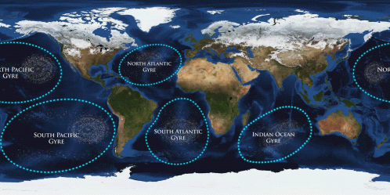  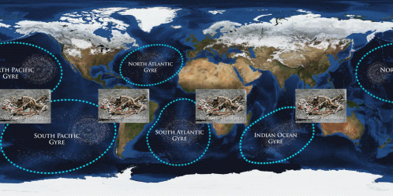  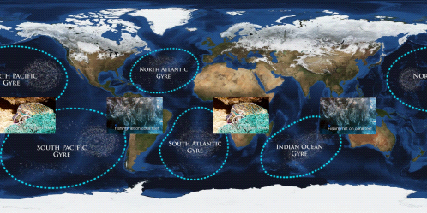 | Ocean currents connect us all. Currents drive weather, deliver nutrient-rich water to the ocean's surface, and unfortunately, they also transport marine debris around the globe.  Marine debris like a plastic bottle dropped on a beach in Miami could be transported by these currents across the Atlantic to Europe or Africa. On the other side of the world, in the Pacific, a fishing net from Asia could wash up on shore in Hawaii.  ---Fade in "Gyres and Debris" layer ---  Once trash enters the ocean environment, it moves in one of five large ocean circulation patterns, known as gyres.  The currents in the gyres gather some of the debris in large aggregation zones, often referred to as “garbage patches.” These patches—much like a peppery soup— contain tiny micro-plastics mixed with scattered larger items.  Because there is no way yet to clean them up, they will likely continue to gather plastics and other materials indefinitely. And, some of these plastics last for hundreds of years. The only way to reduce debris is to prevent it at the source.  That source is us. We are affecting even the most remote places on Earth, places such as Midway Atoll in the Northwestern Hawaiian Islands where debris from the Pacific Rim covers the beaches, threatening the native albatross.  ---Fade in “Eating Debris” layer---  Many birds eat plastic floating in the ocean, mistaking it for food and feeding it to their young. Plastics, ranging from small shards to bottle caps are found inside almost every dead albatross in the region that is examined.  An unknown amount of plastics enter the ocean every day, and yet we know very little about how chemicals in plastics affect these animals or if these chemicals are moving up the food chain.  ---Fade in "Debris Nets" layer, fade out "Eating Debris"---  Another form of marine debris, derelict fishing gear, is also causing problems. Nets like these can drift thousands of miles and entangle animals. Commercial nets can weigh hundreds of pounds and scour precious coral reefs.  These images show the need for improved fishing gear and more sustainable fishing practices.  ---Fade out "Debris Nets " layer---  Because much of this debris is circulating in these gyres and far from shore, it is away from human observation. In fact, many people heard about marine debris for the first time after the disappearance of the Malaysia Airline flight and the search in the Indian Ocean.  Marine debris is one of the most widespread pollution and coastal hazard issues our ocean and waterways face today.
Nutrient Runoff  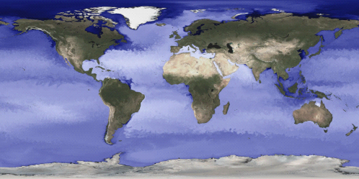  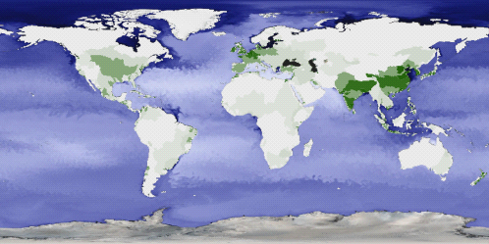 | Another source of ocean pollution, although much less visible than marine debris, is excess nutrients.  We are watching a time-lapse sequence of the world's major rivers (circled in yellow) discharging freshwater into the ocean which you can see as dark blues and purples.  --- Point to Amazon outflow and to Mississippi River outflow---  In addition to massive amounts of freshwater, these rivers also deliver significant quantities of nutrients collected from their watersheds.  --- Fade in "Nitrogen" layer---  One of the key nutrients is nitrogen. Since 1960 the global use of synthetic nitrogen fertilizers has increased 9-fold and continues to rise.  This dataset shows global anthropogenic nitrogen inputs from the world's major watersheds into coastal waters.  The lighter greens indicate areas of lowest inputs and the darker greens are areas of highest inputs.  High nitrogen levels cause algal blooms which sink to the bottom and use oxygen as they decay, resulting in low dissolved oxygen, also called hypoxia.  Hypoxia can cause fish kills, destroy habitat, and exacerbate ocean acidification.  As you can see, Nitrogen runoff is a global problem.  Let's take a closer look at the Mississippi River watershed that drains more than 40% of the continental US including runoff of fertilizers applied to a major agriculture region. The Mississippi discharges these nutrients into the Gulf of Mexico as an enormous point source of pollution.  --- Point to discharge point at Mississippi River Delta---
Nutrients with Dead Zone  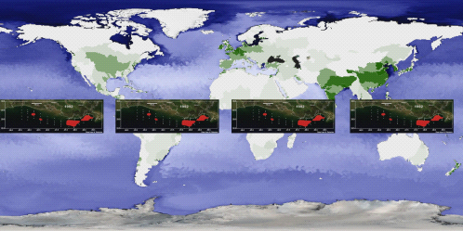 | The red area in this box shows the Gulf of Mexico dead zone between 1985 and 2008. This dead zone is a result of nutrient loading from the Mississippi River watershed.  You can see how the size and the shape of the dead zone fluctuates from year to year as a result of the amount of nitrogen delivered, the volume of river runoff, temperature, winds and currents in the Gulf.  Hypoxia kills organisms that cannot move from the area. That's why these areas are known as "Dead Zones." This one is the size of the state of Massachusetts and is growing.

Keeling Curve Data  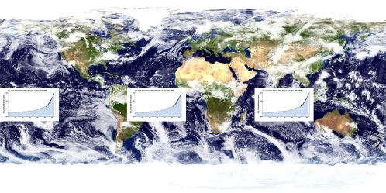 | Ocean pollution also comes from the atmosphere.  This graph shows the increase in carbon dioxide in the atmosphere from 1700 to present. Because the ocean absorbs about 30% of carbon dioxide emissions, the concentration of carbon dioxide dissolved in the global ocean is increasing as carbon dioxide emissions increase.  CO2 is an acid gas and absorption of CO2 by the ocean causes acidification, which we measure as a decrease in ocean pH. The ocean is 30% more acidic today than it was in 1800.
Ocean Acidification pH Data  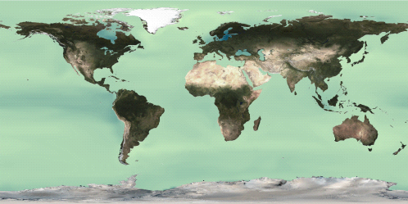  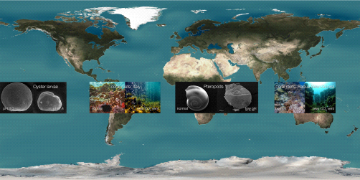 | This dataset shows a model prediction of surface ocean pH from 1895-2080. Notice the subtle, but significant change from green to dark blue as the ocean acidifies. Throughout the 1900s, surface ocean pH did not change much because of the ocean's natural ability to resist chemical change.  But with the accelerated emissions of carbon dioxide occurring now and in the future, the surface ocean will acidify rapidly. Ocean acidity could increase by as much as 150% by the year 2100.  Ocean acidification is currently happening at a rate that is 10 to 100 times faster than any time in the past 50 million years. This poses a large threat to marine ecosystems especially organisms that form calcium carbonate structures like corals and shellfish that are sensitive to ocean acidification.  ---Pause dataset at the end of the model run (2080); Fade in "Impacts PIPs"---  Ocean acidification affects a variety of organisms and ecosystems, such as the ones shown in these pictures.  We can already see the effects of ocean acidification on oyster larvae in hatcheries in the US Pacific northwest that grow poorly when exposed to the acidified waters.  In the Southern Ocean, scientists have found pteropods, a key component of marine food webs, with shells partially dissolved due to acidification.  Places where carbon dioxide naturally vents from the sea floor show us what coral reef communities might look like if ocean acidification continues unabated. In Italy and Papua New Guinea, coral communities thrive in normal seawater, but do not near the carbon dioxide vents.
Ocean Acidification Observation Stations  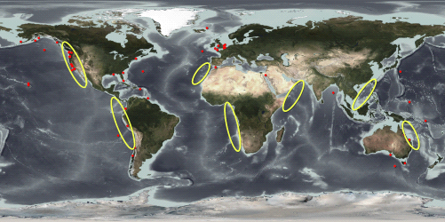 | While the mechanism causing ocean acidification is well understood, we lack sufficient data to explain and document its progression. More ocean observations are needed, particularly in areas where acidification is predicted to occur more rapidly.  Such as upwelling regions, circled on this map. Upwelling regions are more susceptible because deep, cold acidified waters are pulled towards the surface.  The Global Ocean Acidification Observing Network is an international effort that has members from 30 different countries. The red dots on this map show the locations of all of the time-series observations that network members currently maintain.  As you can see there are critical gaps in this network that need to be filled, especially along the coasts.
Species Richness  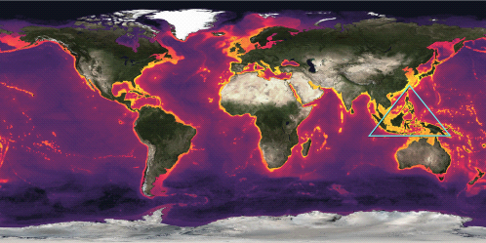 | Coastal areas, more broadly, contain the greatest number of marine ecosystems, such as coral reefs, mangroves, and marshes that provide the food and shelter for commercially and ecologically important marine species.  This dataset is a species richness map showing the approximate global distribution of more than a thousand different harvested fish and invertebrate species.  Gold indicates areas with a higher number of fish species, while dark purple show areas with a lower number of fish species.  Look at the species richness along the coast. Unfortunately, as we have seen, many of these coastal areas are threatened by hypoxia, marine debris, ocean acidification and other effects of human activity. These critical habitats need to be better protected.  Let's take a closer look at the large area between Australia and Vietnam, which encompasses the Coral Triangle. Notice how much orange there is here, indicating a region with high species richness. The Coral Triangle is one of the world's most important hotspots for marine biodiversity and one of the most productive fishing areas in the world.  Many nations in the Coral Triangle depend heavily on fisheries for their livelihood. Some countries in this region rely on fisheries for more than 90% of their protein.  But this resource is threatened by destructive fishing practices, illegal fishing and overfishing.  It takes strong international collaboration to address these global challenges to sustainable fisheries in this and other parts of the world.
Fisheries Catch Model 2055 v 2005  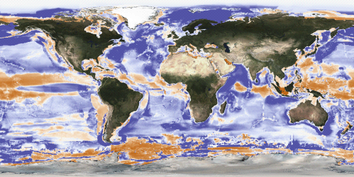 | Another global threat to sustainable fisheries is climate change.  This image shows changes in fisheries catch projected to occur by 2050 due to climate change. The orange areas are projected to have reduced fisheries catch, while blue areas will have higher fisheries catch.  This model suggests that the distribution of major fisheries will shift poleward to higher latitudes and cooler waters because of warming ocean temperature.  These changes in fisheries have large implications for global food security. For example, fisheries in the tropics are projected to be among the most affected by climate change, experiencing on average a 40% reduction in catch by 2050.  In contrast, some areas of the Arctic are expected to have higher fisheries catch as sea ice melts and new habitat becomes available for lower-latitude species escaping warmer ocean conditions.  We have already begun to see the effects of climate change on fisheries. For example, in the Eastern United States, 60% of commercial fish stocks have been shifting poleward and into deeper waters over the last 40 years.  Climate change is one of many global challenges fisheries are facing. Promoting sustainable fishing practices and reducing bycatch now are important to help reduce stress on global fisheries.  Sustainable fisheries management requires strong international collaboration, and as we work together to face these challenges we need to ensure that we follow the best available science and promote ecosystem-based management.

End Images  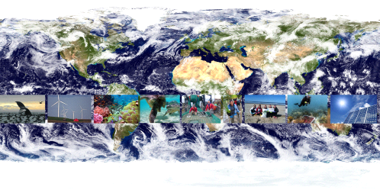 | As we return to our view from space of our beautiful planet, our home, we hope you realize that the work ahead of us means that we have to get down to Earth and work on each of these challenges where we live, in our countries and communities.  ---Fade in “Pictures” layer---  One of the most important things we can see from this perspective is that this is one ocean and that the ocean ecosystem it is not divided by national borders. We have to work as one if we are to protect it.
Credits  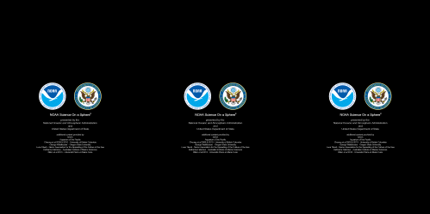 | Thank you for joining us at NOAA's Science on a Sphere.
One Ocean was developed for the Our Ocean 2014 Conference hosted by the US Department of State

Presented by National Oceanic and Atmospheric Administration and United States Department of State

Additional content provided by:
- NASA
- Aquarium of the Pacific
- Cheung et al 2009 & 2010 - University of British Columbia
- George Waldbusser - Oregon State University
- Luca Tiberti - Nemo Association for the Spreading of the Culture of the Sea
- Katharina Fabricius - Australian institute of Marine Sciences
- Bille et al 2013 - Université Pierre-et-Marie Curie

Special thanks to:
- Madelyn Appelbaum
- Susan Baker
- Suzanne Bricker
- Shallin Busch
- Gonzalo Cid
- Richard Feely
- Libby Jewett
- Luis Leandro
- Asma Mahdi
- Carrie McDougall
- Kate Naughten
- Dianna Parker
- Dan Pisut
- Erica Ombres
- Dan Thompson

