Energy Poverty: SOS
The Overarching Problem of Energy Poverty

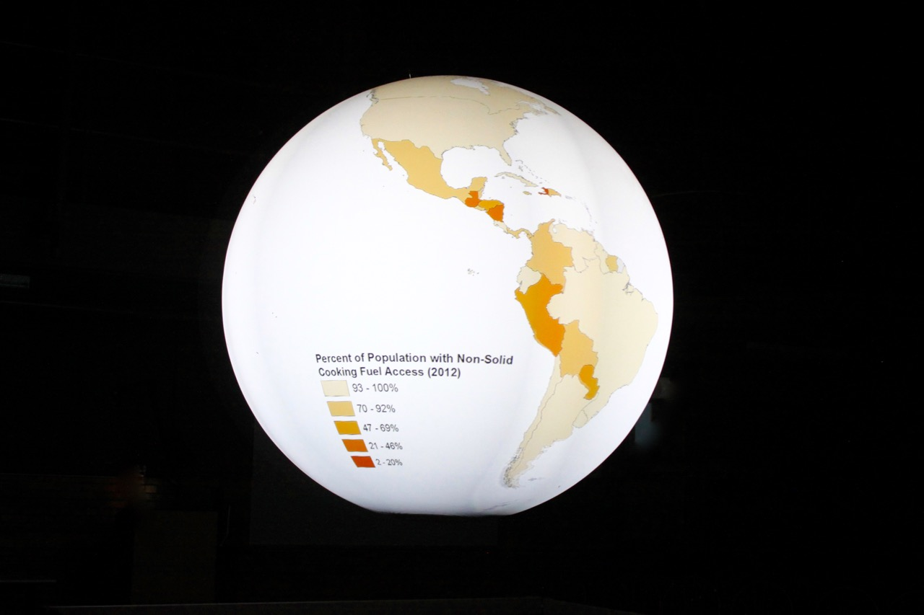

Authors: Faculty Advisors:
Rachel Stukenborg Christie-Joy B. Hartman, Ph.D.
Kaitlin Tomlinson Maria Papadakis, Ph.D.

© James Madison University, 2017

Table of Contents
Preface 3
Overview of the Lesson 5
Acknowledgements 6
Background Analysis 7
Introduction 7
Energy Poverty 7
Consequences of Energy Poverty 9
Nature of Global Poverty 13
The Feedback Loop between Energy Poverty and Global Poverty 16
Quantitative Indicators 19
The Overarching Problem of Energy Poverty 21
Learning Objectives 21
Datasets 21
Instructor Script 24
Pre & Post Assessment 28
Datasets (images) 39
Dataset 1. Non-Solid Fuel Access 40
Dataset 2. Electricity Access 41
Dataset 3. GDP PPP Per Capita 42
Data Table 43
References 52
Further Readings 54

Preface

This 2017 Science on a Sphere (SOS) Student Contest submission is the first of four lesson packages that make up the authors’ larger Senior Capstone Project in the Department of Integrated Science and Technology at James Madison University. The remaining three lesson packages will be completed in May 2017. Each of the first three lesson packages includes a background analysis, a comprehensive lesson plan, supporting teaching and learning resources, and SOS datasets for select energy poverty indicators, such as access to non-solid fuels (percent of population by country). The fourth lesson plan does not utilize the sphere but has many of the same components. The first three explore the nature and consequences of energy poverty and are presented on SOS, while the fourth delves into the social, political, economic and cultural dynamics of sustainable solutions. Data for the sphere datasets were obtained from the World Bank’s Data Catalog and the Center for International Earth Science Information Network. Datasets were created in ArcGIS and exported as individual, static image files (JPEG) for SOS.

The purpose of this project was to develop a set of university-level teaching and learning resources about energy poverty that incorporate a spherical display system, SOS. Energy poverty, commonly understood as the lack of access to clean cooking fuels and electricity, is a complex problem that has detrimental health, economic, social, and environmental effects for both the people living in it and the global community. Furthermore, people living in energy poverty are trapped in a cycle of impoverishment because energy poverty interacts in a reinforcing feedback loop with global poverty. Individuals and societies suffering from energy poverty cannot escape it on their own, and combatting the issue requires action from developed countries. The goal of this project was to increase awareness of energy poverty among university students, and SOS was incorporated to facilitate students visualizing differences in energy access and the resulting consequences on a global scale.

NOAA’s mission involves predicting changes in the climate and fostering an understanding of the causes and consequences of climate change. This project informs on NOAA’s climate science mission because energy poverty can act as a cause of climate change. People living in energy poverty burn solid fuel sources like fuelwood, agricultural residue, and charcoal for cooking and heating needs. However, these low-quality fuels release carbon emissions when burned in unclean and inefficient facilities, making them a contributor to climate change.

Furthermore, people living in energy poverty must obtain access to modern and advanced energy services. Many developing countries are trying to achieve this through fossil fuels instead of renewable energies. An increase in use of fossil fuels will cause a significant increase in carbon and greenhouse gas emissions due to the combustion of larger volumes of fossil fuels. This will further escalate climate change and degrade environmental health. To further complicate the problem, the populations of many countries experiencing energy poverty are also increasing substantially, meaning larger energy needs will need to be met. To understand the causes of climate change, it is first important to understand energy poverty.

This lesson is a step toward achieving public understanding of energy poverty as a climate change contributor. This ties very closely to NOAA’s mission of predicting changes in climate and understanding causes of climate change, because the energy practices of those living in energy poverty affect climate change, and developing countries and their changing population dynamics will determine future climate effects. The elimination of energy poverty is necessary to end suffering, but carrying it out with modern fossil fuels can lead to increased climate change and environmental degradation.

Overview of the Lesson

The purpose of this project was to develop a set of college-level teaching and learning resources about energy poverty that incorporate the spherical display system Science On a Sphere (SOS). This manual consists of the first of four full lesson “packages” regarding energy poverty that make up the authors’ larger Senior Capstone Project in the Department of Integrated Science and Technology at James Madison University in Harrisonburg, Virginia.

This manual contains the Lesson 1 package about the concept of energy poverty, global poverty, and their interactive effects. It includes a background analysis, a comprehensive lesson plan, an instructor script, images, and descriptions.

The manual includes:
Learning Objectives Presentation Tips

Instructor Script Pre & Post Lesson Assessment
Dataset Descriptions Student Handouts & Worksheets

Images

Acknowledgements

The authors thank Professor Christie-Joy B. Hartman, Department of Integrated Science and
Technology and Professor Maria Papadakis, Department of Integrated Science and Technology for their guidance and supervision of our capstone project. The authors also thank Paul Rittenhouse, Instructor, Department of Integrated Science and Technology and Elise Mazur, Teaching Assistant, Department of Integrated Science and Technology for their assistance in learning and debugging ArcGIS.

Background Analysis

Introduction

Energy poverty and global poverty are multidimensional and worldwide problems that interact and reinforce one another. Energy poverty is the lack of access to sufficient energy resources, including electricity and clean cooking fuels, which negatively impacts the well-being of people on the individual and societal levels. Global poverty incorporates economic poverty with the inability to meet human needs, such as hunger, lack of access to clean drinking water, insufficient medical resources, and other forms of impoverishment. This lesson, “The Overarching Problem of Energy Poverty,” serves to analyze the interactions between these two global problems. Energy poverty and global poverty exist in a reinforcing feedback loop, meaning that each problem directly contributes to the other, and one problem cannot be solved without solving the other simultaneously. This literature review will define and analyze the scope of energy poverty and global poverty, how they influence each other, and explain the indicators that will be explored during the lesson to promote understanding.

Energy Poverty

Harnessing and using energy is fundamental to human life, not only in the basic services of cooking, lighting, heating, and obtaining drinking water, but also in modern development in the forms of health services, transportation, and communication technologies (Sanchez, 2010, p. 1; Practical Action, 2010, p. 1). However, many people around the world live in severely energy-impoverished conditions that diminish their ability to meet even their most fundamental human needs (Sanchez, 2010, p. 1; Practical Action, 2010, 1; IEA, 2010, p. 9). This issue is known as “energy poverty” (Sanchez, 2010, p. 1; Practical Action, 2010, p. 1; IEA, 2010, p. 9).
Energy poverty is a very complex problem with circumstantial and environmental variation, and therefore has no universally-accepted, specific and quantifiable definition. The extent of energy need varies with environment and culture (Sanchez, 2010, p. 10). For example, Uganda experiences an average yearly temperature of 73.04°F (Mitchell, 2003). It is inaccurate to assume that their cooling and heating needs are the same as a country such as Russia, which has an average annual temperature of 22.82 °F (Mitchell, 2003). In order to account for this variation, energy poverty is broadly defined as the lack of access to the modern energy services of electricity and clean cooking facilities on the household level (Sanchez, 2010, p. 1; IEA, 2010, p. 8-9). Lack of access to clean cooking facilities means that the household relies on primitive, inefficient and polluting cookstoves as well as traditional biomass for cooking fuel (IEA, 2010, p. 8-9; Global Alliance for Clean Cookstoves, 2016).
In Sanchez’ The Hidden Energy Crisis (2010), a more specific definition of energy poverty is offered to give the readers a better idea of the limited quantity of energy access:
“People are considered to be in ‘energy poverty’ if they do not have access to at least the equivalent of 35 kg of liquefied petroleum gas (LPG) for cooking per capita per year from liquid fuels, gas or supplies of improved solid fuel, as well as efficient and clean cooking stoves. In addition, access to 120 kWh of electricity per capita per year is a minimum requirement for lighting, access to basic services (such as drinking water, communications, healthcare and education, etc.) as well as providing some added contribution towards local production,” (p. 1-2).
Sanchez’ definition is not a universally-accepted definition of energy poverty, but it is useful in comprehension of the concept. For comparison, in 2015, the annual electricity consumption for the average U.S. household was 10,812 kWh (EIA, 2016). Based on Sanchez’ defined threshold of energy poverty in electricity access as less than 120 kWh per capita per year, it would take over 90 households of people living in the least extreme version of energy poverty to match the electricity consumption rate of one household in the U.S.
The non-profit organization Practical Action has also attempted to quantify energy poverty by proposing minimum standards of energy access for several different categories of energy services. When any of these energy access standards are not met at the household level, the people are considered to be living in energy poverty. These are known as the Total Energy Access (TEA) standards. The energy services outlined by the TEA standards include: lighting, cooking and water heating, space heating, cooling, and information and communications. The minimum standards in each of these categories creates a baseline of energy services necessary for people to remain healthy and productive (Practical Action, 2012, p. 42). Practical Action attempts to account for the effect of different environments on the required level of energy access by phrasing the TEA standards in universal ways. For example, the minimum standard for space heating is having access to enough energy to maintain a daytime indoor air temperature of 18 °C (Practical Action, 2012, p. 42). This space heating standard does not express a minimum quantity of energy, but instead expresses a minimum indoor temperature. The environment will determine how much energy is necessary to meet this. The TEA standards also state that in areas where climatic conditions make energy services unnecessary, the standards are considered to be met (Practical Action, 2012, p. 42). However, quantitatively measuring energy poverty in this way can be quite difficult in impoverished areas. For example, one of the cooking TEA standards states that less than 30 minutes per day should be spent collecting fuel per household, but this is very hard to gauge because many people multitask while collecting fuel, making it hard to sort out how much time was spent specifically on collecting fuel (Practical Action, 2012, p. 43). Global assumptions can also not be made from TEA standards, because TEA standards are not a universally-accepted definition of energy poverty and global data on meeting them are not available.
For the purposes of this project, the broad definition of energy poverty as a lack of access to electricity and clean cooking facilities will be used. There are approximately 1.4 billion people around the world that do not have access to electricity, and 2.7 million people that rely on unclean cooking facilities (IEA, 2010, p. 7, 20). Furthermore, these numbers have barely changed within the 21st century, and are even expected to increase due to rising populations and lack of international aid (IEA, 2010, p. 7, 20). These conditions are not uniformly spread across the world, but are instead concentrated in a few, very impoverished areas: primarily sub-Saharan Africa and developing east and south Asia (IEA, 2010, p. 9; Practical Action, 2010, p. 7). People in rural areas are also much more likely to be living in energy poverty than those in urban areas (IEA, 2010, p. 9). 87% of people without access to electricity and 82% of people without access to clean cooking facilities live in rural areas (IEA, 2010, p. 9).
In order to quantitatively explore this definition, indicators of energy poverty will be analyzed. Indicators are demographic data that reflect the negative consequences of energy poverty. These consequences and indicators will be explored in more detail in the following sections. Indicators are necessary for making accurate inferences about people living in energy poverty, and the effect that living in energy poverty has on the individual and national levels.

Consequences of Energy Poverty

Energy poverty inflicts consequences on every aspect of the lives of individuals and the functionality of a society. Individuals are made sick and driven into destitution, while nations cannot provide basic services to their citizens.
On the individual level, negative health effects are a direct consequence of having low to no energy access. People must use energy for cooking but by definition, households in energy poverty do not have conventional and clean cooking methods available to them (Sanchez, 2010, p. 2; Practical Action, 2010, p. 7; Global Alliance for Clean Cookstoves, 2010). They instead cook with low quality biomass sources such as dung, agricultural residue or charcoal on inefficient cookstoves inside the home (Sanchez, 2010, p. 2; Practical Action, 2010, p. 7; Global Alliance for Clean Cookstoves, 2010). Common inefficient stoves are three-stone fires, traditional mud stoves, and metal, cement, pottery or brick stoves with no chimneys or hoods (IEA, 2010, p. 13). The use of these cookstoves causes high volumes of indoor air pollution that are often much higher than outdoor pollution, even in large cities (Global Alliance for Clean Cookstoves, 2016).
Indoor air pollution is caused by the inefficient combustion of biomass, which releases carbon monoxide and other toxic fumes, as well as particulate matter that are in concentrations over 100 times the World Health Organization recommended levels (Global Alliance for Clean Cookstoves, 2016). When these are breathed over a certain period of time, it leads to a myriad of health effects including pneumonia, lung cancer, chronic obstructive pulmonary disease, heart disease, cataracts, and low birthweight in babies (Global Alliance for Clean Cookstoves, 2016). An estimated 1.45 million people die prematurely each year from indoor air pollution, which is higher than the number of deaths caused by malaria or tuberculosis (IEA, 2012, p. 13).
Indoor air pollution is especially of health concern for women and young children, because women and children generally spend more time in the house in poor countries (Global Alliance for Clean Cookstoves, 2016). Women and children disproportionately attend to house chores and cooking, and children that are enrolled in school often utilize a cookstove as a light source for completing homework (Global Alliance for Clean Cookstoves, 2016). This also leads to high child and infant mortality rates as they grow up breathing in high particulate matter and smoke at an early age (Global Alliance for Clean Cookstoves, 2016). These dangerous open flames in close proximity to the living area can also cause burning which may result in scars or even death (Global Alliance for Clean Cookstoves, 2016).
In addition, obtaining enough biomass to maintain and fuel inefficient cookstoves in often time-consuming and strenuous labor (Practical Action, 2012, p.51; IEA, 2010, p.14, Global Alliance for Clean Cookstoves, 2016). Women are often the ones to carry heavy loads of firewood and other fuels for long distances (Practical Action, 2012, p.51, IEA, 2010, p.14). In some areas of Tanzania, women walk five to ten kilometers a day, carrying between 20 and 38 kilograms of fuel (Practical Action, 2012, p.51). This hard, manual labor leads to risk of head and spinal injuries, gender-based violence, dehydration, animal attacks, and skin disorders (IEA, 2010, p.14, Global Alliance for Clean Cookstoves, 2016). The time demand of fuel retrieval also creates gender inequalities, as women are not able to find time for generating income or completing education (Practical Action, 2012, p. 51).
Energy for lighting is also denied on the household level for those living in energy poverty, but lighting is necessary for working, studying, or maintaining a business after the sun goes down (Practical Action, 2012, 49). People without access to electricity for lighting rely on polluting and inefficient forms of lighting, such as kerosene lamps and candles (Practical Action, 2012, 49). Only low levels of light are achievable in these energy impoverished homes which makes it difficult for children to study and perform well in school (Practical Action, 2012, 49). The availability of lighting also allows for the improvement of society as a whole, through access to modern education materials and running businesses for extended hours in the evening (Sanchez, 2010, p.9).
Low or no energy access also means inadequate or unreliable household space heating in the winters and cooling in the summers, which can prove to be fatal if weather is severe (Practical Action, 2012, p. 55). Space heating is especially important in temperate regions, where heating is a necessity for survival in cold seasons (Practical Action, 2012, p. 55). However, around half a billion people in South Asia rely primarily on cookstoves for heating (Practical Action, 2012, p. 55). Prolonged expose to cold temperatures leads to the same respiratory diseases that indoor air pollution does, making the use of inefficient cookstoves for heating and cooking very dangerous (Practical Action, 2012, p. 55). On the hand, indoor space cooling is necessary for hot and humid areas, but people living in energy poverty often do not have the means to access this service. Prolonged exposure to very hot temperatures also causes negative health effects and reduces productivity and comfort (Practical Action, 2012, p.57). For example, cooling is very necessary for preserving food for prolonged periods and preventing contamination (Practical Action, 2012, p.57). On the societal scale, lack of cooling prevents hospitals from achieving reliable storage temperatures of vaccines and medicines which can further impact people that are getting sick from having no energy access to begin with (Sanchez, 2010, p. 9).
Energy poverty also has severe impacts on the environment. Burning solid fuels such as fuelwood, charcoal, biomass, and dung in insufficient cookstoves releases pollutants like carbon dioxide, methane, black carbon, and short-lived climate pollutants (SLPs) into the home and the atmosphere due to incomplete combustion (Practical Action, 2010, p. 10-11, IEA, 2010, p.14). Biomass and coal burning cookstoves are the most greenhouse gas emission-intensive fuel systems in the world, per unit of energy delivered. (Practical Action, 2010, p. 10-11). Practical Action estimates that the incomplete combustion of biomass accounts for around 23 percent of all global black carbon emissions (2010, p. 11). These pollutants from biomass combustion are greenhouse gasses and contribute to climate change (Practical Action, 2010, p. 10). Furthermore, negative environmental effects derive not only from the burning of biomass fuels, but also the collection of them (Practical Action, 2010, p. 10). The inefficient use of fuelwood means large expanses of natural habitat are lost due to unsustainable fuelwood collection. Every year between 2000 and 2010, approximately 13 million hectares of global forest were converted to other uses of lost (Practical Action, 2010, p. 10). Deforestation causes soil degradation, which can lead to mudslides, loss of watershed, loss of biodiversity, and dwindling habitats (IEA, 2010, p. 15). Furthermore, deforestation and soil loss limits the environment’s ability to sequester carbon, further contributing to climate change (IEA, 2010, p. 15).
The social costs of energy poverty are the consequences that a nation collectively experiences because of the inability of individuals to rise out of poverty. Social costs will be referred to in this lesson as those consequences such as poor health, high mortality rates, damage to the environment, gender disparity, education restrictions, and disease outbreaks. Unfortunately, energy poverty has large social costs on nations as a whole because of the compounded drudgery of many of its citizens. Governments of countries with high rates of energy poverty are poor because their citizens are poor, meaning they cannot afford to raise their people out of poverty (Sanchez, 2010, p.19). Energy poverty prevents economic growth and prosperity of entire countries in the same way that it does on an individual scale. As mentioned in the previous section, the majority of people experiencing energy poverty live in rural areas. The effects of rural energy poverty are not just felt in rural areas, but throughout a nation: “Rural energy poverty constitutes a global concern, as it infringes on human well-being and the social and economic development prospects of a country” (Ong, 2015, p. 733). Rural energy poverty causes food insecurity, decreased productivity and economic output, environmental degradation and overall decreased quality of life for an entire nation (Ong, 2015, p. 736). The negative consequences inflicted upon the society of a country depicted by Ong can be categorized as social costs.
There are many social costs that arise from the consequences of energy poverty, including decreased rates of education. Schoolchildren in energy poverty are less likely to perform well or to stay in school. They do not have energy resources to effectively study after dark, and they may need to help with collecting fuel instead of studying more (Sanchez, 2010, p. 9; IEA, 2010, p. 15). An undereducated public further prevents development. Poor health that the use of unclean cooking facilities and lack of electricity access creates also makes it difficult to get out of poverty, because sickness decreases productivity and therefore economic stability (IEA, 2010, p. 15; Kroon, 2013, 504). Energy is also necessary for economic development, in the forms of lighting to allow businesses to hold adequate open hours and communication methods for developing economic ties (Sanchez, 2010, p. 10). Many businesses in energy impoverished countries use diesel generators instead of grid electricity which can cost much more due to expensive fuel transportation. This makes it harder to earn a profit than if grid electricity were available (Practical Action, 2016, p. 26). All of the negative health, environmental, and economic impacts energy poverty creates is what makes it such a high level global concern.
The “energy ladder” is a useful tool developed by the International Energy Agency in understanding the system dynamics of energy poverty on the individual and national levels. The energy ladder, illustrated in Figure 1, organizes common energy consumption patterns of households according to different economic statuses (Kroon, 2013, p. 505).
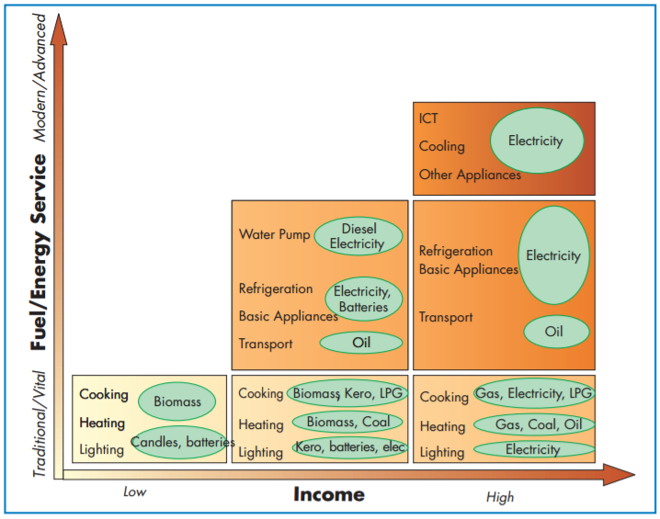
Figure 1. The energy latter is an illustrative tool developed by the International Energy Agency (IEA) that models household fuel transition as economic status increases (IEA, 2002, p. 370).
The energy ladder implies a strong correlation between income and energy consumption, and assumes that while income increases households will utilize more sophisticated energy sources and will consume greater amounts of energy. As economic status increases, a household “moves up the energy ladder.” The ladder has three distinct phases of energy sources in a linear path: primitive fuels, transition fuels, and advanced fuels (Kroon, 2013, p. 505). The primitive fuels are the most polluting and inefficient which include biomass commonly used in areas of energy poverty, such as fuelwood, agricultural waste, and animal dung. Transition fuels include less polluting fuels, such as charcoal, kerosene, and coal. Advanced fuels include the most sophisticated and efficient fuels, such as LPG, electricity, and biofuels (Kroon, 2013, p. 505). While moving up the energy ladder, the number of energy services available to a household also increases (IEA, 2002, p. 371).
As shown by the energy ladder, energy poverty heavily depends on economic poverty. However, it can also be said that economic poverty causes energy poverty. These two issues are closely intertwined. Economic poverty as a component of global poverty will be explored in the next section, and then the relationship between global poverty and energy poverty will be analyzed.

Nature of Global Poverty

Global poverty is a multidimensional problem that cannot be captured by one singular and simple definition. It incorporates economic poverty in the form of low income with non-monetary poverty in the lack of basic human needs such as food, water, and shelter. The United Nations has attempted to characterize the scope of global poverty through eight Millennium Development Goals. These goals form a framework to fight global poverty by isolating its many components into individual issues, and are useful for understanding the non-monetary effects of global poverty (“The Millennium Development Goals Report”, 2015). The Millennium Development Goals are as follows:
- Eradicate extreme poverty and hunger

Extreme economic poverty causes poor health and malnutrition, and prevents people from meeting their basic human needs. Economic poverty results from lack of employment opportunities, poor national economic health, and political turmoil in the form of conflict. As global populations increase exponentially, the available employment opportunities cannot meet the available work force. 45 percent of the global work force also works in vulnerable conditions, which means they may lack formal work arrangements, work in inadequate conditions, and lack social security and representation. These economic issues are not distributed evenly across the globe, but are instead concentrated in a few very poor areas. According to The Millennium Development Goals Report (2015, p. 15), “the overwhelming majority of people living on less than $1.25 a day reside in two regions – Southern Asia and sub-Saharan Africa – and they account for about 80 percent of the global total of extremely poor people.” Furthermore, certain demographics of people are affected more by extreme economic poverty than others due to societal marginalization, including children, young adults, and women.

- Achieve universal primary education

Primary education is necessary for the development of a skilled workforce, increased employment opportunities, and the ability to rise out of poverty. Global primary education rates have improved drastically in recent years, with 91 percent of children in developing countries and 96 percent of children in developed countries receiving a primary education. However, lack of primary education is still concentrated in specific areas, primarily in sub-Saharan Africa, where only 80 percent of children are enrolled in primary education (“The Millennium Development Goals Report”, 2015, p. 25). Enrollment rates also significantly decrease in areas of conflict. Certain demographics are also more likely to lack primary education, including girls, children coming from very poor households, children in rural areas, and children with disabilities.

- Promote gender equality and empower women

Women are often underrepresented and oppressed in many aspects of society in developing countries due to the designation of household responsibilities, cultural restraints, and discrimination. However, the elimination of gender disparity has positive effects on all areas of development in a country. While many developing countries have achieved the ideal gender parity index (the ratio of female enrollment to male enrollment) in primary education, many regions still see significant differences and inequalities. Furthermore, while 64 percent of developing countries have achieved ideal gender parity in primary education, only 36 percent have in secondary education, and only a small 4 percent have in tertiary education (“The Millennium Development Goals Report”, 2015, p. 29). Women are also often underrepresented in wage employment: globally, only 50 percent of working-age women are employed, compared to 77 percent of men (“The Millennium Development Goals Report”, 2015, p. 30). Women are also more likely than men to receive lower earnings and work in vulnerable environments, especially in southern Asia and sub-Saharan Africa. Women are also significantly underrepresented in decision-making bodies all over the world, with only 18 percent of all global political ministers being women (“The Millennium Development Goals Report”, 2015, p. 31).

- Reduce child mortality

Every day in 2015, roughly 16,000 children under five died from mostly preventable causes, like pneumonia, diarrhea, and malaria (“The Millennium Development Goals Report”, 2015, p. 32-33). While this number has improved drastically in recent years, progress is still crucial, as effective and affordable treatments exist. While child mortality is improving in many developing countries, sub-Saharan Africa accounts for about half of the world’s under-five deaths, and is expected to increase in coming years as the population grows.

- Improve maternal health

In 2013, roughly 800 women died every day from pregnancy and childbirth-related complications that are mostly preventable (“The Millennium Development Goals Report”, 2015, p. 39). Maternal deaths are caused by the lack of health professionals skilled in childbirth and antenatal care after childbirth, due to poverty. These conditions are most extreme in sub-Saharan Africa and Southern Asia, where only 52 percent of births are attended by health professionals (“The Millennium Development Goals Report”, 2015, p. 29). Furthermore, in developing countries, mothers in urban areas are much more likely to receive professional care than those in rural areas. The availability of contraception also significantly reduces the number of unwanted pregnancies, unsafe abortions and maternal deaths. However, globally, only 64 percent of couples that are married or in a union have access to methods of contraception (“The Millennium Development Goals Report”, 2015, p. 41).

- Combat HIV/AIDS, malaria, and other diseases

HIV/AIDS is a significant issue in developing countries due to the lack of comprehensive knowledge of the disease, and subsequent risky sexual behavior. Lack of anti-retroviral therapy treatment causes high death rates, and many children are orphaned by AIDS-related deaths. Sub-Saharan Africa is most severely affected by HIV/AIDS with 1.5 million new infections recorded in 2013, and AIDS being the number one cause of adolescent deaths (“The Millennium Development Goals Report”, 2015, p. 45). Deaths from malaria, a curable disease, are also of great humanitarian concern. In 2015, 214 million cases of infection and 472,000 deaths were recorded (“The Millennium Development Goals Report”, 2015, p. 47). Malaria can be treated effectively when diagnosed quickly and economic resources exist for treatment technologies, but poverty significantly limits a country’s ability to combat malaria.

- Ensure environmental sustainability

Global deforestation decreases air and water quality, and is prominent in some of the most impoverished locations in Africa and South America. Deforestation also contributes to climate change. The effects of climate change will be felt significantly in areas affected by poverty, in the forms of food shortages caused by unsuccessful agriculture and weather extremes, especially to those living near a coast. Water scarcity is also a prominent environmental issue for underdeveloped countries: it affects 40 percent of people around the world and is expected to increase (“The Millennium Development Goals Report”, 2015, p. 55). Countries may experience lack of clean water due to financial and technical inability to provide insufficient infrastructure. When clean water access does not exist, people begin to rely on unclean water sources, leading to a myriad of health effects. Environmental issues are a complicated aspect of global poverty, because they are caused by unsustainable practices all over the world, but are felt more prominently in areas without the financial means to combat them.

- Develop a global partnership for development

The final development goal deals with the lack of global aid for people living in poverty. Many impoverished countries have no means of raising themselves out of poverty on their own, due to the lack of modern technologies to contribute to global economic systems. Aid agencies are necessary to help undeveloped countries rise from poverty, integrate themselves into global trade systems, and gain access to modern communication technologies.
The Millennium Developmental Goals are very useful in demonstrating that global poverty has many different dimensions and cannot be accurately described in a simple definition. The MDGs define global poverty based on its many diverse factors: lack of access to basic human needs, lack of education, poor maternal and infant health, gender inequality, environmental instability, and lack of global aid.
Global poverty is also defined in economic terms by the World Bank, through what is known as the “extreme poverty line”. The poverty line defines an exact threshold for extreme economic impoverishment based on daily income, and gives a monetary value to understanding the conditions of those living in poverty. The extreme poverty line is defined as living on or under an income of $1.90 per day, which is an average of national poverty lines from 15 of the poorest countries in the world (Malawi, Mali, Ethiopia, Sierra Leone, Niger, Uganda, The Gambia, Rwanda, Guinea-Bissau, Tanzania, Tajikistan, Mozambique, Chad, Nepal, and Ghana), adjusted to the 2011 purchasing power parity (PPP) index. PPP indexes are developed by the International Comparison Program, and are used to standardize the purchasing power of one monetary unit based on the cost of living across county borders (“Global Monitoring Report”, 2016, p. 4-5). National poverty lines estimate the minimum income needed in a specific country to meet biological needs, but also reflect what that country deems as culturally necessary to survival (Ferreira, 2015, p. 5, 50). These national poverty lines utilize per capita income instead of consumption, because the world’s poorest countries do not have reliable data on per capita consumption. Subsequently, the extreme poverty line is a reflection of income, not consumption. While data on consumption would be more useful in analyzing the actual buying power of people living in poverty, the World Bank must utilize the available and reliable data from these poor countries.
The poverty line is updated every few years by the World Bank in order to account for changing values of money and costs of living around the world. The currently accepted poverty lines were updated in October 2015. It has been projected that in 2015, 700 million people, or 9.6 percent of the global population, were living in extreme poverty. 95 percent of the global population living in extreme poverty are concentrated in three areas: sub-Saharan Africa, South Asia, and East Asia and the Pacific. Examples of countries in extreme poverty are Chad, Ethiopia, Mali, Uganda, and Tanzania (“Global Monitoring Report”, 2016, p. 3-6). There are also several developing countries in which poverty rates vary widely: there are high concentrations of people living in extreme poverty, but the country as a whole is not considered to be in extreme poverty. Examples include India, China, and Madagascar (“Global Monitoring Report”, 2016, p. 34).
Living under the extreme poverty line warrants the decreased standard of living described by the Millennium Development Goals. Extreme poverty implies inability to meet basic human needs and a lack of access to basic services, including healthcare, education, and electricity and other energy services.

The Feedback Loop between Energy Poverty and Global Poverty

The issues of energy poverty and global poverty are intertwined in a positive feedback loop, meaning that they reinforce each other. People living in energy poverty do not have the economic resources to invest in technologies such as electricity and clean cooking fuels to rise out of energy poverty (IEA, 2002, p. 371; Practical Action, 2010, p. 27). Vice versa, people on both the household and societal levels cannot make a profit to advance and escape economic poverty without modern technologies like electricity and clean cooking fuels (Ong, 2014, p. 733). As stated in Practical Action’s Poor People’s Energy Outlook, “a vicious cycle can be identified: a lack of energy access leads to limited income-earning capability, which reduces purchasing power, which in turn limits the access to energy that could improve incomes,” (2010, p. 28). Because of this system it is extremely difficult to escape either, and in order to remedy one condition, the other must be addressed at the same time.
Energy Practical Action’s Poor People’s Energy Outlook outlines three basic mechanisms by which energy poverty prevents people from rising out of global poverty (2012, p. 7). Energy poverty prevents people from making a living because (1) a lack of energy access means decreased earning opportunities, (2) certain jobs are less productive without energy access, and (3) energy poverty causes drudgery that prevents people from having the time or being physically able to work jobs (2012, p. 7). Energy for lighting, cooling, heating, and cooking are necessary for many job opportunities to exist, such as jobs in health services, restaurants, and industrial heat processes (Practical Action, 2010, p. 30). Modern energy services can also significantly improve existing earning opportunities by allowing for businesses to maintain adequate hours with electrical lighting, improving efficiency to reduce waste, and improving quality of goods and services. Energy access also improves health which allows for consistency in performance, and allows people to allocate more time to earning money, instead of collecting the fuel necessary to survive (Practical Action, 2010, p. 30).
The Millennium Development Goals explored in the last section were designed to combat and reduce extreme poverty (“The Millennium Development Goals Report”, 2015; IEA, 2010, p.15). However, while energy access is important in reducing poverty, the MDGs do not have a specific goal relating to energy poverty, and barely mention energy access (IEA, 2010, p. 15; Practical Action, 2010, v). Energy access is critical to achieving every development goal (IEA, 2010, p.15).
Energy access is crucial to Goal 1, eradicating extreme economic poverty and hunger, because access to clean cooking facilities allows healthy and efficient household activity, which will allow more time for economically productive activities ((IEA, 2010, p. 15; Practical Action, 2010, p . 14). Access to electricity will allow for improved lighting, drinking water, and agriculture, which will further improve health and time available for economic production (IEA, 2010, p. 15; Practical Action, 2010, p. 7). A sick population with no access to modern energy resources will not be able to rise out of poverty.
Goal 2, achieving universal primary education, can also not be achieved without eliminating energy poverty. Many children are not able to focus on school because of the extensive time they must spend collecting fuel and carrying out household activities (IEA, 2010, p. 15, Practical Action, 2010, p. 14). Furthermore, they are unable to effectively study at home due to poor lighting (IEA, 2010, p. 15; Practical Action, 2010, p. 7). A quality education also requires energy resources for lighting, communication, information technologies (IEA, 2010, p. 15; Practical Action, 2010, p. 7).
Goal 3, promoting gender equality and empowering women, requires the elimination of the physical and time demands on women of obtaining fuel for maintaining inefficient cookstoves. When it becomes unnecessary for women to constantly gather cooking fuels, they are able to spend more time on advancing themselves through education and economic opportunities (IEA, 2010, p. 15). Energy for lighting also increases public safety, encouraging women to participate in more community activities (IEA, 2010, p.15, Practical Action, 2010, p. 7).
Goals 4 and 5, reducing child mortality and improving maternal health, require access to clean cooking fuels for the reduction of indoor air pollution, because women and children spend more time indoors (IEA, 2010, p.15; Practical Action, 2010, p. 14). Access to modern energy resources also allows for other improved living conditions, including clean drinking water and access to health services.
Goal 6, combatting HIV/AIDS, malaria, and other diseases, also requires energy for improved health services with the energy for communication and transportation (IEA, 2010, p. 15; Practical Action, 2010, p. 7). Energy for cooling is needed to provide medical supplies (Practical Action, 2010, 22).
Energy access is also necessary for goal 7, ensuring environmental stability. The incomplete combustion of biomass releases carbon and contributes to climate change and must be replaced with less-polluting and more efficient energy services (IEA, 2010, p. 15; Practical Action, 2010, p. 7). The deforestation and soil degradation caused by the heavy use of fuelwood must also be reduced (IEA, 2010, p. 15).
Finally, in Goal 8, developing a formal partnership for development, electricity is crucial for communications that will allow for relations to form (IEA, 2010, p. 15). As stated by World Bank Vice President Rachel Kyte, “Access to energy is absolutely fundamental in the struggle against poverty. It is energy that lights the lamp that lets you do your homework that keeps the heat on in a hospital that lights the small businesses where most people work. Without energy, there is no economic growth, there is no dynamism, and there is no opportunity," (Kyte, 2013).
The energy ladder, explored in the “Consequences of Energy Poverty” section, is useful in illustrating the dynamics between energy poverty and global poverty. As shown in Figure 1, as household income increases, the use of advanced fuels and the availability of modern energy services increases, showing that economic resources are necessary to provide for energy advancement. From the other perspective, Figure 1 also shows that as the use of advanced energy fuels and services increases, household income increases, implying energy resources are necessary for economic productivity (Kroon, 2013, p. 505, IEA, 2002, p. 371). These issues are heavily dependent on each other, and must be simultaneously addressed (Practical Action, 2010, p. 28).

Quantitative Indicators

Many indicators will be used in “The Overarching Problem of Energy Poverty” to visualize on the Sphere and analyze the relationship between energy poverty and global poverty, including population density, access to electricity, access to non-solid fuels, GDP PPP per capita, and the Human Development Index (HDI).
Population density shows the distribution of population across the world, measured in the number of people per unit area (CIESEN, 2015). The “Gridded Population of the World (GPW)”, a dataset created by the Center for International Earth Science Information Network (CIESEN), models human population at a detailed spatial resolution across the continuous global surface, instead of just across country lines (CIESEN, 2015). Global and energy poverty are issues that vary depending on environment and concentration of people. Including CIESEN population density in the lesson will allow for useful comparisons of population with other indicators.
Access to electricity is the represented by the percentage of individuals in a country that have electric service (World Bank, 2012). This is a simplistic and one-dimensional indicator that directly shows one part of the definition of energy poverty: lack of access to electricity (World Bank, 2012). Examples of developed countries with 100% electricity access are Australia, the United Kingdom, Greece, and Lithuania (World Bank, 2012). Examples of countries with very low rates of electricity access are Malawi (9.8%), Chad (6.4%) and South Sudan (5.06%) (World Bank, 2012). This indicator becomes especially useful in analyzing energy poverty when overlapped with population density, because it visualizes how the concentration of people in a country affects the national access to electricity. In poor countries, people in less-dense and rural areas are less likely to have access to electricity, which will be shown by overlapping these indicators. In this project, electricity access data will be taken from the World Bank Global Electrification database, which records data from industry and national surveys (World Bank, 2012).
Access to non-solid fuels is represented by the percentage of individuals in a country that have access to a fuel source other than biomass (World Bank, 2012). This indicator shows the other part of the definition of energy poverty: lack of access to clean cooking fuels. While it cannot be assumed that all fuels in this data set are used only for cooking, it is useful still to see what percentage of a population has any access to an advanced fuel source. Developed countries in which 100% of the population has access to non-solid fuels include Japan, Germany, and Egypt. Examples of countries with low rates of access to non-solid fuels include Uganda (2.6%), Guinea (2.2%), and Liberia (2%).
GDP PPP per capita is a useful indicator for analyzing a country’s economic wealth according to population size (World Bank, 2015). GDP PPP per capita normalizes country wealth by summing the gross value added by all resident producers and any product taxes, while subtracting any subsidies (World Bank, 2015). This value is then divided by population size, to account for the average person’s economic product (World Bank, 2015). This value is adjusted to the purchasing power parity (PPP) in US dollars rather than attempting to compare varying currencies (World Bank, 2015). When overlaid with population density and electrification, this is a helpful visual representation of the feedback loop between energy poverty and global poverty. Areas with lower GDP PPP per capita often have less access to electricity. Similarly, areas with higher GDP PPP per capita often have higher electricity access. This shows that without money, people are less able to afford electricity, and without electricity it is harder to earn more money.
The Human Development Index (HDI) attempts to analyze both the economic and non-monetary aspects of a country’s level of development in one dimensionless, comparative indicator (UNDP, 2015, p. 3). The HDI compiles a country’s average life expectancy at birth, average years of schooling, and the gross national income (GNI) per capita into one weighted metric (UNDP, 2015, p. 3). The index compiles this information onto a scale from 0 to 1 (UNDP, 2015, p. 3). Life expectancy accounts for the health aspect of development, years of schooling accounts for a country’s access to basic human services like education, and the GNI per capita accounts for a country’s economic standing (UNDP, 2015, p. 3). The Human Development Index is useful for analyzing global poverty, because global poverty includes economic poverty and nonmonetary forms of poverty that contribute to a decreased standard of living. According to 2014 data, Norway has the highest HDI in the world at 0.944, with life expectancy of 81.6 years, expected years of schooling at 17.5 years, and GNI PPP per capita at $64,992 (UNDP, 2015, p. 208). Comparatively, Niger has the lowest HDI in the world at 0.3488, with life expectancy at 63.7 years, expected years at 4.1 years, and GNI PPP per capita at $908 (UNDP, 2015, p. 211).

The Overarching Problem of Energy Poverty

Run time: 50 - 75 minutes

This lesson plan is the first section of a larger modifiable Science on a Sphere module on Energy Poverty designed for college-level courses. This first lesson can range from 50-75 minutes. A 50-minute class would assign the post-class worksheet as homework, and a 75-minute class would complete the worksheet at the end of class. This lesson, The Overarching Problem of Energy Poverty, is the foundation of the overall module and should not be skipped.

Learning Objectives

Big Idea: Energy poverty and global poverty are caught in a reinforcing feedback loop.

Lesson Goal: For students to develop a conceptual understanding of energy services, energy poverty, and global poverty.

Student Learning Goals and Objectives:

- Students will demonstrate an understanding of the following concepts by analyzing datasets on the Sphere and answering corresponding multiple choice questions using “clicker” technology:
- Energy services
- Energy poverty
- Global poverty
- Feedback loop

- Students will analyze relationships between different Science on a Sphere datasets in order to draw conclusions on how global poverty and energy poverty affect each other.

Datasets

Nighttime Lights
Nighttime Lights shows the Earth at night with lights generated by electricity. The data were recorded by the Defense Meteorological Satellite Program (DMSP) in the National Geophysical Data Center (NGDC), and aggregated by the Earth Observation Group. https://sos.noaa.gov/Datasets/dataset.php?id=96

Defense Meteorological Satellite Program (DMSP); National Aeronautics and Space Administration (NASA); NOAA/National Centers for Environmental Information/Earth Observations Group (EOG). (1995). Nighttime Lights. [Dataset]. Retrieved from https://sos.noaa.gov/Datasets/dataset.php?id=96

Population Density
This dataset shows the average number of people per square kilometer per country. The data were taken from the Nelson Institute Center for Sustainability and the Global Environment at the University of Wisconsin in Madison. https://sos.noaa.gov/Datasets/dataset.php?id=470

Nelson Institute Center for Sustainability and the Global Environment. (2000). Human Statistics. [Dataset]. Retrieved from https://sos.noaa.gov/Datasets/dataset.php?id=470

Population Density at Night (2000)
This dataset combines population density (CIESIN) with night-lights data (DMSP) to show the distribution of human population across the world in comparison to where lighting generated by electricity exists. https://svs.gsfc.nasa.gov/30214

National Aeronautics and Space Administration (NASA)/Goddard Space Flight Center; Defense Meteorological Satellite Program (DMSP); Center for International Earth Science Information Network (CIESIN). (2007). Population Density at Night. [Dataset]. Retrieved from https://svs.gsfc.nasa.gov/30214

Non-Solid Fuel Access
This dataset shows the percentage of the population in a country that has access to non-solid fuels. The data were obtained from the World Bank’s Sustainable Energy for all (SE4ALL) database from the WHO Global Household Energy database, and compiled on a world dataset using ArcGIS for the purposes of this project. The image is included in the ‘Datasets (Images)’ section of this manual.

World Bank, Sustainable Energy for all (SE4ALL) database from WHO Global Household Energy database. (2012). Access to non-solid fuel (% of population). [Data file]. Retrieved from http://data.worldbank.org/indicator/EG.NSF.ACCS.ZS
Electricity Access
This dataset shows the percentage of the population in a country that has access to electricity. The data were obtained from the World Bank’s Sustainable Energy for all (SE4ALL) database from the World Bank Global Electrification database, and compiled on a world dataset using ArcGIS for the purposes of this project. The image is included in the ‘Datasets (Images)’ section of this manual.

World Bank, Sustainable Energy for All (SE4ALL) database from World Bank, Global Electrification database. (2012). Access to electricity (% of population). [Data file]. Retrieved from http://data.worldbank.org/indicator/EG.ELC.ACCS.ZS
GDP PPP Per Capita
This dataset shows the global differences in GDP PPP per capita on the country level. The data were obtained from the World Bank’s International Comparison Program (ICP) database, and compiled on a world dataset using ArcGIS for the purposes of this project. The image is included in the ‘Datasets (Images)’ section of this manual.

World Bank, International Comparison Program database. (2015). GDP (current US$). [Data file]. Retrieved from http://data.worldbank.org/indicator/NY.GDP.PCAP.PP.CD

Instructor Script

Pre-lesson Preparation (1 hour, before presentation)

Before taking part in the lesson, students will be asked to complete an assignment in order to familiarize themselves with the global geography of impoverished areas and to spur their understanding of energy poverty. This will ensure that all students who complete the assignment are coming to the lesson with the same foundational knowledge of geography, and will have begun thinking about energy as a service and the problems of energy poverty and global poverty and their interrelatedness. By beginning the thinking process beforehand, students will be able to develop a deeper understanding of these concepts during the lesson. This will also allow time for the initial “wonder” of observing a lesson on Science on a Sphere: many students who are observing a Science on a Sphere lesson for the first time take time to adjust to the technology, which could interfere with their learning. The pre-lesson preparation assignment is found at the end of this lesson plan.

Students should be assigned one country from the list of countries in Part C in the pre-lesson preparation assignment. For a smaller class of 20 or less students, each country should be assigned once. This can be done by correlating a number (1 through 20) on the list to students’ last names. For larger classes, more than 20 students, country assignments can be repeated, but each country should be assigned at least once. This can be done be correlating a number (1 through 20) on the list to the students’ last names, and applying them chronologically until 20 reached, then starting over again at 1.

Procedures/Lesson Sequence

This portion of the class is instructor led. Students will watch the Science on a Sphere presentation and discuss the information presented as a large group. This activity is the introduction to Science on a Sphere presentation and delves into the concepts of energy poverty, global poverty, energy services, and feedback loops. It is designed for a 50-minute class period with additional take home post worksheets that can be used in class for 75-minute class periods.

Before any datasets are displayed on the sphere, it is important for the instructor to explain to the class that the shading scale for all of the datasets is uniform: dark coloring indicates the “bad” level of the indicator. For example, in the dataset showing access to non-solid fuels, low percentages of total access are dark orange and high percentages of total access are light orange. The datasets are intentionally designed this way in order to draw viewers’ attention to the energy impoverished countries rather than the developed countries. All datasets created for this lesson are intentionally not adjusted to mimic the Earth’s natural tilt of 23 degrees in order to allow for better critical thinking and analysis. The instructor should feel free to tilt the datasets at any time in order to show a country higher up on the globe to make important points to the class.

For classes of 20 or less, students should be encouraged to walk around the sphere as datasets are displayed. This will allow for more individual analysis and will help with answering worksheet and clicker questions. For classes larger than 20, students should remain in their seats for the lesson or they can be paired into groups of 2 and take turns walking around the sphere.

Lesson Opening (10 minutes): The instructor should review the pre-assignment to ensure that the students came to the right conclusions and are in the right mindset for this presentation.

- Clicker Question 1: Drawing on your understanding of energy poverty, which person is living in energy poverty?
- Jalal who must do his homework by kerosene lamp light.
- Ali who cooks with manure as fuel.
- Jenny who cooks with fuelwood and has no electricity.
- Mack who cooks with fuelwood and has no water purification system.
Students should select “c”.

- Clicker Question 2: Drawing on your understanding of global poverty, which person is living in global poverty?
- Jasmine who is living on $3 a day, cannot afford to go to the doctor, cannot buy enough groceries, and cannot get a full education.
- Jack who cannot afford rent.
- Meghann who is living on $2 a day.
- Manny who cooks with switch grass as fuel and has no electricity at home.
Students should select “a”.

Dataset 1, 2, 3 Progression (10 minutes): Students will then look at three datasets in sequence to analyze the correlations between access to electricity in the form of light, and population density. The sequence is as follows: Nighttime Lights, Population Density, and finally Population Density at Night. The instructor should help the students make the connection that places with no lights but high population indicates that the vast majority of those people are living without any electricity.

- In-Class Worksheet Question 1: Record your observations of what areas or countries have the most lights and which have few or none.

- Clicker Question 3: Why does Sub-Saharan Africa has the least amount of lights on the Nighttime Lights dataset?
  - They suffer from both energy and global poverty.
  - They have the lowest population.
  - They have the lowest population.
  - Their cultural views prevent them from adapting modern fuel sources.
Students should select “a”.

- Clicker Question 4: Where on the dataset are areas of high population without lights?
  - Europe, United States
  - Sub-Saharan Africa, Rural China
  - Mexico, Japan
  - South America, Russia
Students should select ‘b’.

Instructor should ask the students, why is this? What does it indicate?

Dataset 4 Reflection (3 minutes): Students will then look on the Sphere at the first of two indicators of energy poverty that comprise the definition of energy poverty: lack of access to non-solid fuels. This will allow them to orient themselves with where energy poverty exists in the world. When viewing the dataset showing non-solid fuel access, the instructor should review the definition of unclean cooking fuels.

- Clicker Question 5: Which of the following is a “clean” cooking fuel?
  - Fuel wood
  - Crops and switchgrass
  - Kerosene
  - Manure
Students should select “c”.

Dataset 5 Reflection (3 minutes): Students will look at the second of two indicators of energy poverty that comprise the definition of energy poverty on the Sphere: lack of access to electricity.

- In-Class Worksheet Question 2: What range of electricity access and clean cooking fuel access does your assigned country fall into?

Dataset 6 Reflection (3 minutes): Students will look at GDP PPP Per Capita.

- In-Class Worksheet Question 3: What relationship is there between GDP PPP Per Capita and access to non-solid cooking fuels? Do you think this correlation goes in one direction, or do both factors affect each other?

Discussion (15 minutes): Students will share in pairs the indicators for their assigned countries, and then discuss how they think energy poverty and global poverty affect their country, and how they are related. The instructor should explain that energy poverty and global poverty exist in a reinforcing feedback loop. The instructor should first define a reinforcing feedback loop as a system of two components in which the effect of one component heightens the effect of the other component, and vice versa. This is also known as a positive feedback loop. The instructor should emphasize that people living in energy poverty are essentially trapped in their impoverished state because of this system.

- Clicker Question 6: In what areas of the world are energy poverty and global poverty most prevalent?
- The entire continent of Africa.
- Sub-Saharan Africa and Central America.
- Developing Southern Asia and Oceania.
- Sub-Saharan Africa and developing Southern Asia.
Students should select “d”.

Wrap-Up (10 minutes): Lesson closing: Instructor will present the post-lesson assignment.

Pre & Post Assessment
The following sections include a pre-lesson preparation assignment, in-class “clicker”-style multiple choice questions and answers, an in-class worksheet and corresponding answers, and a post-lesson assignment. These resources will be used to assess the students’ learning and comprehension of the concepts presented before, during, and after observing the presentation.

The Overarching Problem of Energy Poverty: Pre-Lesson Preparation Assignment

Part A: Watch the following videos and answer the questions:

Video 1 – What is Poverty: Compassion International made a concise video explaining the definition of poverty, how many people worldwide live in poverty, and its consequences. It also explains that poverty not just a lack of money but also lack of access to essential services and goods. It will help students gain knowledge of what poverty is, who is affected by it, and the long term consequences of poverty. This will then help them make connections between poverty and energy poverty later in the lesson.

- “What is Poverty? – Compassion International” (2 minutes) https://www.youtube.com/watch?v=k-PvTqo1gX0
Compassion International. (2012, October 15). What is Poverty? – Compassion International [Video File]. YouTube. Retrieved from https://www.youtube.com/watch?v=k-PvTqo1gX0

Video 2 – Access to Energy: Practical Action starts off showing the percentage of the world living without electricity and simultaneously using ethos to help viewers understand direct consequences for people living without it. It quickly shows two examples of energy sources used in energy impoverished countries, open fires and kerosene lamps. This video focuses on the relationships between access to electricity and daily activities that encourage growth such as available school time, homework lighting, and clean cooking conditions. Practical Action then shows cheap and cleaner technologies implemented in these countries by Practical Action such as hydropower and solar power technologies, and clean cook stoves. This video will help students understand consequences of lack of access to electricity but also show them that clean cookstoves and renewable energies are effective, positive solutions.

- “Access to Energy” – Practical Action (3 minutes) https://www.youtube.com/watch?v=2JHs2y9x-pw
Practical Action. (2010, August 20). Access to energy [Video File]. YouTube. Retrieved from https://www.youtube.com/watch?v=2JHs2y9x-pw

After watching the Access to Energy video, students will then read a short article by Practical Action on energy poverty that pairs well with the video. This article expands on defining energy poverty, who lives with it, the consequences, and sustainable solutions. An important concept touched on briefly in this article is that electricity is a service not a fuel. Electricity is a service, meaning that it provides and allows for essential actions and activities. It is also not something people can go forage for like they could for a fuel. This will help students understand energy poverty more fully, the current possible solutions, and how important electricity is.

- Practical Action. (2009). Energy Poverty: the hidden energy crisis. Warwickshire, UK: Practical Action Publishing Ltd. http://practicalaction.org/docs/advocacy/energy_poverty_hidden_crisis.pdf

Video 3 – The Magic Washing Machine: Hans Rosling makes the case that all people deserve access to modern energy services such as washing machines and cars, but shows how this access is not uniform across the world. Rosling explains that energy services are necessary for human health and advancement because modern energy services allow people to spend less time on cooking and housekeeping which reduces strenuous physical labor and frees more time for education, running a business, and other forms of development. His example is that when a household gains a washing machine, the mother has time to read to her children, help them with their education, spend more quality time, and also build on her own education and skill set with her newfound free time.

- “Hans Rosling and the Magic Washing Machine” – TED (9 minutes) https://www.youtube.com/watch?v=BZoKfap4g4w
TED. (2011, March 21). The magic washing machine | Hans Rosling [Video File]. YouTube. Retrieved from https://www.youtube.com/watch?v=BZoKfap4g4w

Questions:
- In your own words, define global poverty. Is global poverty just the lack of money? List five consequences of global poverty.
- In your own words, define energy poverty. List five consequences of energy poverty.
- What is the difference between an energy fuel and an energy service? Is electricity a fuel or a service?
- Hans Rosling explains in The Magic Washing Machine video that washing machines give you books. What does he mean by that?

Part B: Choose one country from each list and compare their different indicators from the included data table. Human Development Index, HDI, is a number used to rank countries on their human development based on life expectancy, education, and per capita income. How does HDI reflect the other indicators you have looked a for your two countries? Use specific values to defend your conclusions. You can also refer to World Bank datasets:
- World Bank database of indicators: http://data.worldbank.org/indicator

List of energy impoverished countries:
- Angola
- Central African Republic
- Sierra Leone
- Somalia
- Chad
- Mali
- Congo, Dem. Rep.
- Nigeria
- Lesotho
- Equatorial Guinea
- Cote d'Ivoire
- Afghanistan
- Pakistan
- Mauritania
- Benin
- Guinea
- Burkina Faso
- Guinea-Bissau
- South Sudan
- Niger

List of energy rich countries:
            - Luxembourg
            - Iceland
            - Finland
            - Norway
            - Japan
            - Slovenia
            - Singapore
            - Andorra
            - Estonia
            - Sweden
            - Cyprus
            - San Marino
            - Monaco
            - Czech Republic
            - Korea, Rep.
            - Italy
            - Denmark
            - Austria
            - Portugal
            - Ireland

Part C: You will be assigned a country from the following list. Locate and label it on the dataset below, and be prepared to identify your country during the Science on a Sphere presentation. Next, note the indicators for your assigned country as done in Part B.

      - Burundi
      - Guinea-Bissau
      - Liberia
      - Madagascar
      - Mali
      - Rwanda
      - Sierra Leone
      - South Sudan
      - Ethiopia
      - Guinea

      - Uganda
      - Malawi
      - Niger
      - Central African Republic
      - Mozambique
      - Tanzania
      - Somalia
      - Togo
      - Chad
      - Congo, Dem. Republic
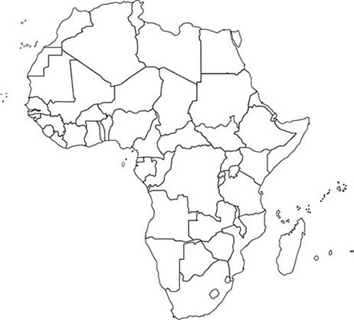

Retrieved from: http://www.worldatlas.com/webimage/countrys/af.htm

The Overarching Problem of Energy Poverty: In-Class Clicker Questions and Answers
- Clicker Question 1: Drawing on your understanding of energy poverty, which person is living in energy poverty?
  - Jalal who must do his homework by kerosene lamp light.
  - Ali who cooks with manure as fuel.
  - Jenny who cooks fuelwood and has no electricity.
  - Mack who cooks with fuelwood and has no water purification system
Students should select “c”.

- Clicker Question 2: Drawing on your understanding of global poverty, which person is living in global poverty?
  - Jasmine who is living on $3 a day, cannot afford to go to the doctor, cannot buy enough groceries, and cannot get a full education.
  - Jack who cannot afford rent.
  - Meghann who is living on $2 a day.
  - Manny who cooks with switch grass as fuel and has no electricity at home.
Students should select “a”.

- Clicker Question 3: Why does Sub-Saharan Africa has the least amount of lights on the Nighttime Lights dataset?
  - They suffer from both energy and global poverty.
  - They have the lowest population.
  - They have the lowest population.
  - Their cultural views prevent them from adapting modern fuel sources.
Students should select “a”.

- Clicker Question 4: Where on the dataset are areas of high population without lights?
  - Europe, United States
  - Sub-Saharan Africa, Rural China
  - Mexico, Japan
  - South America, Russia
Students should select ‘b’.

- Clicker Question 5: Which of the following is a clean cooking fuel?
  - Fuel wood
  - Crops and switchgrass
  - Kerosene
  - Manure
Students should select “c”

- Clicker Question 6: In what areas of the world are energy poverty and global poverty most prevalent?
- The entire continent of Africa.
- Sub-Saharan Africa and Central America.
- Developing Southern Asia and Oceania.
- Sub-Saharan Africa and developing Southern Asia.
Students should select “d”.

The Overarching Problem of Energy Poverty: In-Class Worksheet

Question 1: Record your observations of what areas or countries have the most lights and which have few or none.

Question 2: What range of electricity access and clean cooking fuel access does your assigned country fall into? Compare your country to other countries in a similar range on the SOS dataset.

Question 3: What relationship is there between GDP PPP Per Capita and access to non-solid cooking fuels? Do you think this correlation goes in one direction, or do both factors affect each other?

The Overarching Problem of Energy Poverty: In-Class Worksheet Answers

Question 1: What range of electricity access and clean cooking fuel access does your assigned country from the pre-lesson assignment that you identified on a dataset (Part C) fall into?

Students should identify the range of electricity access and clean cooking fuel access from the corresponding datasets that their country falls into based on the dataset’s color key.

Question 2: Record your observations of what areas or countries have the most lights on the Nighttime Lights dataset and which have few or none.

Students should note that the areas of the dataset with the most lights are eastern United States and California, parts of Canada, Western Europe, eastern Asia and Japan, the Middle East around the Red Sea, and the Nile delta in Egypt have the most lights. Students should observe that areas of the globe without many lights include sub-Saharan Africa, central South America, Southern Asia and Russia, and parts of Australia. It is important that students recognize that parts continents are lit while other parts are not; for example, students should not generalize that all of Africa is not well lit, while the Nile Delta and parts of the South Africa are well lit, and students should not generalize that all of Europe is well lit, while parts of western Europe are not as well lit.

Question 3: What relationship is there between GDP PPP Per Capita and access to non-solid cooking fuels? Do you think this correlation goes in one direction, or do both factors affect each other?

The datasets show that countries that have low GDP PPP Per Capita also tend to have lower percentages of access to non-solid fuels. However, the correlation goes both ways: countries with low access to non-solid fuels also have low GDP PPP per capita. These factors affect each other in a reinforcing feedback loop. People with low economic resources are unable to afford clean cooking fuels, but clean cooking fuels are required for economic advancement because extensive labor and time is required to obtain biomass fuels, which means they will have no economic resources. People living in energy poverty are trapped in this cycle.

The Overarching Problem of Energy Poverty: Post-Lesson Assignment

Based on the definition of energy poverty as the lack of access to clean cooking fuels and electricity, is your assigned country affected by energy poverty? What indicators of global poverty viewed on the Sphere (other than access to electricity and access to non-solid cooking fuels) support your answer and why? Do some research on your country and determine how it is affected by global poverty and energy poverty, using reliable sources such as the World Factbook, World Bank, and IEA. How would your life be affected if you were to live on the same level of energy access as your assigned country? (400-500 words).

The Overarching Problem of Energy Poverty: Post-Lesson Assignment Rubric

Every country listed on the pre-lesson assignment is an African country affected by energy poverty, and therefore the student should say yes to the initial question.

Students should recognize that the indicators of global poverty shown on the Sphere, GDP PPP per capita and HDI (which incorporates GNI, life expectancy, and average years of schooling) also support that the country is living in energy poverty, because the issues of energy poverty and global poverty are closely related in a reinforcing feedback loop. When one issue is present, the other is also present, meaning that indicators of global poverty support that the country is also affected by energy poverty. Students should go into the details of the reinforcing feedback loop; impoverished people do not have the means to obtain modern energy services, but need modern energy services to advance and rise out of poverty.

Students should use reliable resources to get an idea of how their country is affected by energy poverty and global poverty by looking at the negative social, economic, and political effects. This includes, but is not limited to, lower life expectancy, fewer years of schooling, inequality of schooling between genders, increased maternal and infant mortality, and increased rates of illness.

The student should recognize that they would be denied many of the energy services they are accustomed to if they were to live on the same level of energy access as their assigned country. These include, but are not limited to, using advanced cooking technologies, having access electrical lighting, having modern appliances such as dishwashers, washing machines, dryers, and refrigerators, having modern forms of transportation, having modern communication resources, having access to modern health services, and having access to energy for entertainment. Students should also elaborate on the impact this lack of energy services would have on their lives, including but not limited to negative health effects, less time for productive activities like education and running a business, and overall decreased societal development.

Datasets (images)

This section contains the original images created by the authors. Using data from the World Bank, maps were created in ArcGIS and saved as JPEG files. These include Non-Solid Fuel Access, Electricity Access, and GDP PPP Per Capita.

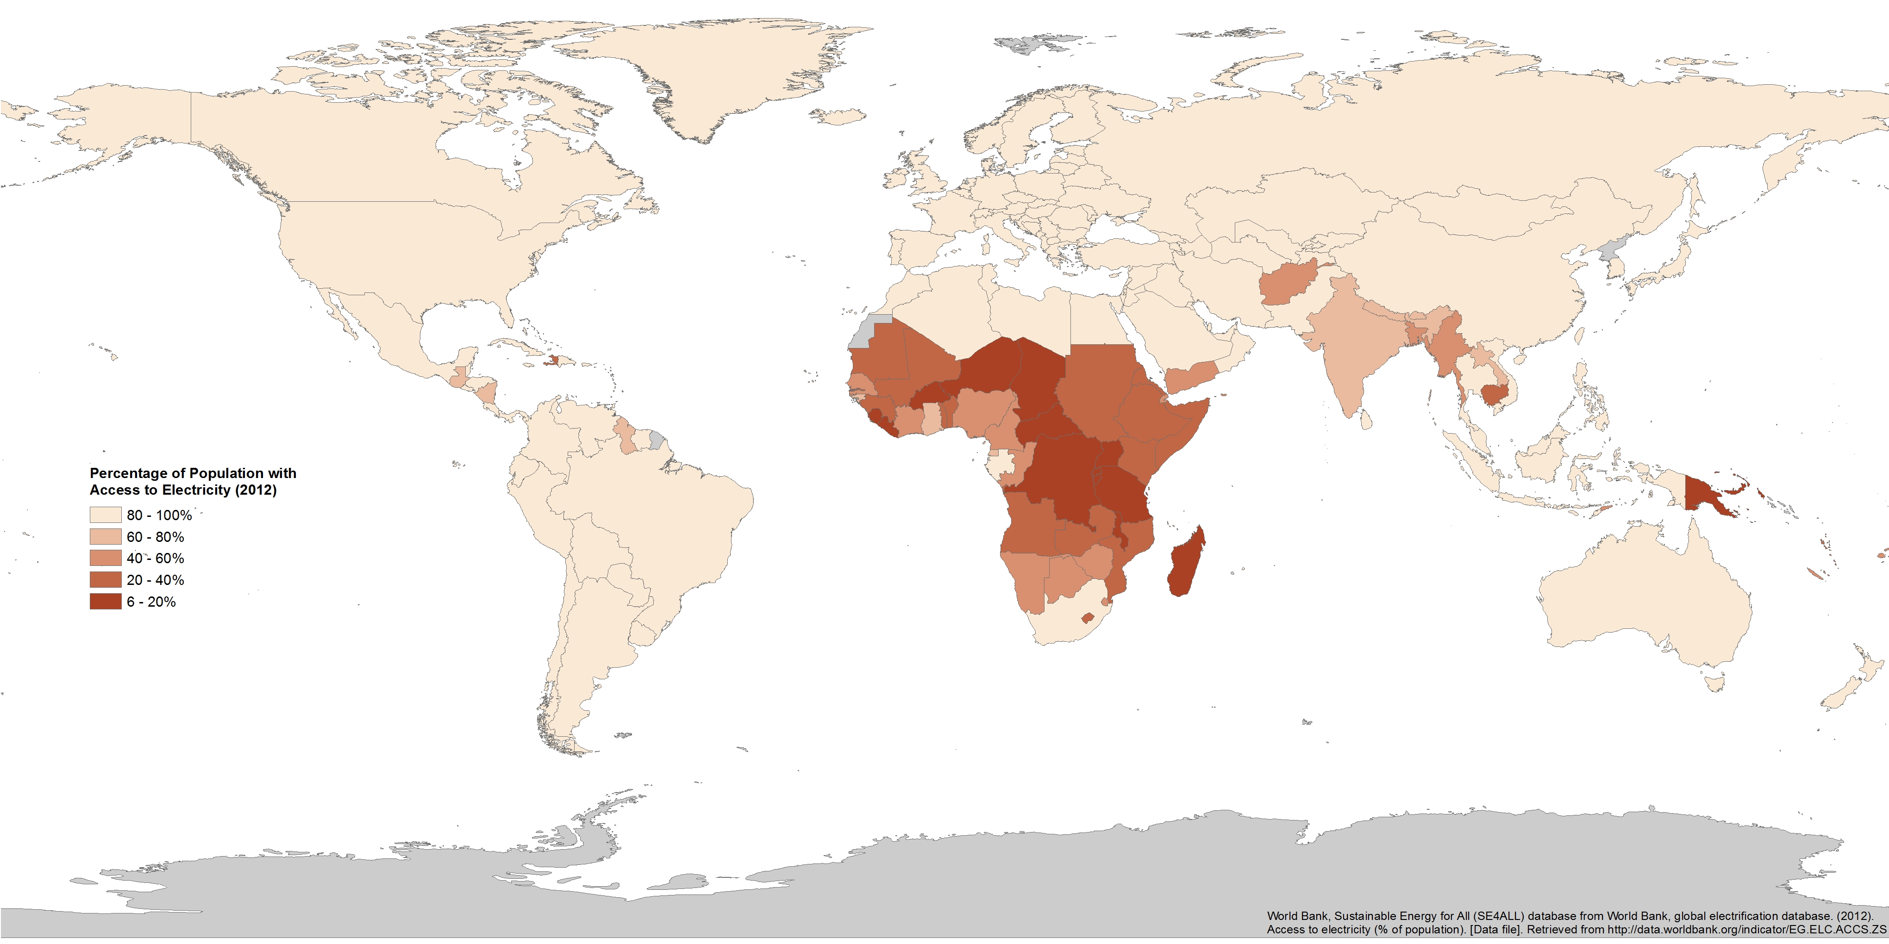
Dataset 1. Non-Solid Fuel Access

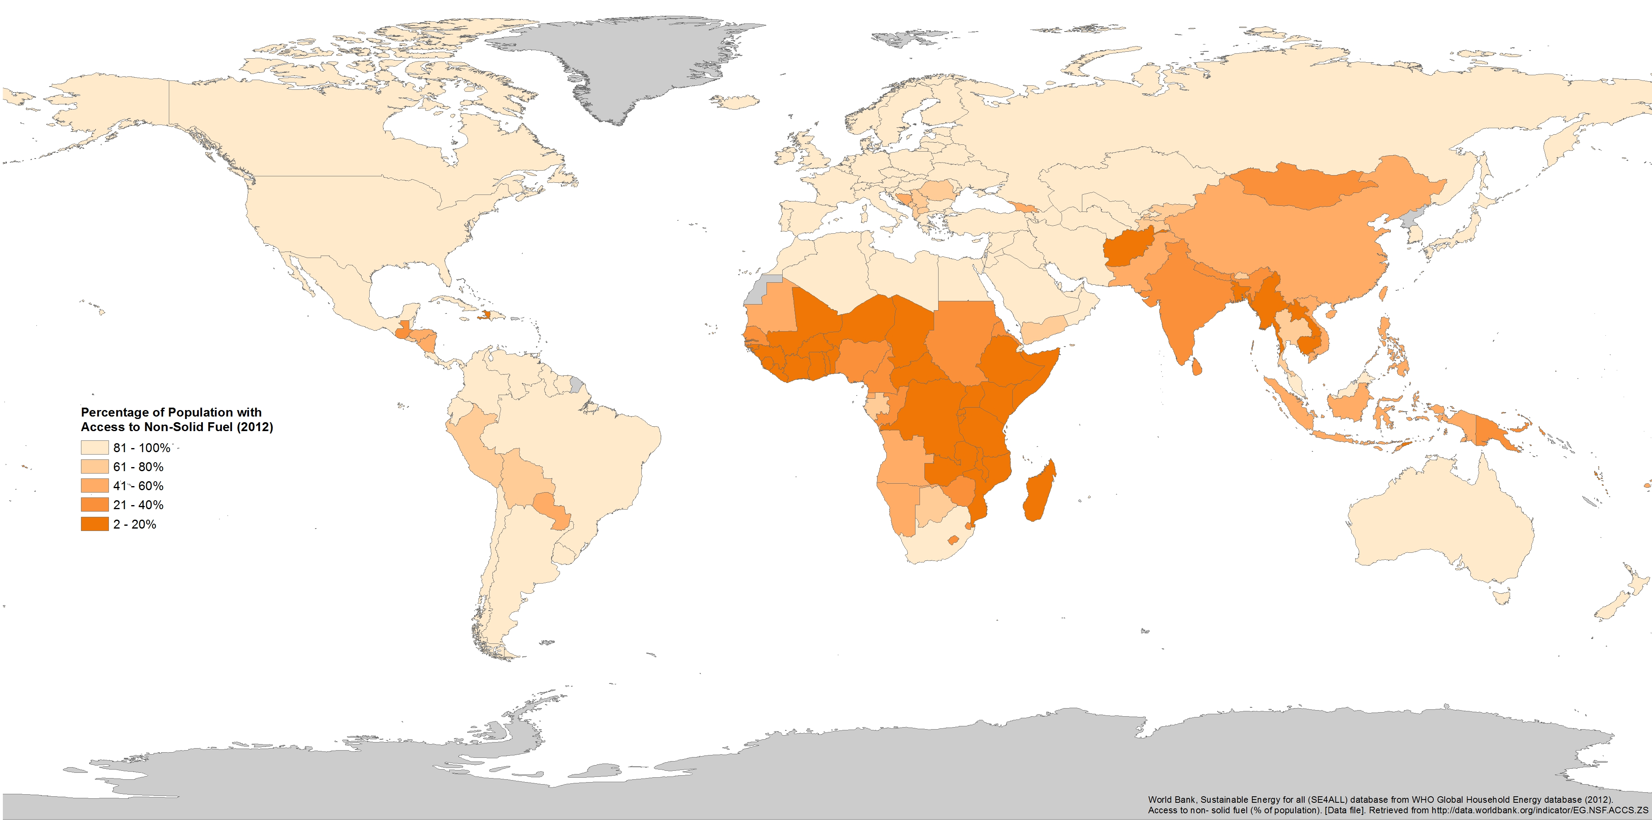
Dataset 2. Electricity Access

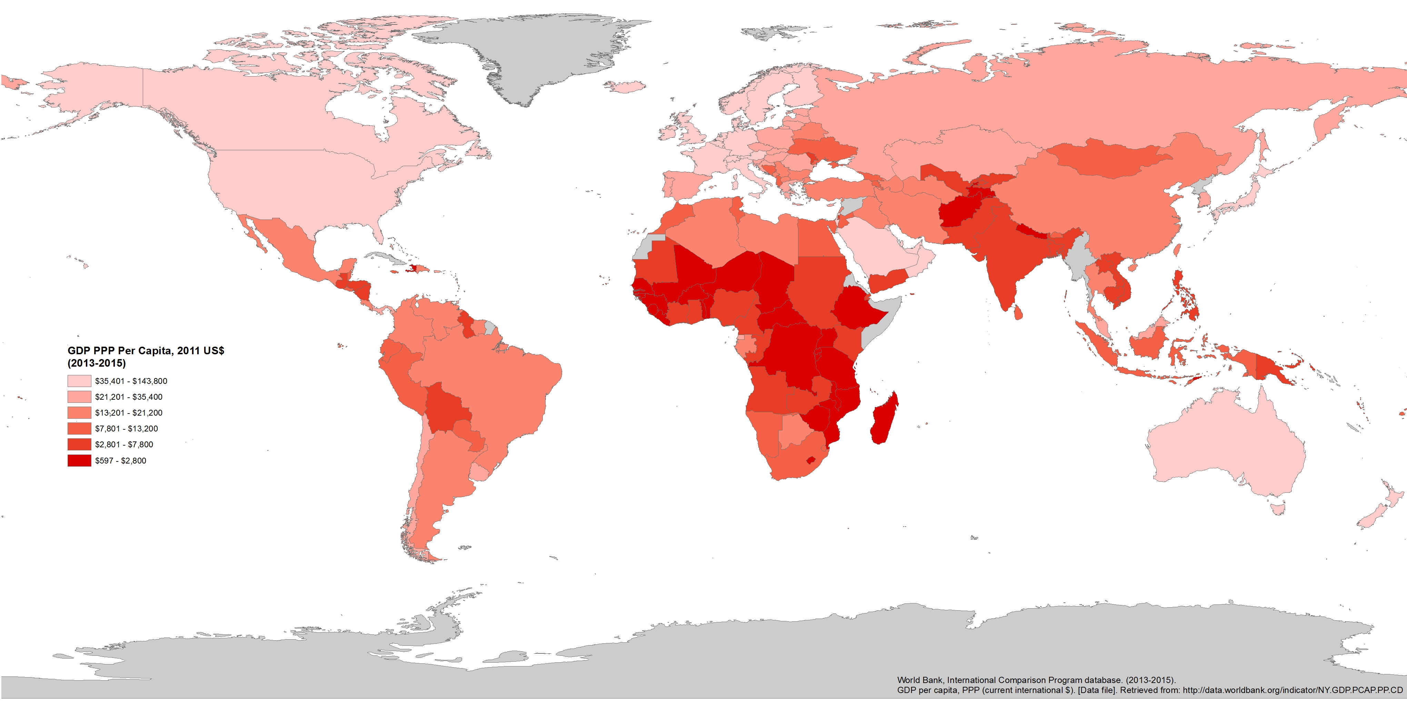
Dataset 3. GDP PPP Per Capita

Data Table
This section contains a tabular version of the specific data for each indicator.
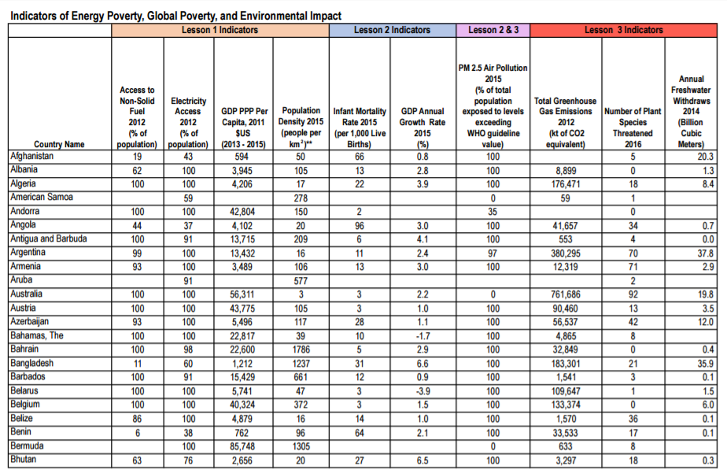
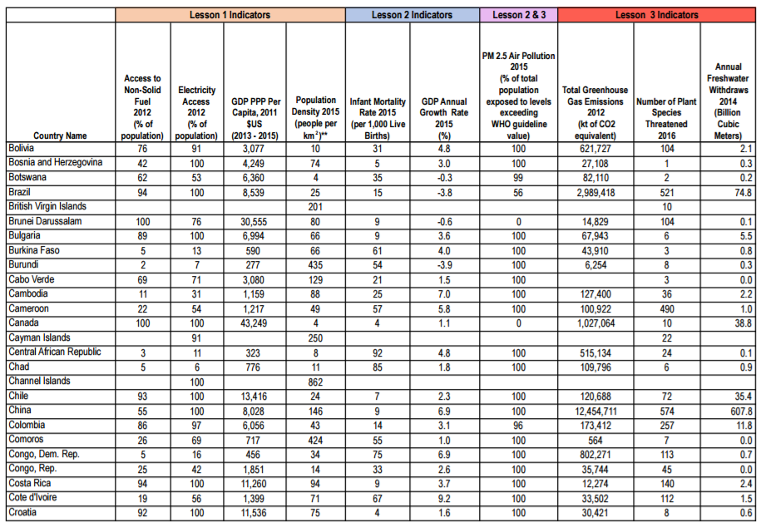

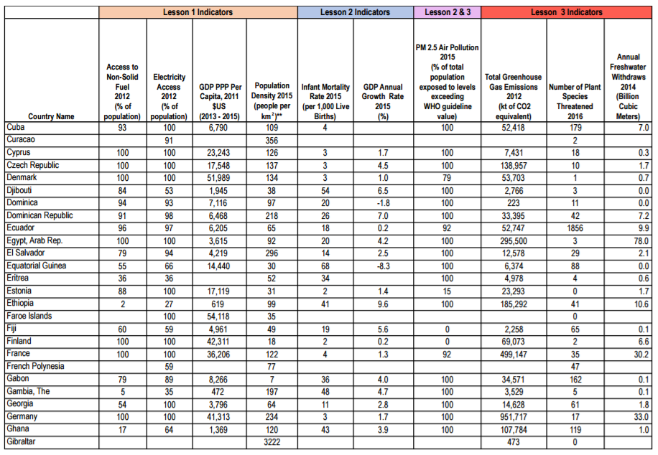

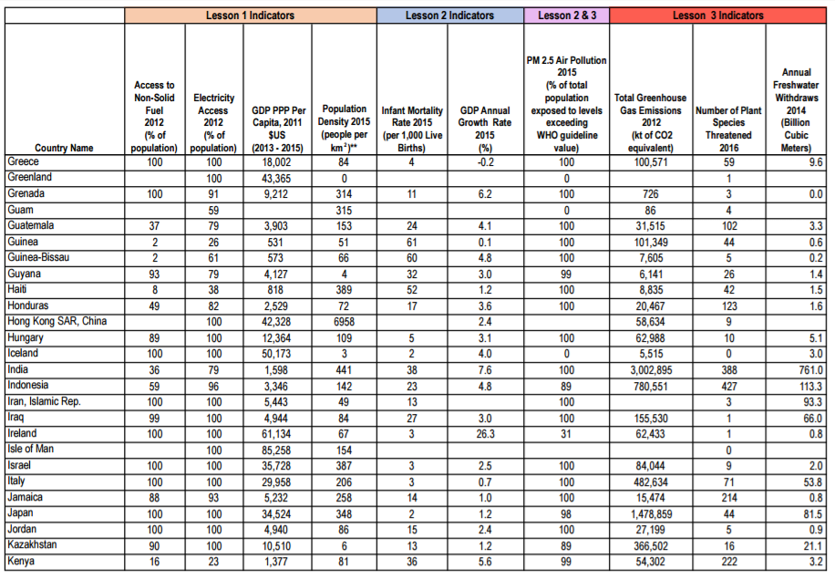

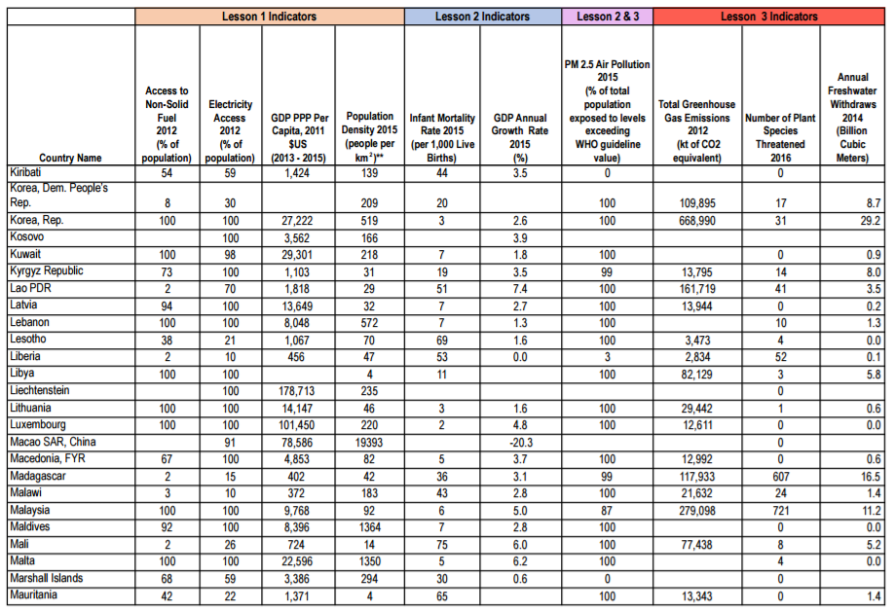

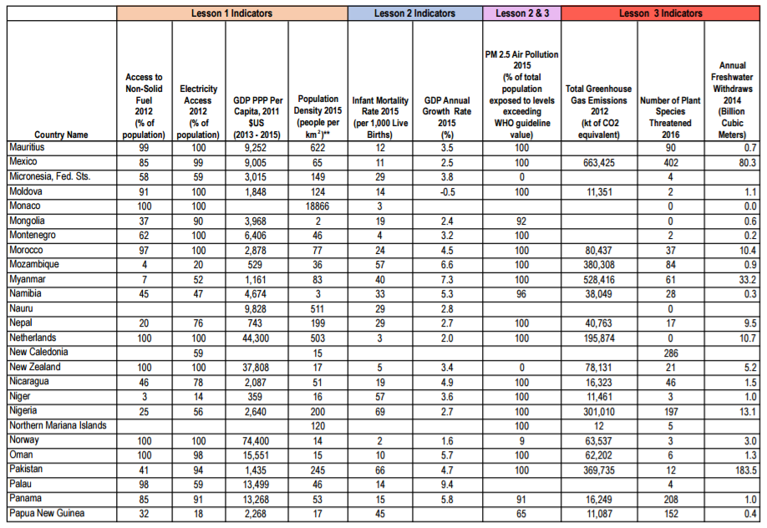

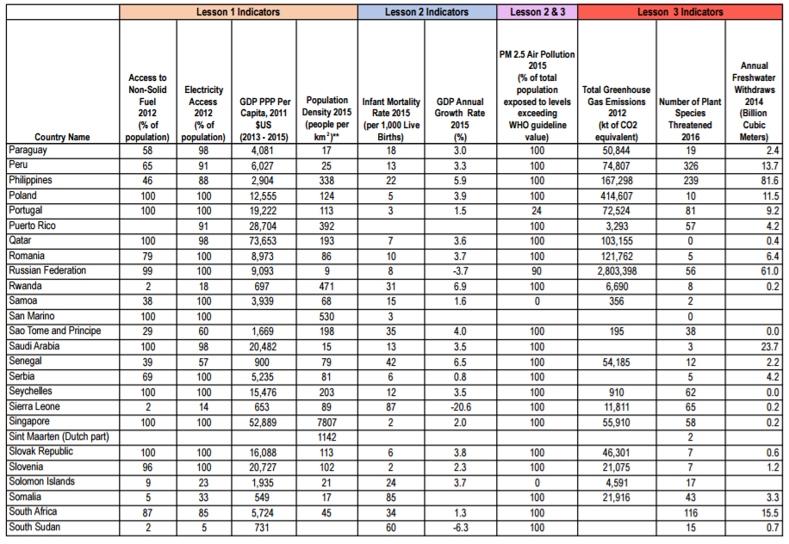

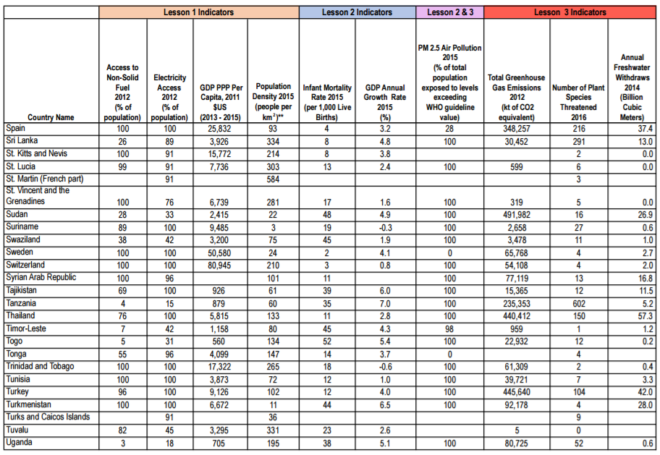

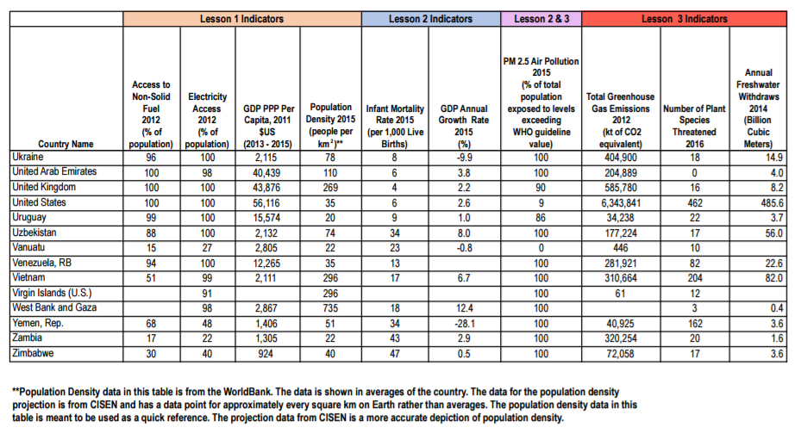

References

Center for International Earth Science Information Network - CIESIN - Columbia University. 2016. Gridded Population of the World, Version 4 (GPWv4): Administrative Unit Center Points with Population Estimates. Palisades, NY: NASA Socioeconomic Data and Applications Center (SEDAC). http://dx.doi.org/10.7927/H4F47M2C.
Ferreira, F.; Chen, S.; Dabalen, A; Dikhanov, Y.; Hamadeh, N.; etc. (2015). A global count of the extreme poor in 2012. World Bank.
Global Alliance for Clean Cookstoves. Health. United Nations Foundation. 2016. Retrieved from: http://cleancookstoves.org/impact-areas/health/
International Energy Agency. (2010). Energy poverty: How to make modern energy access available World Energy Outlook 2010. Paris, France.
International Energy Agency. (2002). World energy outlook 2002. OECD/IEA. Paris, France.
United Nations Development Programme (UNDP). (2015). Human development report 2015: Work for human development. United Nations Development Programme. New York, NY, USA.
Kroon, B., Brouwer, R., Beukering, P. (2013). The energy ladder: Theoretical myth or empirical truth? Result from meta-analysis. Renewable and Sustainable Energy Reviews. Amsterdam, the Netherlands.
Kyte, R, Vice President of the World Bank. (2013). Cited in Marianna Lavelle, Five surprising facts about energy poverty. National Geographic.
Mitchell, T.D., Carter, T.R., Jones, P.D., Hulme, M., New, M. (2003) A comprehensive set of high-resolution grids of monthly climate for Europe and the globe: The observed record and 16 scenarios. World Bank Data Catalog.
Ong, C. (2015). Choice of Energy Paths: Its Implications for Rural Energy Poverty in Less Developed Countries. Society & Natural Resources, 28(7), 733-748.
Practical Action. (2016). Poor people’s energy outlook 2016: National energy access planning from the bottom up. Practical Action Publishing, Rugby, UK.
Practical Action. (2012). Poor people’s energy outlook 2012: Energy for earning a living. Practical Action Publishing, Rugby, UK.
Practical Action. (2010). Poor people’s energy outlook 2010. Practical Action Publishing, Rugby, UK.
Reddy, S. & Lahoti, R. (2015). $1.90 per day: What does it say? New Left Review, 97, 106-127.
Sanchez, T. (2010). The hidden energy crisis: How policies are failing the world’s poor. Warwickshire, UK: Practical Action Publishing Ltd.
United Nations Department of Economic and Social Affairs. (2015). The millennium development goals report 2015. United Nations. New York.
U.S. Energy Information Administration. (2016). 2015 average monthly bill: Residential. U.S. Department of Energy.
The World Bank. (2016). Global monitoring report 2015/2016: Development goals in an era of demographic change. World Bank Group and the International Monetary Fund.
World Bank, International Comparison Program database. (2015). GDP (current US$). [Data file]. Retrieved from http://data.worldbank.org/indicator/NY.GDP.PCAP.PP.CD
World Bank, Sustainable Energy for All (SE4ALL) database from World Bank, Global Electrification database. (2012). Access to electricity (% of population). [Data file]. Retrieved from http://data.worldbank.org/indicator/EG.ELC.ACCS.ZS
World Bank, Sustainable Energy for all (SE4ALL) database from WHO Global Household Energy database. (2012). Access to non-solid fuel (% of population). [Data file]. Retrieved from http://data.worldbank.org/indicator/EG.NSF.ACCS.ZS

Further Readings

Halff, A., Sovacool, B., Rozhon, J. (2015). Energy poverty: Global challenges and local solutions. Oxford University Press, Oxford, UK.
Practical Action. (2010). Poor people’s energy outlook 2010. Practical Action Publishing, Rugby, UK.
Karekezi, Stephen. McDade, Susan. “Energy, Poverty, and Development”. http://www.iiasa.ac.at/web/home/research/Flagship-Projects/Global-Energy-Assessment/GEA_Chapter2_development_hires.pdf (Accessed December 13 2016).
United Nations Department of Economic and Social Affairs. (2015). The millennium development goals report 2015. United Nations. New York.

All icons used in this manual are Creative Commons images and selected from the Noun Project . Individual designer attribution for each icon is below: Learning Objectives: Pete Fecteau, VA SOL Correlations: Jan Christoph Borchardt, Next Generation Science Standards: Adrian Rguez Perez, Dataset Descriptions: Creative Stall, Student Handouts and Worksheets: Jaclyn Ooi, Presentation Tip: mh, Instructor Script: TukTuk Design, Audience FAQs: Anas Ramadan, and Pre & Post Visit Assessment: Berkay Sargin.

