The Overarching Problem of Energy Poverty

Run time: 50 - 75 minutes

This lesson plan is the first section of a larger modifiable Science on a Sphere module on Energy Poverty designed for college-level courses. This first lesson can range from 50-75 minutes. A 50-minute class would assign the post-class worksheet as homework, and a 75-minute class would complete the worksheet at the end of class. This lesson, The Overarching Problem of Energy Poverty, is the foundation of the overall module and should not be skipped.

Learning Objectives

Big Idea: Energy poverty and global poverty are caught in a reinforcing feedback loop.

Lesson Goal: For students to develop a conceptual understanding of energy services, energy poverty, and global poverty.

Student Learning Goals and Objectives:

- Students will demonstrate an understanding of the following concepts by analyzing datasets on the Sphere and answering corresponding multiple choice questions using “clicker” technology:
- Energy services
- Energy poverty
- Global poverty
- Feedback loop

- Students will analyze relationships between different Science on a Sphere datasets in order to draw conclusions on how global poverty and energy poverty affect each other.

Datasets

Nighttime Lights
Nighttime Lights shows the Earth at night with lights generated by electricity. The data were recorded by the Defense Meteorological Satellite Program (DMSP) in the National Geophysical Data Center (NGDC), and aggregated by the Earth Observation Group. https://sos.noaa.gov/Datasets/dataset.php?id=96

Population Density
This dataset shows the average number of people per square kilometer per country. The data were taken from the Nelson Institute Center for Sustainability and the Global Environment at the University of Wisconsin in Madison. https://sos.noaa.gov/Datasets/dataset.php?id=470

Nelson Institute Center for Sustainability and the Global Environment. (2000). Human Statistics. [Dataset]. Retrieved from https://sos.noaa.gov/Datasets/dataset.php?id=470

Population Density at Night (2000)
This dataset combines population density (CIESIN) with night-lights data (DMSP) to show the distribution of human population across the world in comparison to where lighting generated by electricity exists. https://svs.gsfc.nasa.gov/30214

National Aeronautics and Space Administration (NASA)/Goddard Space Flight Center; Defense Meteorological Satellite Program (DMSP); Center for International Earth Science Information Network (CIESIN). (2007). Population Density at Night. [Dataset]. Retrieved from https://svs.gsfc.nasa.gov/30214

Non-Solid Fuel Access
This dataset shows the percentage of the population in a country that has access to non-solid fuels. The data were obtained from the World Bank’s Sustainable Energy for all (SE4ALL) database from the WHO Global Household Energy database, and compiled on a world dataset using ArcGIS for the purposes of this project. The image is included in the ‘Datasets (Images)’ section of this manual.

World Bank, Sustainable Energy for all (SE4ALL) database from WHO Global Household Energy database. (2012). Access to non-solid fuel (% of population). [Data file]. Retrieved from http://data.worldbank.org/indicator/EG.NSF.ACCS.ZS
Electricity Access
This dataset shows the percentage of the population in a country that has access to electricity. The data were obtained from the World Bank’s Sustainable Energy for all (SE4ALL) database from the World Bank Global Electrification database, and compiled on a world dataset using ArcGIS for the purposes of this project. The image is included in the ‘Datasets (Images)’ section of this manual.

GDP PPP Per Capita
This dataset shows the global differences in GDP PPP per capita on the country level. The data were obtained from the World Bank’s International Comparison Program (ICP) database, and compiled on a world dataset using ArcGIS for the purposes of this project. The image is included in the ‘Datasets (Images)’ section of this manual.

World Bank, International Comparison Program database. (2015). GDP (current US$). [Data file]. Retrieved from http://data.worldbank.org/indicator/NY.GDP.PCAP.PP.CD

Instructor Script

Pre-lesson Preparation (1 hour, before presentation)

Before taking part in the lesson, students will be asked to complete an assignment in order to familiarize themselves with the global geography of impoverished areas and to spur their understanding of energy poverty. This will ensure that all students who complete the assignment are coming to the lesson with the same foundational knowledge of geography, and will have begun thinking about energy as a service and the problems of energy poverty and global poverty and their interrelatedness. By beginning the thinking process beforehand, students will be able to develop a deeper understanding of these concepts during the lesson. This will also allow time for the initial “wonder” of observing a lesson on Science on a Sphere: many students who are observing a Science on a Sphere lesson for the first time take time to adjust to the technology, which could interfere with their learning. The pre-lesson preparation assignment is found at the end of this lesson plan.

Students should be assigned one country from the list of countries in Part C in the pre-lesson preparation assignment. For a smaller class of 20 or less students, each country should be assigned once. This can be done by correlating a number (1 through 20) on the list to students’ last names. For larger classes, more than 20 students, country assignments can be repeated, but each country should be assigned at least once. This can be done be correlating a number (1 through 20) on the list to the students’ last names, and applying them chronologically until 20 reached, then starting over again at 1.

Procedures/Lesson Sequence

This portion of the class is instructor led. Students will watch the Science on a Sphere presentation and discuss the information presented as a large group. This activity is the introduction to Science on a Sphere presentation and delves into the concepts of energy poverty, global poverty, energy services, and feedback loops. It is designed for a 50-minute class period with additional take home post worksheets that can be used in class for 75-minute class periods.

Before any datasets are displayed on the sphere, it is important for the instructor to explain to the class that the shading scale for all of the datasets is uniform: dark coloring indicates the “bad” level of the indicator. For example, in the dataset showing access to non-solid fuels, low percentages of total access are dark orange and high percentages of total access are light orange. The datasets are intentionally designed this way in order to draw viewers’ attention to the energy impoverished countries rather than the developed countries. All datasets created for this lesson are intentionally not adjusted to mimic the Earth’s natural tilt of 23 degrees in order to allow for better critical thinking and analysis. The instructor should feel free to tilt the datasets at any time in order to show a country higher up on the globe to make important points to the class.

For classes of 20 or less, students should be encouraged to walk around the sphere as datasets are displayed. This will allow for more individual analysis and will help with answering worksheet and clicker questions. For classes larger than 20, students should remain in their seats for the lesson or they can be paired into groups of 2 and take turns walking around the sphere.

Lesson Opening (10 minutes): The instructor should review the pre-assignment to ensure that the students came to the right conclusions and are in the right mindset for this presentation.

- Clicker Question 1: Drawing on your understanding of energy poverty, which person is living in energy poverty?
- Jalal who must do his homework by kerosene lamp light.
- Ali who cooks with manure as fuel.
- Jenny who cooks with fuelwood and has no electricity.
- Mack who cooks with fuelwood and has no water purification system.
Students should select “c”.

- Clicker Question 2: Drawing on your understanding of global poverty, which person is living in global poverty?
- Jasmine who is living on $3 a day, cannot afford to go to the doctor, cannot buy enough groceries, and cannot get a full education.
- Jack who cannot afford rent.
- Meghann who is living on $2 a day.
- Manny who cooks with switch grass as fuel and has no electricity at home.
Students should select “a”.

Dataset 1, 2, 3 Progression (10 minutes): Students will then look at three datasets in sequence to analyze the correlations between access to electricity in the form of light, and population density. The sequence is as follows: Nighttime Lights, Population Density, and finally Population Density at Night. The instructor should help the students make the connection that places with no lights but high population indicates that the vast majority of those people are living without any electricity.

- In-Class Worksheet Question 1: Record your observations of what areas or countries have the most lights and which have few or none.

- Clicker Question 3: Why does Sub-Saharan Africa has the least amount of lights on the Nighttime Lights dataset?
  - They suffer from both energy and global poverty.
  - They have the lowest population.
  - They have the lowest population.
  - Their cultural views prevent them from adapting modern fuel sources.
Students should select “a”.

- Clicker Question 4: Where on the dataset are areas of high population without lights?
  - Europe, United States
  - Sub-Saharan Africa, Rural China
  - Mexico, Japan
  - South America, Russia
Students should select ‘b’.

Instructor should ask the students, why is this? What does it indicate?

Dataset 4 Reflection (3 minutes): Students will then look on the Sphere at the first of two indicators of energy poverty that comprise the definition of energy poverty: lack of access to non-solid fuels. This will allow them to orient themselves with where energy poverty exists in the world. When viewing the dataset showing non-solid fuel access, the instructor should review the definition of unclean cooking fuels.

- Clicker Question 5: Which of the following is a “clean” cooking fuel?
  - Fuel wood
  - Crops and switchgrass
  - Kerosene
  - Manure
Students should select “c”.

Dataset 5 Reflection (3 minutes): Students will look at the second of two indicators of energy poverty that comprise the definition of energy poverty on the Sphere: lack of access to electricity.

- In-Class Worksheet Question 2: What range of electricity access and clean cooking fuel access does your assigned country fall into?

Dataset 6 Reflection (3 minutes): Students will look at GDP PPP Per Capita.

- In-Class Worksheet Question 3: What relationship is there between GDP PPP Per Capita and access to non-solid cooking fuels? Do you think this correlation goes in one direction, or do both factors affect each other?

Discussion (15 minutes): Students will share in pairs the indicators for their assigned countries, and then discuss how they think energy poverty and global poverty affect their country, and how they are related. The instructor should explain that energy poverty and global poverty exist in a reinforcing feedback loop. The instructor should first define a reinforcing feedback loop as a system of two components in which the effect of one component heightens the effect of the other component, and vice versa. This is also known as a positive feedback loop. The instructor should emphasize that people living in energy poverty are essentially trapped in their impoverished state because of this system.

- Clicker Question 6: In what areas of the world are energy poverty and global poverty most prevalent?
- The entire continent of Africa.
- Sub-Saharan Africa and Central America.
- Developing Southern Asia and Oceania.
- Sub-Saharan Africa and developing Southern Asia.
Students should select “d”.

Wrap-Up (10 minutes): Lesson closing: Instructor will present the post-lesson assignment.

Pre & Post Assessment
The following sections include a pre-lesson preparation assignment, in-class “clicker”-style multiple choice questions and answers, an in-class worksheet and corresponding answers, and a post-lesson assignment. These resources will be used to assess the students’ learning and comprehension of the concepts presented before, during, and after observing the presentation.

The Overarching Problem of Energy Poverty: Pre-Lesson Preparation Assignment

Part A: Watch the following videos and answer the questions:

Video 1 – What is Poverty: Compassion International made a concise video explaining the definition of poverty, how many people worldwide live in poverty, and its consequences. It also explains that poverty not just a lack of money but also lack of access to essential services and goods. It will help students gain knowledge of what poverty is, who is affected by it, and the long term consequences of poverty. This will then help them make connections between poverty and energy poverty later in the lesson.

- “What is Poverty? – Compassion International” (2 minutes) https://www.youtube.com/watch?v=k-PvTqo1gX0
Compassion International. (2012, October 15). What is Poverty? – Compassion International [Video File]. YouTube. Retrieved from https://www.youtube.com/watch?v=k-PvTqo1gX0

Video 2 – Access to Energy: Practical Action starts off showing the percentage of the world living without electricity and simultaneously using ethos to help viewers understand direct consequences for people living without it. It quickly shows two examples of energy sources used in energy impoverished countries, open fires and kerosene lamps. This video focuses on the relationships between access to electricity and daily activities that encourage growth such as available school time, homework lighting, and clean cooking conditions. Practical Action then shows cheap and cleaner technologies implemented in these countries by Practical Action such as hydropower and solar power technologies, and clean cook stoves. This video will help students understand consequences of lack of access to electricity but also show them that clean cookstoves and renewable energies are effective, positive solutions.

- “Access to Energy” – Practical Action (3 minutes) https://www.youtube.com/watch?v=2JHs2y9x-pw
Practical Action. (2010, August 20). Access to energy [Video File]. YouTube. Retrieved from https://www.youtube.com/watch?v=2JHs2y9x-pw

After watching the Access to Energy video, students will then read a short article by Practical Action on energy poverty that pairs well with the video. This article expands on defining energy poverty, who lives with it, the consequences, and sustainable solutions. An important concept touched on briefly in this article is that electricity is a service not a fuel. Electricity is a service, meaning that it provides and allows for essential actions and activities. It is also not something people can go forage for like they could for a fuel. This will help students understand energy poverty more fully, the current possible solutions, and how important electricity is.

- Practical Action. (2009). Energy Poverty: the hidden energy crisis. Warwickshire, UK: Practical Action Publishing Ltd. http://practicalaction.org/docs/advocacy/energy_poverty_hidden_crisis.pdf

Video 3 – The Magic Washing Machine: Hans Rosling makes the case that all people deserve access to modern energy services such as washing machines and cars, but shows how this access is not uniform across the world. Rosling explains that energy services are necessary for human health and advancement because modern energy services allow people to spend less time on cooking and housekeeping which reduces strenuous physical labor and frees more time for education, running a business, and other forms of development. His example is that when a household gains a washing machine, the mother has time to read to her children, help them with their education, spend more quality time, and also build on her own education and skill set with her newfound free time.

- “Hans Rosling and the Magic Washing Machine” – TED (9 minutes) https://www.youtube.com/watch?v=BZoKfap4g4w
TED. (2011, March 21). The magic washing machine | Hans Rosling [Video File]. YouTube. Retrieved from https://www.youtube.com/watch?v=BZoKfap4g4w

Questions:
- In your own words, define global poverty. Is global poverty just the lack of money? List five consequences of global poverty.
- In your own words, define energy poverty. List five consequences of energy poverty.
- What is the difference between an energy fuel and an energy service? Is electricity a fuel or a service?
- Hans Rosling explains in The Magic Washing Machine video that washing machines give you books. What does he mean by that?

Part B: Choose one country from each list and compare their different indicators from the included data table. Human Development Index, HDI, is a number used to rank countries on their human development based on life expectancy, education, and per capita income. How does HDI reflect the other indicators you have looked a for your two countries? Use specific values to defend your conclusions. You can also refer to World Bank datasets:
- World Bank database of indicators: http://data.worldbank.org/indicator

List of energy impoverished countries:
- Angola
- Central African Republic
- Sierra Leone
- Somalia
- Chad
- Mali
- Congo, Dem. Rep.
- Nigeria
- Lesotho
- Equatorial Guinea
- Cote d'Ivoire
- Afghanistan
- Pakistan
- Mauritania
- Benin
- Guinea
- Burkina Faso
- Guinea-Bissau
- South Sudan
- Niger

List of energy rich countries:
            - Luxembourg
            - Iceland
            - Finland
            - Norway
            - Japan
            - Slovenia
            - Singapore
            - Andorra
            - Estonia
            - Sweden
            - Cyprus
            - San Marino
            - Monaco
            - Czech Republic
            - Korea, Rep.
            - Italy
            - Denmark
            - Austria
            - Portugal
            - Ireland

Part C: You will be assigned a country from the following list. Locate and label it on the dataset below, and be prepared to identify your country during the Science on a Sphere presentation. Next, note the indicators for your assigned country as done in Part B.

      - Burundi
      - Guinea-Bissau
      - Liberia
      - Madagascar
      - Mali
      - Rwanda
      - Sierra Leone
      - South Sudan
      - Ethiopia
      - Guinea

      - Uganda
      - Malawi
      - Niger
      - Central African Republic
      - Mozambique
      - Tanzania
      - Somalia
      - Togo
      - Chad
      - Congo, Dem. Republic
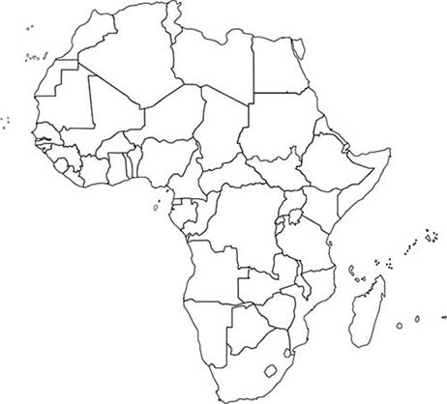

Retrieved from: http://www.worldatlas.com/webimage/countrys/af.htm

The Overarching Problem of Energy Poverty: In-Class Clicker Questions and Answers
- Clicker Question 1: Drawing on your understanding of energy poverty, which person is living in energy poverty?
  - Jalal who must do his homework by kerosene lamp light.
  - Ali who cooks with manure as fuel.
  - Jenny who cooks fuelwood and has no electricity.
  - Mack who cooks with fuelwood and has no water purification system
Students should select “c”.

- Clicker Question 2: Drawing on your understanding of global poverty, which person is living in global poverty?
  - Jasmine who is living on $3 a day, cannot afford to go to the doctor, cannot buy enough groceries, and cannot get a full education.
  - Jack who cannot afford rent.
  - Meghann who is living on $2 a day.
  - Manny who cooks with switch grass as fuel and has no electricity at home.
Students should select “a”.

- Clicker Question 3: Why does Sub-Saharan Africa has the least amount of lights on the Nighttime Lights dataset?
  - They suffer from both energy and global poverty.
  - They have the lowest population.
  - They have the lowest population.
  - Their cultural views prevent them from adapting modern fuel sources.
Students should select “a”.

- Clicker Question 4: Where on the dataset are areas of high population without lights?
  - Europe, United States
  - Sub-Saharan Africa, Rural China
  - Mexico, Japan
  - South America, Russia
Students should select ‘b’.

- Clicker Question 5: Which of the following is a clean cooking fuel?
  - Fuel wood
  - Crops and switchgrass
  - Kerosene
  - Manure
Students should select “c”

- Clicker Question 6: In what areas of the world are energy poverty and global poverty most prevalent?
- The entire continent of Africa.
- Sub-Saharan Africa and Central America.
- Developing Southern Asia and Oceania.
- Sub-Saharan Africa and developing Southern Asia.
Students should select “d”.

The Overarching Problem of Energy Poverty: In-Class Worksheet

Question 1: Record your observations of what areas or countries have the most lights and which have few or none.

Question 2: What range of electricity access and clean cooking fuel access does your assigned country fall into? Compare your country to other countries in a similar range on the SOS dataset.

Question 3: What relationship is there between GDP PPP Per Capita and access to non-solid cooking fuels? Do you think this correlation goes in one direction, or do both factors affect each other?

The Overarching Problem of Energy Poverty: In-Class Worksheet Answers

Question 1: What range of electricity access and clean cooking fuel access does your assigned country from the pre-lesson assignment that you identified on a dataset (Part C) fall into?

Students should identify the range of electricity access and clean cooking fuel access from the corresponding datasets that their country falls into based on the dataset’s color key.

Question 2: Record your observations of what areas or countries have the most lights on the Nighttime Lights dataset and which have few or none.

Students should note that the areas of the dataset with the most lights are eastern United States and California, parts of Canada, Western Europe, eastern Asia and Japan, the Middle East around the Red Sea, and the Nile delta in Egypt have the most lights. Students should observe that areas of the globe without many lights include sub-Saharan Africa, central South America, Southern Asia and Russia, and parts of Australia. It is important that students recognize that parts continents are lit while other parts are not; for example, students should not generalize that all of Africa is not well lit, while the Nile Delta and parts of the South Africa are well lit, and students should not generalize that all of Europe is well lit, while parts of western Europe are not as well lit.

Question 3: What relationship is there between GDP PPP Per Capita and access to non-solid cooking fuels? Do you think this correlation goes in one direction, or do both factors affect each other?

The datasets show that countries that have low GDP PPP Per Capita also tend to have lower percentages of access to non-solid fuels. However, the correlation goes both ways: countries with low access to non-solid fuels also have low GDP PPP per capita. These factors affect each other in a reinforcing feedback loop. People with low economic resources are unable to afford clean cooking fuels, but clean cooking fuels are required for economic advancement because extensive labor and time is required to obtain biomass fuels, which means they will have no economic resources. People living in energy poverty are trapped in this cycle.

The Overarching Problem of Energy Poverty: Post-Lesson Assignment

Based on the definition of energy poverty as the lack of access to clean cooking fuels and electricity, is your assigned country affected by energy poverty? What indicators of global poverty viewed on the Sphere (other than access to electricity and access to non-solid cooking fuels) support your answer and why? Do some research on your country and determine how it is affected by global poverty and energy poverty, using reliable sources such as the World Factbook, World Bank, and IEA. How would your life be affected if you were to live on the same level of energy access as your assigned country? (400-500 words).

The Overarching Problem of Energy Poverty: Post-Lesson Assignment Rubric

Every country listed on the pre-lesson assignment is an African country affected by energy poverty, and therefore the student should say yes to the initial question.

Students should recognize that the indicators of global poverty shown on the Sphere, GDP PPP per capita and HDI (which incorporates GNI, life expectancy, and average years of schooling) also support that the country is living in energy poverty, because the issues of energy poverty and global poverty are closely related in a reinforcing feedback loop. When one issue is present, the other is also present, meaning that indicators of global poverty support that the country is also affected by energy poverty. Students should go into the details of the reinforcing feedback loop; impoverished people do not have the means to obtain modern energy services, but need modern energy services to advance and rise out of poverty.

Students should use reliable resources to get an idea of how their country is affected by energy poverty and global poverty by looking at the negative social, economic, and political effects. This includes, but is not limited to, lower life expectancy, fewer years of schooling, inequality of schooling between genders, increased maternal and infant mortality, and increased rates of illness.

The student should recognize that they would be denied many of the energy services they are accustomed to if they were to live on the same level of energy access as their assigned country. These include, but are not limited to, using advanced cooking technologies, having access electrical lighting, having modern appliances such as dishwashers, washing machines, dryers, and refrigerators, having modern forms of transportation, having modern communication resources, having access to modern health services, and having access to energy for entertainment. Students should also elaborate on the impact this lack of energy services would have on their lives, including but not limited to negative health effects, less time for productive activities like education and running a business, and overall decreased societal development.

Datasets (images)

This section contains the original images created by the authors. Using data from the World Bank, maps were created in ArcGIS and saved as JPEG files. These include Non-Solid Fuel Access, Electricity Access, and GDP PPP Per Capita.

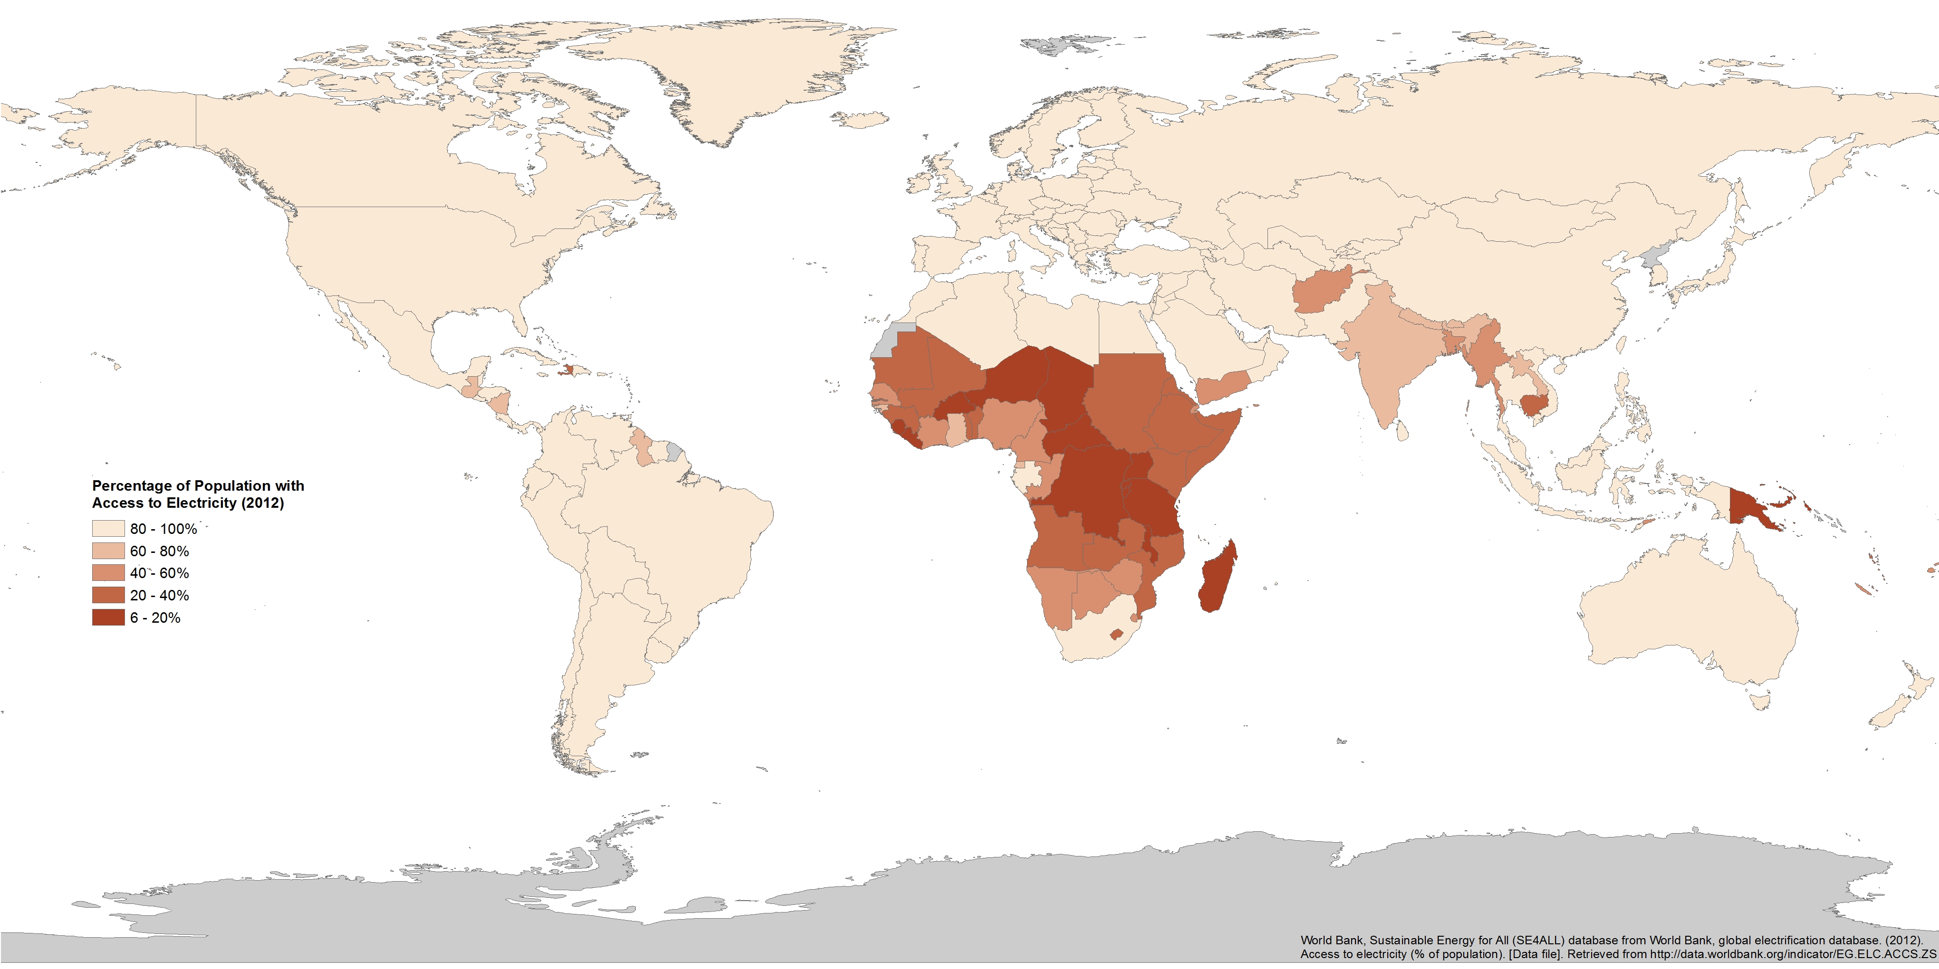
Dataset 1. Non-Solid Fuel Access

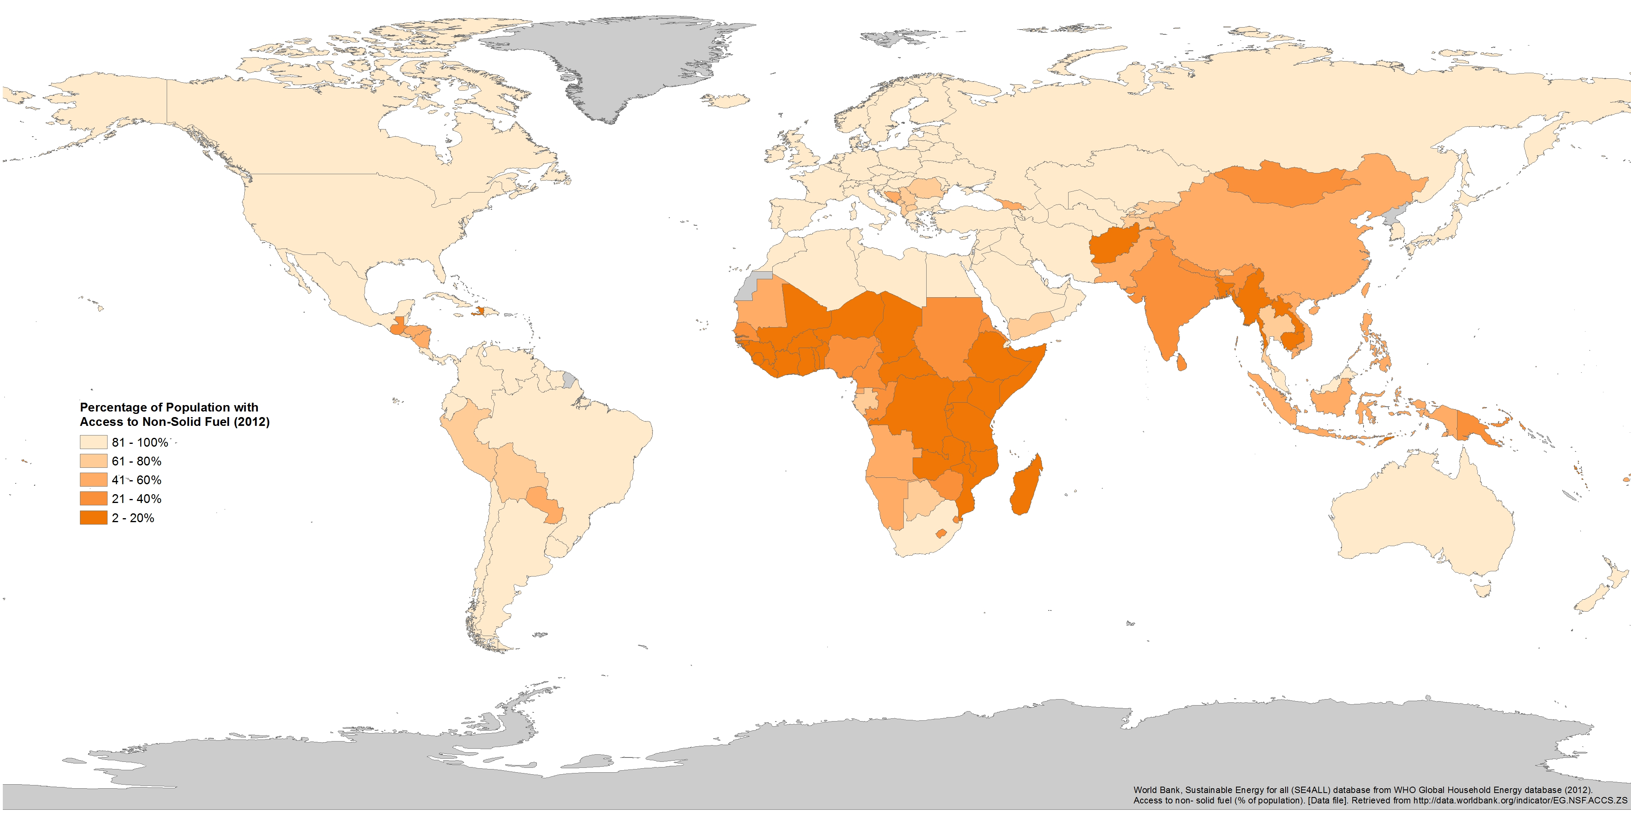
Dataset 2. Electricity Access

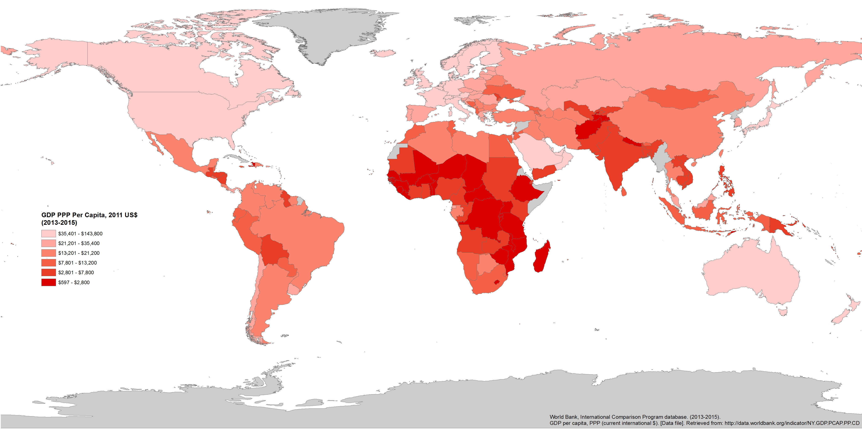
Dataset 3. GDP PPP Per Capita

Data Table
This section contains a tabular version of the specific data for each indicator.
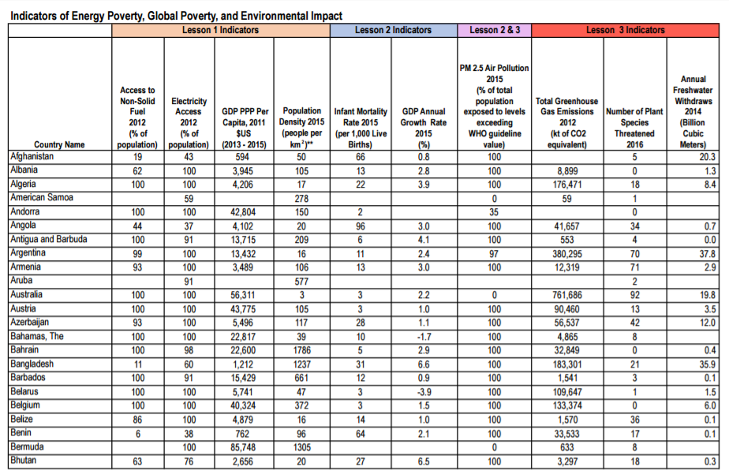
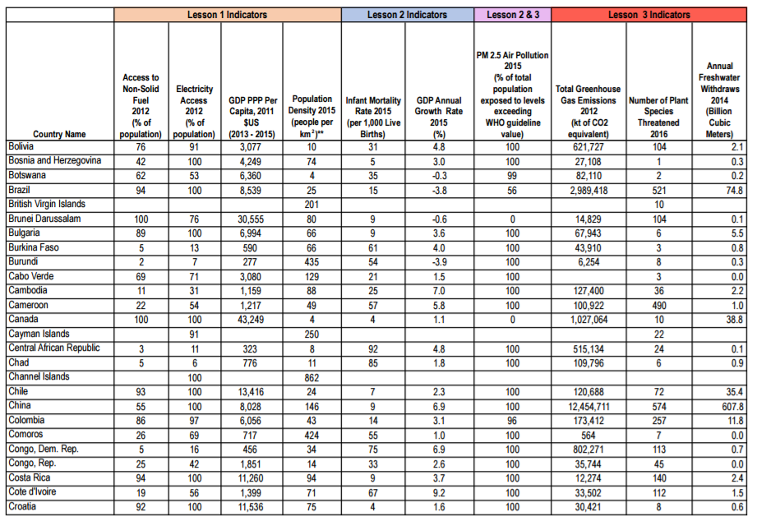

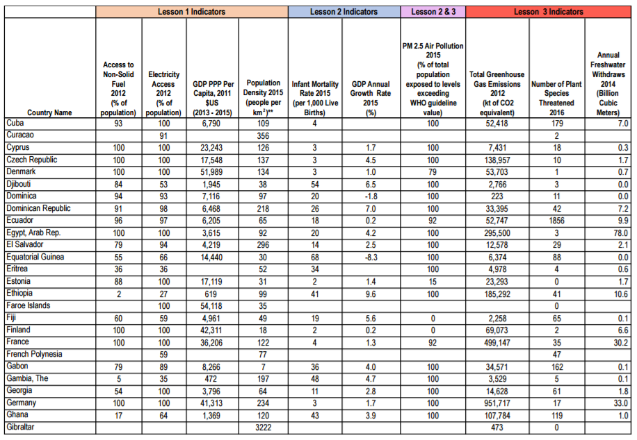

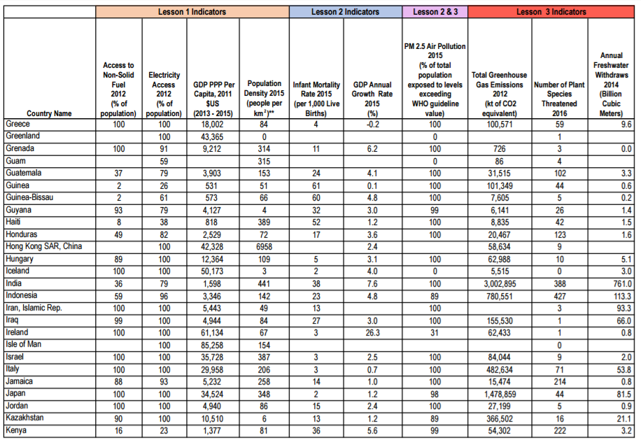

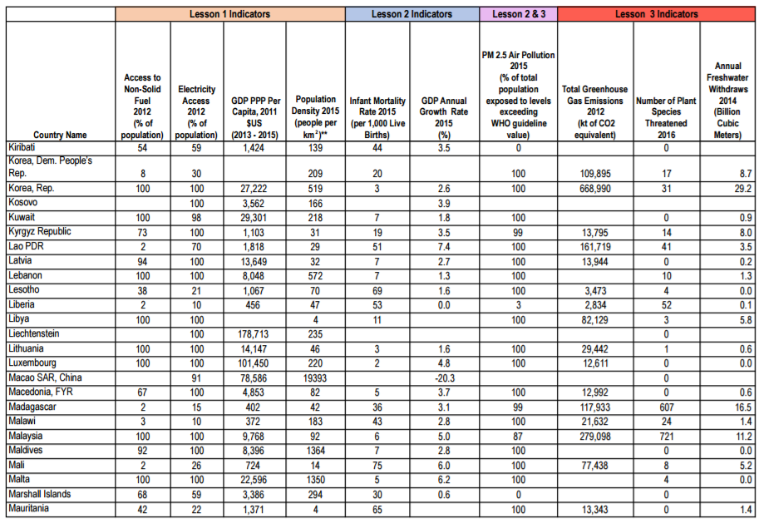

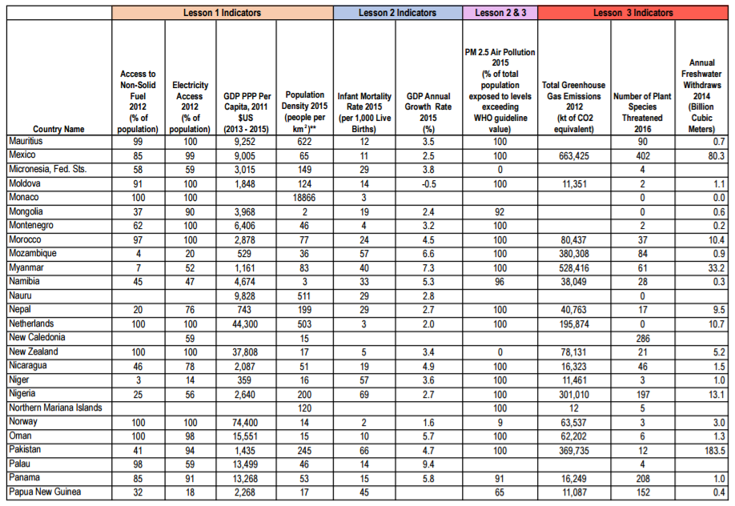

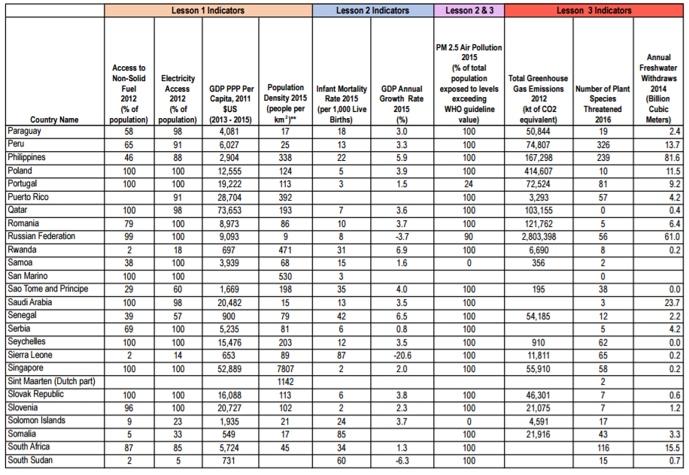

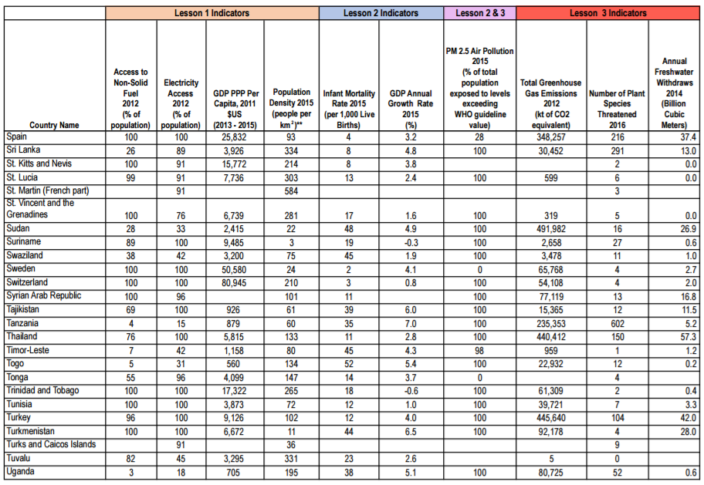

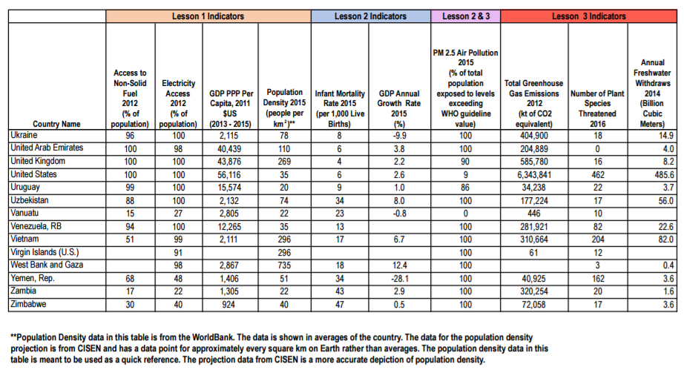

References

Center for International Earth Science Information Network - CIESIN - Columbia University. 2016. Gridded Population of the World, Version 4 (GPWv4): Administrative Unit Center Points with Population Estimates. Palisades, NY: NASA Socioeconomic Data and Applications Center (SEDAC). http://dx.doi.org/10.7927/H4F47M2C.
Ferreira, F.; Chen, S.; Dabalen, A; Dikhanov, Y.; Hamadeh, N.; etc. (2015). A global count of the extreme poor in 2012. World Bank.
Global Alliance for Clean Cookstoves. Health. United Nations Foundation. 2016. Retrieved from: http://cleancookstoves.org/impact-areas/health/
International Energy Agency. (2010). Energy poverty: How to make modern energy access available World Energy Outlook 2010. Paris, France.
International Energy Agency. (2002). World energy outlook 2002. OECD/IEA. Paris, France.
United Nations Development Programme (UNDP). (2015). Human development report 2015: Work for human development. United Nations Development Programme. New York, NY, USA.
Kroon, B., Brouwer, R., Beukering, P. (2013). The energy ladder: Theoretical myth or empirical truth? Result from meta-analysis. Renewable and Sustainable Energy Reviews. Amsterdam, the Netherlands.
Kyte, R, Vice President of the World Bank. (2013). Cited in Marianna Lavelle, Five surprising facts about energy poverty. National Geographic.
Mitchell, T.D., Carter, T.R., Jones, P.D., Hulme, M., New, M. (2003) A comprehensive set of high-resolution grids of monthly climate for Europe and the globe: The observed record and 16 scenarios. World Bank Data Catalog.
Ong, C. (2015). Choice of Energy Paths: Its Implications for Rural Energy Poverty in Less Developed Countries. Society & Natural Resources, 28(7), 733-748.
Practical Action. (2016). Poor people’s energy outlook 2016: National energy access planning from the bottom up. Practical Action Publishing, Rugby, UK.
Practical Action. (2012). Poor people’s energy outlook 2012: Energy for earning a living. Practical Action Publishing, Rugby, UK.
Practical Action. (2010). Poor people’s energy outlook 2010. Practical Action Publishing, Rugby, UK.
Reddy, S. & Lahoti, R. (2015). $1.90 per day: What does it say? New Left Review, 97, 106-127.
Sanchez, T. (2010). The hidden energy crisis: How policies are failing the world’s poor. Warwickshire, UK: Practical Action Publishing Ltd.
United Nations Department of Economic and Social Affairs. (2015). The millennium development goals report 2015. United Nations. New York.
U.S. Energy Information Administration. (2016). 2015 average monthly bill: Residential. U.S. Department of Energy.
The World Bank. (2016). Global monitoring report 2015/2016: Development goals in an era of demographic change. World Bank Group and the International Monetary Fund.
World Bank, International Comparison Program database. (2015). GDP (current US$). [Data file]. Retrieved from http://data.worldbank.org/indicator/NY.GDP.PCAP.PP.CD
World Bank, Sustainable Energy for All (SE4ALL) database from World Bank, Global Electrification database. (2012). Access to electricity (% of population). [Data file]. Retrieved from http://data.worldbank.org/indicator/EG.ELC.ACCS.ZS
World Bank, Sustainable Energy for all (SE4ALL) database from WHO Global Household Energy database. (2012). Access to non-solid fuel (% of population). [Data file]. Retrieved from http://data.worldbank.org/indicator/EG.NSF.ACCS.ZS

Further Readings

Halff, A., Sovacool, B., Rozhon, J. (2015). Energy poverty: Global challenges and local solutions. Oxford University Press, Oxford, UK.
Practical Action. (2010). Poor people’s energy outlook 2010. Practical Action Publishing, Rugby, UK.
Karekezi, Stephen. McDade, Susan. “Energy, Poverty, and Development”. http://www.iiasa.ac.at/web/home/research/Flagship-Projects/Global-Energy-Assessment/GEA_Chapter2_development_hires.pdf (Accessed December 13 2016).
United Nations Department of Economic and Social Affairs. (2015). The millennium development goals report 2015. United Nations. New York.

