SOS Script: El Niño & La Niña Impacts (with captions), El Niño and La Niña Seasonal Impacts, & River Discharge 1988 and 1989

Key Points Visuals

El Niño and La Niña are phases of a naturally occurring climate cycle called El Niño/Southern Oscillation.  ENSO involves large-scale changes in sea-surface temperature across the eastern tropical Pacific.  Warmer ocean surface temperatures occur in the eastern tropical Pacific during El Niño. During La Niña, ocean surface temperatures here are cooler.  Changes in ocean temperature lead to atmospheric changes, which impact the weather.  Changes in the ocean & atmosphere can also have major impacts on the economy.  - Changes in ocean temperatures cause some fish populations to decline or to move to areas that fisherman cannot easily access.  - Too much or too little rain can cause many issues for farmers. For example, rice farmers in places like Bangladesh rely on seasonal rains. If it is too dry, farmers often struggle.  - When the supply of crops and other natural resources is low, prices rise. | El Niño & La Niña Impacts (with captions)  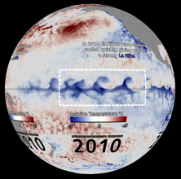  http://sos.noaa.gov/Datasets/dataset.php?id=321
This animation shows the commonly expected seasonal impacts of El Niño and La Niña.  During El Niño, the winter conditions tend to be:  - Generally wetter & cooler in the U.S., but warmer in the Pacific Northwest  - Warmer & wetter in the equatorial Pacific  - Drier and warmer in parts of southern Africa  - Drier & warmer in Southeast Asia  El Niño summers are:  - Drier in southeast Asia and Australia  - Wetter in the middle of the Pacific  - Warmer on the west coast of South America  La Niña winters are usually the opposite of El Niño winters.  .  - The southern U.S. is dry and warm  - The equatorial Pacific is dry & cool  - Southeast Asia is wetter  La Niña summers lead to cooler conditions on the west cost of South America and southeast Asia. | El Niño and La Niña Seasonal Impacts  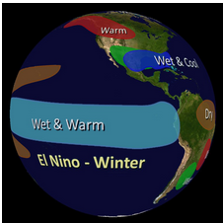  http://sos.noaa.gov/Datasets/dataset.php?id=465
Let’s look at river discharge for the years 1988 and 1989 to see if typical El Niño & La Niña trends appear.  WHAT IS RIVER DISCHARGE? Greater river discharge reflects greater precipitation.  Strong El Niño conditions occurred during the first six months of 1988  - Although the U.S. generally tends to be wetter during El Niño winters, many U.S. rivers had below average discharge during the winter of 1988. It was a long-lasting drought year in the west and mid-west and El Niño did not bring much relief.  - January & February were wetter in parts of the Southern U.S. in 1988  - In the beginning of 1988, northeastern South America was drier, which is typical of El Niño  - Australia was dry as is typical for El Niño  La Niña conditions were particularly strong from January to November 1989.  - Overall, discharge was lower along the coast of Peru and Chile.  - Heavy rain in early 1989 lead to increased discharge in Malaysia, the Philippines and Indonesia.  - In many La Niña years, there is more snowfall and rainfall in the northern Rockies and the Pacific Northwest of the USA, but this pattern is less obvious for the year 1989. | River Discharge 1988 and 1989  