Overview:
Based on teacher workshop feedback and formative work with student field trips, we developed a storyline for the Science On a SphereⓇ to meet the Broader Impacts portion of a scientific research grant (see Credits at end of script). The script and image sequence (playlist) take the audience from variability in the global biosphere to a look at productive regions of the ocean and the contributing factors like nutrients. The story then takes the audience below the surface in depth increments to see changing chemistry with depth, highlighting the depth of the oxygen minimum zone off the coast of Peru. With the research locations pinpointed, the presentation delves into the nitrogen cycle comparing it to photosynthesis and respiration, concluding with the central project research question, “How much nitrogen gas is lost to the atmosphere through these processes?” which were just described. To answer the audience/public question, “Why do we care?”, the final global image shows a computer model of the ocean chlorophyll concentration while the presenter discusses the use of computer modeling to make predictions about our changing ocean and climate systems.
Audience:
Appropriate for a general adult audience up through image 16. Images (pips) 17-21 cover redox chemistry of the C and N cycles and may be reserved for HS Science/AP audiences and above.

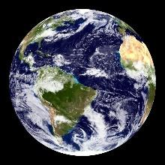  1. Blue Marble | - Opening questions  - Welcome and introduction  - Orientation to the sphere, recognized locations on Earth, colors  - Explanation of different types of images to be displayed: satellite data- true color, satellite data- false color, contoured station data, computer model data
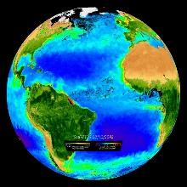  2. Biosphere: Marine Chlorophyll Concentration and Land Vegetation | - Help visitors identify colors.  - This is a false color image, using color to show concentrations of Chl a in the ocean and assigning a range of colors, from dark green to brown to show the density of vegetation on land.  - The oceans are shaded based on the chlorophyll (green pigment in plants) concentration as indicated on the color bar below.  - The lands are shaded to depict the vegetation.  - This image helps us to see regions on Earth that are more productive, in terms of plant growth, than others.  - We understand why many of these regions differ, both on land and in the ocean.  - Engage audience by asking why we care about these differences. (agriculture, jungle, deserts, fishing, good visibility snorkeling)
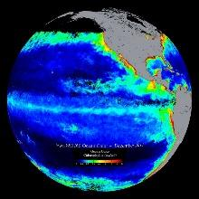  3. Ocean Color (monthly) – Real-time | - Focus on the ocean productivity. This image shows an average concentration of chlorophyll for the past month.  - Notice where the highest concentrations of chlorophyll or phytoplankton, the single-celled plant that is responsible for most of the ocean’s primary productivity.  - Why are coastal regions likely to have the highest productivity? (runoff, upwelling)  - Explain coastal upwelling, most intense along the eastern side of the ocean basins, particularly the eastern Pacific. (due to structure of the continental shelf and prevailing wind direction)  - Nutrients brought up from the deep to “fertilize” the phytoplankton blooms at the surface.  - Key point- nutrients are limiting in the ocean and where there is a constant or steady source of new nutrients (nitrate is the most important), productivity is greatest.  - Second Key point- Coastal Peru is an area of high productivity and high biogeochemical activity. That makes it interesting to biological, chemical, and physical oceanographers as a research area.
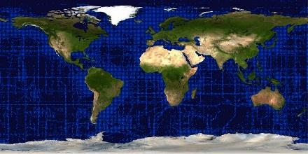  4. World Ocean Atlas 2013 station locations | - Using data from ocean research cruises, deploying bottles to collect water at depths from the surface to more than 500 meters,  - These are not yet things we can measure from space as satellite rely on energy transmission or color to collect data. (Only recently has salinity been something measured from space.)  - As you can see, there are areas of the ocean that have not been surveyed. (Ocean Lit Principle #7)  - What you’ll see next is a picture of nutrient concentrations and dissolved oxygen concentrations built by scientists on these cruises.  - What kinds of questions do you think nutrient concentrations and oxygen concentrations could answer? (plant/phyto growth, mixing, waves, respiration, photosyn, decomposition)
5. Dissolved Nitrate at Surface | - Analogy for Nitrate (NO₃⁻) concentration in the ocean is plant fertilizer concentration. Nitrate is the limiting nutrient for phytoplankton in the ocean. In lake systems, the limiting nutrient is generally phosphate (PO₄³⁻).  - This image shows the concentration of nitrate at the surface.  - Where do you see high concentrations? Low concentrations?
6. Dissolved Oxygen at Surface | - This image show the concentration of dissolved oxygen at the surface of the ocean.  - [As needed, can use analogy of a bubbler in a fish tank used to add dissolved oxygen to the water as the fish use it up (absorbed through their gills)]  - Why is oxygen something that will tell us, as scientists, more about the biology in the water column? [may need to define water column] (photosynthesis, respiration—O₂ produced or consumed)  - Where do you see high concentrations? Low concentrations?
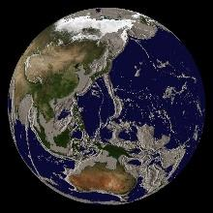  7. Ocean Drain (with gray bathymetry) | - Imagine being able to use a straw to suck the surface water out of the ocean, enabling us to see what’s down at 100m below the surface, 500m below the surface, or even, to see what’s at the bottom.  - [This is a model to introduce the idea of looking at concentrations of nitrate and oxygen at different depths, going down.]
8. Dissolved Nitrate at Surface | - As seen before, this shows the yearly average nitrate concentration at the surface of the ocean. Notice patterns of darker orange, indicating higher concentrations (sustained over time through mixing, recycling, or slow uptake)  - Remind that nitrate is the most important nutrient for phytoplankton productivity.
9. Dissolved Nitrate at 100m | - Now, look at the concentration of nitrate at 100m (remind of model like removing surface water as needed).  - Where do you see a change in color compared to the last image? (eastern equatorial Pacific and Atlantic, northern Pacific)  - Do you know anything else about those regions? (winds, storm movement, El Nino, desert dust, cold, coastal productivity)
10. Dissolved Nitrate at 500m | - Going deeper, looking at the concentration of nitrate at 500m.  - What do you notice? (much darker, equatorial, eastern Pacific, northern Pacific, white in northern Atlantic and southern Indian)  - Why does concentration generally increase as you go deeper? (surface productivity, decomposition or remineralization with sinking, accumulation at thermocline, colder water, water at the bottom for a long time accumulating)  - [Don’t worry about location patterns yet]
11. Dissolved Oxygen at Surface | - Back up at the surface, this shows this concentration of dissolved oxygen, as we saw earlier.  - Think of dissolved oxygen (dO₂) concentration as an indicator of:  - cold water (holds more dO₂) either mixed upward or cooled by atmosphere  - contact with the air/atmosphere  - biological respiration (O₂ consumed/reduced, lowers conc.) Not just a big word- relate to people breathing in oxygen, which allows us to break down our food for energy, and we exhale carbon dioxide.  - NOTE: dO₂ does not tell us directly much about levels of photosynthesis, since photosynthesis is at the surface where water is already saturated with O₂.  - Predict how the concentration might change going down to 100m. (less contact w/atmosphere ↓, colder water ↑, more respiration of phytoplankton dying and settling out of surface water ↑)
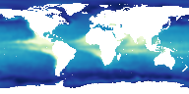  12. Dissolved Oxygen at 100m | - This image shows the concentration of dissolved oxygen at 100m depth.  - Dark blue is high concentration and white is low concentration.  - White or low oxygen regions are well defined and are very consistent features, known as the Oxygen Minimum Zones of the ocean.  - These regions are distinct down to 300m.
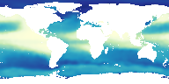  13. Dissolved Oxygen at 500m | - At 500m you begin to see larger areas of low dissolved oxygen, indicating biological respiration and lack of contact with the atmosphere to mix more oxygen back into the water.  - Review biological processes- Photosynthesis produces oxygen, Respiration uses oxygen and produces carbon dioxide.
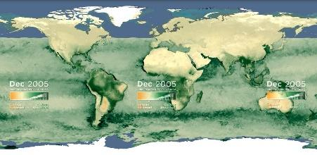  14. Earth’s Green Carbon Machine  (animation cut ~ frame 14000-37000) | - In the ocean, in this visual, you don’t see orange areas of intense carbon release or respiration. Why not?  - In the ocean, carbon uptake or photosynthesis occurs in the surface waters, where there is sunlight. Respiration and carbon release occur deeper down, so isn’t measured by the satellite that took these images.  - It’s this process of respiration and further recycling of carbon, nitrogen, and oxygen down below the surface, at 200-500 meters that we’re interested in understanding and quantifying more accurately.
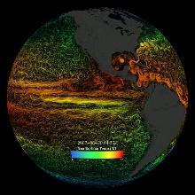  15. Sea Surface Currents and Temperature (gray land) | - The global sea surface current flows are colored by corresponding sea surface temperatures. These surface flows and temperatures represent only the top few meters of the oceans. They are primarily driven by the surface winds.  - The dynamic circulation and wind forcing also drives surface waters away from the coastlines, causing deep water to well up, bringing with it the regenerated nutrients that support surface photosynthesis.  - Notice the patterns of circular, spinning eddies in the coastal regions. These eddies penetrate below the surface and create microcosms for research.
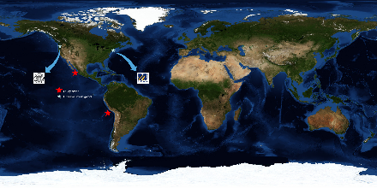  16. Research locations | - A group of scientists from the University of Washington and the University of Massachusetts Dartmouth were awarded a research grant from the National Science Foundation to learn more about the recycling of organic matter as it relates to climate change, particularly, the nitrogen cycle in oxygen minimum zones.  - In their work, they hope to better quantify the loss of nitrogen or N₂ gas from the ocean into the atmosphere.  - Our atmosphere is mostly (78%) nitrogen, so it’s not the addition of nitrogen to the atmosphere that is guiding the question, but the loss of nitrogen from the ocean affecting the productivity of phytoplankton affecting the uptake of carbon dioxide by the ocean as well as affecting the marine food chain.
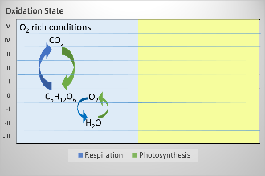  - Oxidation States 1 - Aerobic  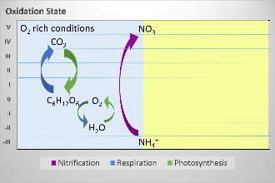  - Oxidation States 2 - Aerobic  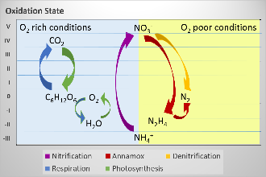  19. Oxidation States 4 – Anaerobic Redox | Biochemistry Explanation: for advanced audiences (HS+)  Following discussion works from strong understanding of the carbon cycle and the energy transfer reactions and parallels those concepts with the nitrogen cycle also as energy transfer reactions, just under different conditions. Looking at both cycles as oxidation/reduction reactions which store or release energy.  - Looking at photosynthesis and respiration using Oxidation/Reduction reactions and the change in oxidation state of products and reactants.  - Photosynthesis: CO₂ reduced to C₆H₁₂O₆ and H₂O oxidized to O₂  - Respiration: C₆H₁₂O₆ oxidized to CO₂ and O₂ reduced to H₂O  - In oxygen rich environment, breakdown or remineralization of organic matter includes oxidation of ammonium (NH₄⁺) to nitrate (NO₃⁻) by decomposers like bacteria.  - In the absence of oxygen (like Oxygen Minimum Zones), certain types of bacteria can drive respiration or oxidation of organic matter by reducing nitrate (NO₃⁻) along 2 different pathways to nitrogen gas (N₂).  - Two pathways are known as Denitrification and Anammox (anaerobic ammonium oxidation).
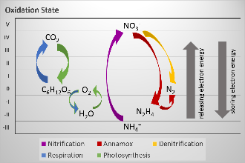  20. Oxidation States 5 -  Energy flow | - Benefit for the organisms—energy.  - Driving reactions with the available ions or molecules to store or release energy for growth.  - We can quantify photosynthetic cycles pretty well, but what about quantifying this alternate form of productivity that also produces organic carbon (C₆H₁₂O₆)?
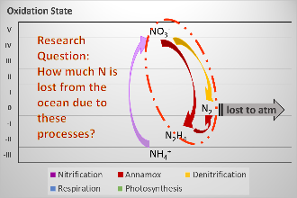  21. Research Question | - If researchers can better measure and quantify these Nitrogen cycle processes, and more specifically the removal of nitrate from the ocean by denitrification and anammox processes, models and forecasts for changes in systems due to a changing climate will be more accurate.  - Research question: How much nitrogen gas is lost from the ocean due to these processes?  - By designing instruments that can more accurately measure the rate of nitrogen gas production in oxygen minimum zones, they are improving our knowledge of ocean systems.
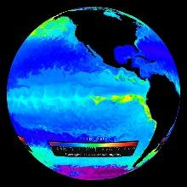  22. Chlorophyll Concentration Model | - This is a model of chlorophyll concentration in the ocean, showing higher concentrations of chlorophyll or phytoplankton in red, and lower concentrations in blue/purple.  - A model like you see here can only be built with efforts such as the researchers from University of Washington and U. Mass Dartmouth, quantifying rates of change, mimicking change with mathematical equations, and using technology to give us visuals to understand.
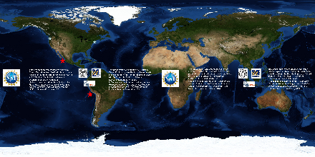  23. Credits | - From NOAA—  - The ocean plays a role in everything, from the air we breathe to daily weather and climate patterns.  - Like your heart and circulatory system, the ocean pumps water, heat, nutrients, and even living things, all around the world.  - Most of our knowledge of the ocean lies in shallow waters. Deep waters remain a mystery even though we are relying more and more on these areas for food, energy, and other resources.  - Through ocean research such as this, we work to establish the baseline information needed to better understand environmental change, filling gaps in the unknown to deliver reliable and authoritative science that is foundational to providing foresight about future conditions and informing the decisions we confront every day on this dynamic planet.

Credits:
This presentation was created by A.Brickley, Ocean Explorium, New Bedford, MA and made possible through the Broader Impacts of Award #1153295 to C. McNeil & E. D’Asara of U.Washington and M. Altabet of U.Massachusetts Dartmouth for Collaborative Research: Autonomous Lagrangian Floats for Oxygen Minimum Zone Chemistry from the National Science Foundation, 2014.

