Datasets used in FORECAST: TROPICAL CYCLONE

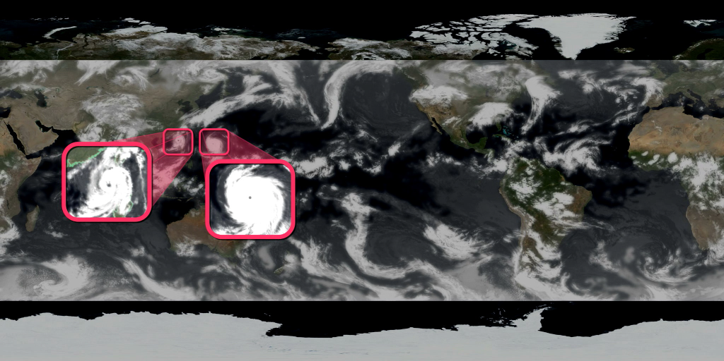
GLOBAL CLOUD COVER—IR MOSAIC
From: GOES-East, GOES-West, Meteosat-9, Meteosat-7, and MT-SAT satellites
Data source: NOAA Climate Prediction Center, http://www.cpc.noaa.gov/

Description: This dataset merges the observations of five geostationary satellites into a seamless mosaic that covers parts of the globe where climatologists require continual measurements. The satellites' sensors measure thermal infrared radiation — essentially, heat — emitted by clouds in the atmosphere as well as land and ocean surfaces. The warmer these surfaces are, the more infrared radiation they emit. Radiation intensity is represented by grayscale values, where the warmest surfaces (land) are black and the coldest surfaces (clouds) are white. Since temperature generally decreases as altitude increases, the tops of high-altitude clouds show the whitest traces. Often this indicates large, robust storms like hurricanes or intense thunderstorms.

The dataset, which the satellites capture every half hour, day and night, is processed by programmers and scientists from NOAA's Climate Prediction Center. It is one of the few datasets that give scientists a whole-Earth, near-real-time view of how storm systems evolve. It is used for weather forecasting, climate monitoring, and to diagnose problems with climate models.

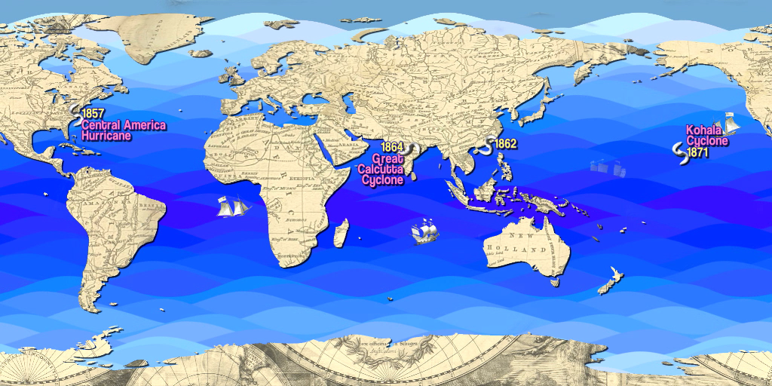
NOTABLE HISTORICAL TROPICAL CYCLONES
Source: Various

We mapped landfall and ocean records of selected tropical cyclones from the period 1279 to 1938. Sources include NOAA and other online resources as well as books and historical documents. See AMNH_Forecast_useful_resources.doc.
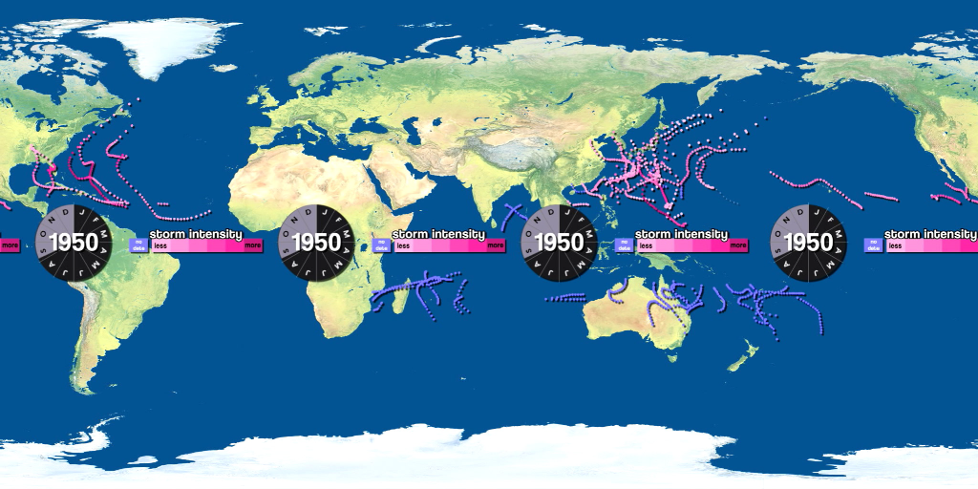
1950 TROPICAL CYCLONE TRACKS
Data source: International Best Track Archive for Climate Stewardship (IBTrACS), NOAA National Climatic Data Center http://www.ncdc.noaa.gov/oa/ibtracs/
Description: IBTrACS is a global dataset of tropical cyclone tracks. It merges track data that exist separately at 12 meteorological centers around the world. Each track contains separate storm observations plotted in time and space.
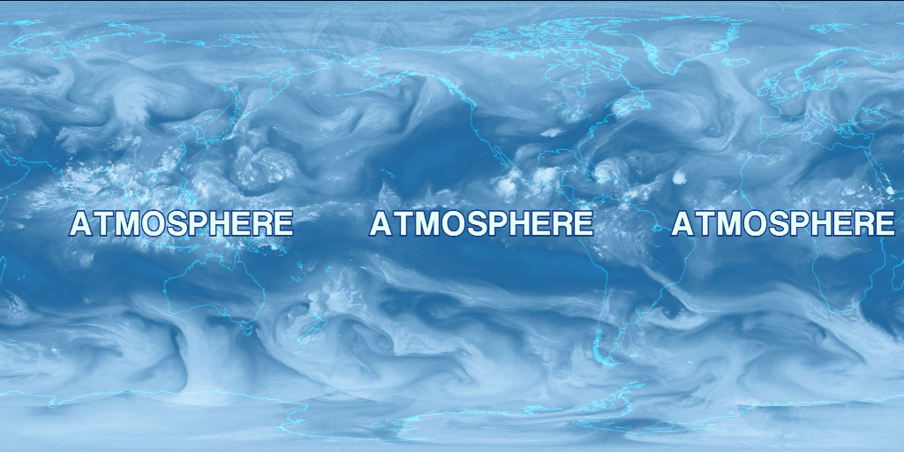
GLOBAL CLOUD COVER (WATER VAPOR MOSAIC)
From: GOES-East, GOES-West, MTSAT, Meteosat-7, MSG-9, and NASA Terra and Aqua satellites
Data source: Space Science and Engineering Center, University of Wisconsin, http://www.ssec.wisc.edu/data/
Description (from SOS site): Because water vapor emits radiation, satellites can be set to detect water vapor in the atmosphere. All clouds contain water vapor, so when the satellite detects an area with a high concentration of water vapor, it is detecting a cloud. The clouds in hurricanes are easy to detect because they are well formed and contain an excess of water vapor.
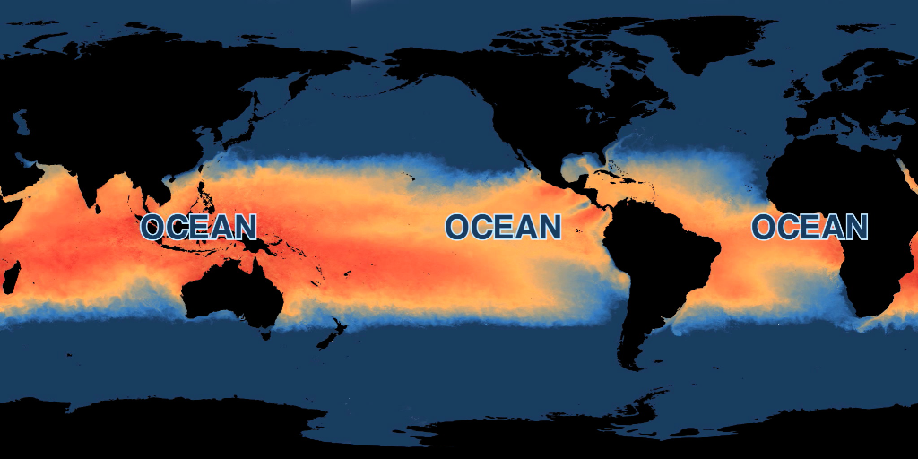
SEA SURFACE TEMPERATURE
From: NASA Aqua satellite, AMSR-E sensor
Data source: http://neo.sci.gsfc.nasa.gov/Search.html?group=30
Description (from NASA NEO): Most satellite sensors measures sea surface temperatures by observing infrared energy emitted by Earth's oceans, but infrared energy cannot pass through clouds. Because large areas of the Earth are cloud-covered each day, daily global maps of sea surface temperature from infrared-sensing satellite sensors are patchy. The Advanced Scanning Microwave Radiometer for EOS (AMSR-E) on NASA's Aqua satellite measures sea surface temperature by observing energy coming from Earth in the microwave frequency. Some frequencies of microwave radiation pass through any clouds, allowing AMSR-E to map global sea surface temperatures every day. AMSR-E is a collaboration between the Japanese space agency, JAXA, and NASA.
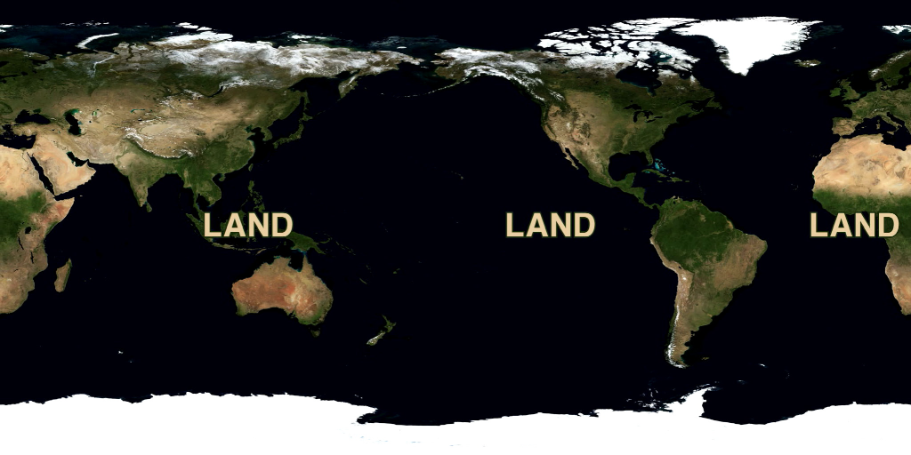
BLUE MARBLE NEXT GENERATION
From: NASA Terra satellite, MODIS sensor
Data source: http://neo.sci.gsfc.nasa.gov/Search.html?group=15
Description (from NASA NEO): The Moderate Resolution Imaging Spectroradiometer (MODIS) on NASA's Terra satellite sees Earth's entire surface almost every day. Over time, scientists can combine MODIS' daily views of the globe into single images of the whole Earth, called "global composites." The images you see here (named "Blue Marble: Next Generation") show the Earth's land surface in true color. Twelve Blue Marble images are available in NEO -- one composite image for each month of the year 2004. These datasets allow visitors to explore changes on the land surface of our home planet over time. Notice how the patterns of green (plants), browns (exposed land surface), and white (snow) change through the course of the seasons. Clouds were removed to allow a maximum view of the surface. The BMNG series of global images was made by Reto Stockli, of NASA's Earth Observatory, using data courtesy the MODIS Land Science Team.
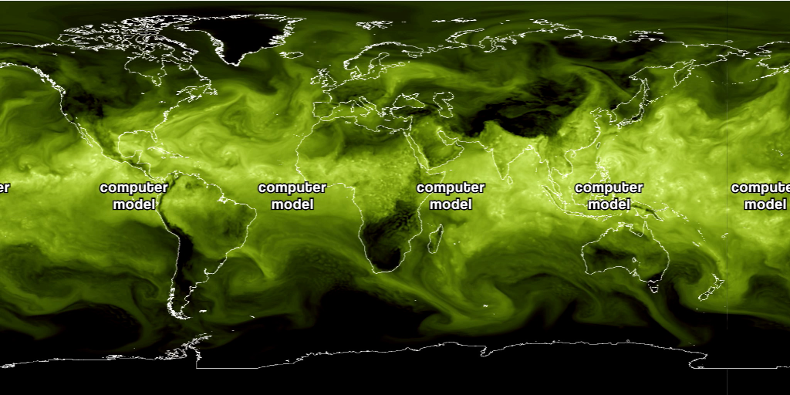
WATER VAPOR MODEL SIMULATION
Source: Shian-Jiann Lin, NOAA Geophysical Fluid Dynamics Laboratory, http://www.gfdl.noaa.gov/
Description: This is an output of a high-resolution global computer model that simulates the circulation of water vapor in Earth’s atmosphere (see Water Vapor Mosaic dataset above) for the period September 6 – 14, 2008. The simulation highlights several major tropical cyclones, including Hurricanes Hanna and Ike.
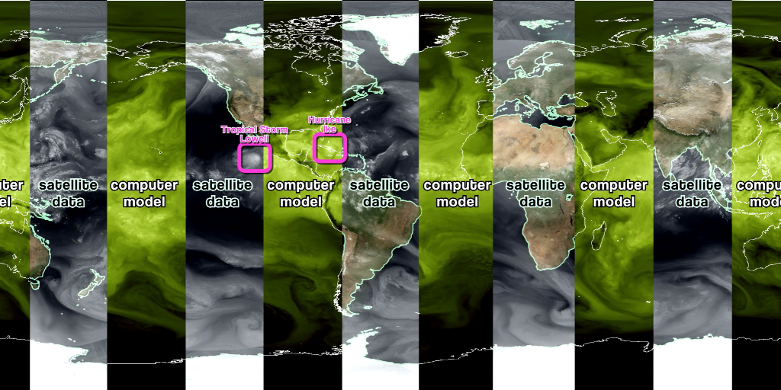
WATER VAPOR MODEL VS OBSERVED
Description: We compared the satellite-derived water vapor dataset with the water vapor model output for the period September 6 – 14, 2008. While the computer model cannot precisely duplicate observed water vapor patterns, the two sequences are very similar, especially at the outset of the model sequence. This is because the model’s forecast begins on September 6 from a set of initial conditions. Small differences between actual conditions and simulated conditions in the initial state become larger differences as time continues: the hallmark of a chaotic system.

Below is a comparison of the observed track of Hurricane Ike with the model’s predicted 10-day track. As you can see, the GFDL model’s forecast for this particular storm is quite accurate.


