This page was updated on 7/21/14.

This is the place to learn about SphereCasting in detail, find out about upcoming SphereCast events, and review the process to participate in SphereCasting.

Any comments or suggestions for future SphereCasts are appreciated.

When is the Next SphereCast?

No SphereCasts are currently scheduled.
Interested in hosting a SphereCast? Do you have a planned event or upcoming lecture featuring Science On a Sphere® that you'd like to share with the rest of the SOS community? Let us know!

- Playlist file to download: None at this time

- Custom datasets to download: None at this time

- Video Stream Link: None at this time

What is SphereCasting?

A SphereCast is an SOS presentation done simultaneously at multiple sites by a single presenter, via the Internet. Many sites can receive the SphereCast, but only one site is the host presenter. There are two components to a SphereCast: (1) Remote control of a presentation on an SOS system, and (2) A live video lecture of the presenter that accompanies the SOS presentation.

(1) Remote Control of a Presentation

Remote control of the SOS system means that whatever commands the presenter issues to the SOS system at the host site are immediately replicated on all the SOS systems that are watching the SphereCast. So, when the presenter loads a new dataset, that data is loaded on all the watching systems. When the presenter starts or stops the animation, or orients the sphere, all the remote spheres behave identically.

The remote control software component is specialized SOS software (already installed on your SOS computer). This software connects to an XMPP server running at ESRL in Boulder, Colorado (NOAA's Earth System Research Laboratory, the home of SOS). An external internet connection to the SOS computer is required to run this software.

(2) A Live Video Presentation

The streaming video component works similarly to other live webcasts you may have viewed. At ESRL, we are currently using the Apple QuickTime technology for broadcasting and receiving the video. Since the video streaming part of a SphereCast is independent of the sphere control part, other hosting sites may use a different solution for video streaming, or even an audio-only solution. Other video streaming technologies that have been used by various sites include Google Hangouts and Blue Jeans.

The rest of this documentation assumes that the streaming QuickTime server at ESRL will be used for video streaming. If this is not the case for the scheduled SphereCast, you can ignore those instructions in the text and special instructions will be provided on the SphereCasting homepage for the particular video streaming technology that will be used when the SphereCast is scheduled.

How to Receive a SphereCast

Please read the following documentation to learn how to receive a SphereCast at your SOS site.

- How to Receive a SphereCast

How to Host a SphereCast

Please read the following documentation to learn how to host a SphereCast from your SOS site.

- How to Host a SphereCast

What Hardware and Software Do I Need to Receive a SphereCast?

- SOS system running version 4.2.1 or later (some earlier versions of SOS may be supported, but we strongly recommend you upgrade your SOS to the latest to avail of all features)
- High speed internet connection
- PC or Mac computer for streaming video
- Apple QuickTime Player for streaming video
- Large screen near the SOS sphere for showing the streaming video of the presenter
- Audio system connection/speakers for hearing the host presenter

NOTE: The rest of this documentation assumes that the streaming QuickTime server at ESRL will be used for video streaming. If this is not the case for the scheduled SphereCast, you can ignore those instructions in the text and special instructions will be provided on the SphereCasting homepage for the particular video streaming technology that will be used when the SphereCast is scheduled.

SOS software release 4.2.1 or later contains all the necessary software components to allow a local SOS system to be remotely controlled during the SphereCast. To check the version of your SOS software, select "About SOS" from the SOS menu of the SOS graphical user interface program, SOS Stream GUI.

A SphereCast is an Internet-intensive event. Therefore, a reasonably high-speed Internet connection is required. A dedicated incoming bandwidth of at least 1.5 MBits/sec will provide a quality experience for your audience. Both the SOS system and the streaming video computer require access to the Internet.

For the streaming video component, a dedicated Windows PC or Mac computer is required, with its own high-speed Internet connection. In terms of hardware connections, this system is independent of the SOS system. One can actually watch a SphereCast video stream without having a collocated SOS system, but of course, then it's just a webcast lecture rather than a SphereCast!

The Apple QuickTime Player is the easiest way to receive the video streaming component of the SphereCast. It is available at no charge for Windows and Mac from the Apple web site (http://www.apple.com/quicktime).

The computer receiving the stream should have a connected large screen or monitor close to the sphere, and also be connected to a house audio system so the audience can clearly see and hear the remote presenter while also watching the sphere.

Step-by-Step Instructions to Receive a SphereCast

Please follow the steps below to prepare to receive a SphereCast.

(1) Prepare hardware and software, well in advance!

Well in advance of the SphereCast, you'll need to make sure you have the required hardware and software.

(2) Contact us to set up an account.
In order for your SOS to receive the SOS commands sent by the host site, you must have an account set up on our XMPP server (located at NOAA ESRL in Boulder, CO). Send an email to sos.gsd@noaa.gov to request an account, and we will send you a username and password for your SOS site.

(3) Schedule the SphereCast.

Schedule and advertise locally. Ensure that your SOS space is available and reserved internally for the SphereCast event, including setup time, in advance.

A few days before the SphereCast, let us know you'll be watching. We like to know who's in the audience, and there might be some internet security or performance configuration we need to do to accommodate our audience sites.

(4) Test local audio/video connectivity for streaming audio/video.

This test assumes the host site will be using the ESRL streaming video server. If this is not the case, separate instructions will posted for all receiving sites.

To test video/audio connectivity from your site to our QuickTime streaming video servers, try the following links. Ultimately, you'll want to test this with the same hardware (a dedicated Mac or PC with QuickTime Viewer) and Internet connection that you'll be using to receive the audio/video part of the live SphereCast. That will validate your Internet connectivity, streaming software, and audio-video hardware. These clips don't require an SOS system.

- Apple QuickTime Test Clip (1:10). This is an Apple-supplied clip of an animated QuickTime Logo and some accompanying audio. It's computer-generated, so it should look and sound good.

- Prototype SphereCast Clip (35:52). This is an archive copy of the first SphereCast prototype, led by Dr. Alexander E. MacDonald from the ESRL SOS Planet Theater, to the SOS User Meeting at the Bishop Museum, on July 30, 2008. The audio quality is rather poor because our Planet Theater is very reverberant.
(5) Test connectivity to the ESRL remote control server for sphere control.

To test remote-control connectivity from your SOS system to our SOS remote-control servers, first load the normal-demo.sos playlist into SOS Stream GUI (from the File menu, select "Open Playlist..."). Then, open the Utilities menu on SOS Stream GUI and select “View a SphereCast”.

This will open the SOS SphereCast Viewer interface. Enter the Username and Password that we sent you. Make sure the Server field is filled out with “frink.fsl.noaa.gov”. Select “Test” from the SphereCast Session section. Click “Connect”.

If your connection succeeds (assuming our test program that sends out test commands is running on our server in Boulder, CO), your sphere will start moving around in random fits and bursts of motion. This indicates that your connection has succeeded. To disconnect from the test, click the “Disconnect” button.

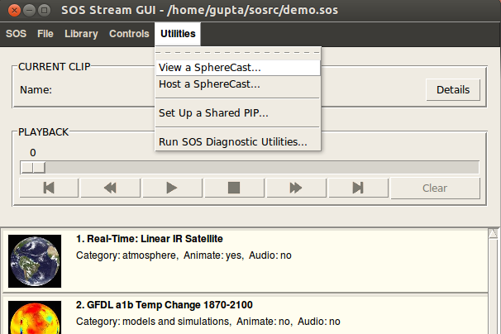 | 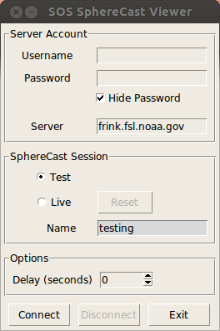

(6) Test the SphereCast playlist.

- Get a copy of the SphereCast playlist. As the date for the SphereCast get’s closer, we'll publish a copy of the SphereCast playlist on our SphereCasting homepage. On your SOS computer, go to the SphereCasting homepage and right-click on the “Playlist to Download” link and save the file to your SOS computer’s “sosrc” folder.
- Sync to the latest data. From SOS Stream GUI, open the SphereCast playlist (from the File menu, select "Open Playlist..."). Then, from the File menu, select "Update Playlist Data...". This connects with the ESRL FTP servers and downloads any new data as needed. Depending on your Internet connection and the state of your database, this may take quite a while.
- Verify that all datasets load properly onto the sphere by clicking each dataset in the SphereCast playlist.

NOTE: If this is a private SphereCast, the host site will send you the SphereCast playlist and any custom datasets.

(7) 10-30 minutes before the scheduled SphereCast...Connect to the video stream.

The host site will run a pre-show stream so that you can connect before the scheduled start. To run the video stream, just navigate your web browser on your streaming video computer to the link listed by the “Video Stream Link” of SphereCasting homepage.

(8) 10-30 minutes before the scheduled SphereCast...Connect to the SphereCast remote control server.

First, make sure the SphereCast playlist (from Step 6 above) is already loaded on your SOS system, and clip 1 is selected.

From the Utilities menu of SOS Stream GUI, open the SOS SphereCast Viewer interface again. Enter the Username and Password that we sent you. Make sure the Server field is filled out with “frink.fsl.noaa.gov”. Select “Live” from the SphereCast Session section. By default, the Name of the Session will be set to “spherecast”.

If you are receiving a private SphereCast that has not been advertised to the whole SOS network, the host site may have provided you with a different SphereCast Session Name. If this is the case, enter that name into the “Name” field.

Click “Connect”. At this point, your sphere will be remotely controlled from the host site. Note that you may not see any actions occurring on the sphere until the official SphereCast presentation begins.

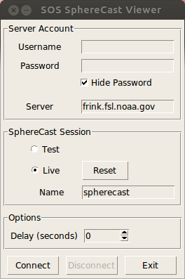

Additional Options

(1) Better Synchronization Between Sphere Controls and Streaming Video

Because of network delays and other factors, the sphere commands might not be in sync with the video (for example, a host site presenter may click the next clip in the playlist and start talking about it, but a receiving site may not receive the “next clip” command until a few seconds later due to network traffic).

In order to better sync video to the sphere commands that are being sent from the host site to a receiving site, a receiving site can adjust the Delay parameter in the Options section of the SOS SphereCast Viewer interface. This might require some testing. For example, while the host site is broadcasting on a day you are testing your SphereCasting setup, you can connect to their broadcast to evaluate how in sync the video is to the sphere commands. If there is a delay, you can Disconnect, adjust the Delay parameter, and then Connect again until you find the closest synchronization. Write the final value down so you will have it handy for the day of the actual SphereCast (of course, this will only be a best approximation, as network delays may vary on any given day).

(2) Display the Host Site Presenter in a PIP on the Sphere

Rather than displaying the streaming video of the presenter on an auxiliary monitor that is near the sphere, as of SOS version 4.2.0, you can now display the streaming video in a PIP that is on the sphere. This special PIP is called a Shared PIP and it can stay on the sphere for the duration of the SphereCast playlist. In its current version, the host site must be streaming an RTSP video stream (which is what the QT Broadcaster as well as a number of other technologies use to stream video). Please see the following release notes for more details:

http://sos.noaa.gov/Docs/LivePIPReleaseNotes-v4.2.pdf

What Hardware and Software Do I Need to Host a SphereCast?

Hosting a SphereCast for other sites requires some additional hardware and software components, in addition to those needed to receive a SphereCast. While there are other streaming video solutions, our current SphereCast video servers are using Apple's streaming QuickTime technology. The easiest way to take advantage of this infrastructure is to use a Mac computer running QuickTime Broadcaster (freely available for download at http://support.apple.com/kb/DL764) to feed your SphereCast video via our servers.

A video camera is required for the video streaming part of the SphereCast, of course. To use QuickTime Broadcaster, the camera needs to be able to connect to the Mac that compresses and encodes the video for streaming. A tripod and lighting kit is highly recommended for a quality video production. A dedicated microphone for your presenter is also critical for the presenter to be easily understood by the remote sites.

The Internet bandwidth requirements for hosting a SphereCast are more demanding than for receiving one. Many high-speed internet connections are asymmetrical, with higher bandwidths downstream (incoming) than upstream (outgoing). For hosting a SphereCast, adequate upstream bandwidth of at least 1.5 MBits/sec is required.

Your SOS system must be running version 4.2.1 or later (some earlier versions of SOS may be supported, but we strongly recommend you upgrade your SOS to the latest to avail of all features).

Step-by-Step Instructions to Host a SphereCast

Please follow the steps below to prepare to host a SphereCast.

(1) Prepare hardware and software, well in advance!

Well in advance of the SphereCast, you'll need to make sure you have the required hardware and software.

(2) Contact us to set up an account.

In order for your site to host a SphereCast and send out SOS control commands to other sites, you must have an account set up on our XMPP server (located at NOAA ESRL in Boulder, CO). Send an email to sos.gsd@noaa.gov to request an account, and we will send you a user name and password for your SOS site.

(3) Test local video connectivity.

This test assumes the host site will be using the ESRL streaming video server. If this is not the case, separate instructions will need to be sent to all receiving SOS sites in advance of how to connect to the video stream. If doing a SOS network-wide SphereCast, we can put these instructions on the SphereCasting homepage.

To test video connectivity from your site to our QuickTime streaming video servers, try the following links. Ultimately, you'll want to test this with the same hardware (a dedicated Mac or PC with QuickTime Viewer) and Internet connection that you'll be using to present the audio/video part of the live SphereCast. That will validate your Internet connectivity, streaming software, and audio-video hardware. These clips don't require an SOS system.

- Apple QuickTime Test Clip (1:10). This is an Apple-supplied clip of an animated QuickTime Logo and some accompanying audio. It's computer-generated, so it should look and sound good.

- Prototype SphereCast Clip (35:52). This is an archive copy of the first SphereCast prototype, led by Dr. Alexander E. MacDonald from the ESRL SOS Planet Theater, to the SOS User Meeting at the Bishop Museum, on July 30, 2008. This video is representative of what you might expect for a typical SphereCast. The audio quality is rather poor because our Planet Theater is very reverberant.

(4) Test connectivity to the ESRL remote control server.

To test remote-control connectivity from your SOS system to our SOS remote-control servers, first load the normal-demo.sos playlist into SOS Stream GUI (from the File menu, select "Open Playlist..."). Then, open the Utilities menu on SOS Stream GUI and select “Host a SphereCast”.

This will open the SOS SphereCast Host interface. Enter the Username and Password that we sent you. Make sure the Server field is filled out with “frink.fsl.noaa.gov”. Select “Test” from the SphereCast Session section. Click “Connect”.

If your connection succeeds (assuming our test program that sends out test commands is running on our server in Boulder, CO), your sphere will start moving around in random fits and bursts of motion. This indicates that your connection has succeeded. To disconnect from the test, click the “Disconnect” button.

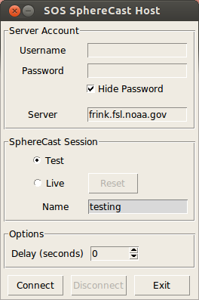

(5) Set up the video and audio stream.

This section assumes the host site will be using the ESRL streaming video server and QuickTime Broadcaster to broadcast the video stream. If this is not the case, separate instructions will need to be sent to all receiving SOS sites in advance of how to connect to the video stream. If doing a SOS network-wide SphereCast, we can put these instructions on the SphereCasting homepage.

Open the QuickTime Broadcaster program on your Mac. Fill in the Audio and Video portions of the QuickTime Broadcaster interface as is appropriate for your site. If you need help, let us know. For the Network options section of QuickTime Broadcaster, fill in the following parameters:

Transmission: Automatic Unicast (Announce)
Host Name: frink.fsl.noaa.gov
File: spherecast
Username: Email sos.gsd@noaa.gov to get the username
Password: Email sos.gsd@noaa.gov to get the password

Check Broadcast over TCP.

You can preview your broadcast by selecting “Source” from the Preview drop-down menu located in the upper left-hand corner of the interface.

When you are ready to broadcast the stream, click the “Broadcast” button.

(6) Schedule the SphereCast, well in advance!

Schedule and advertise to other SOS sites well in advance. SOS sites need to have time to make sure space is available and reserved internally for the SphereCast event, as well as time to setup their hardware and software to receive the SphereCast.

If you are doing a SOS network-wide SphereCast:

(A) send us your SphereCast event playlist so we can put it on our SphereCasting homepage and make it available for download by other SOS sites. If you are creating any new datasets for this event that are not in our SOS Data Catalog, you will need to make those available to SOS sites in advance as well. (We can also make those datasets available for download on our SphereCasting homepage.)

(B) Schedule a time with us at least a few days before the SphereCast event to test out your host setup. During the test, you will run your SphereCast event playlist and you will control the sphere (orientation and playback controls), as well as run your live video and audio, and we will act as a receiving site and make sure we can receive your SOS commands on our sphere, as well as your video and audio.

If you are doing a private SphereCast with just one site or a few other sites:

You will follow (A) and (B) above, except that you should send the playlist and any custom datasets directly to those sites and do the test with those sites (of course, we are happy to assist if any issues arise).

In addition, you will need to come up with a SphereCast Session Name that you can fill into the Name slot of the SOS SphereCast Host interface. You will need to send this name to all sites who will be receiving your SphereCast so they can connect to your specific SphereCast. You can choose a simple name, such as the name or abbreviation of your museum. The Name field will only accept alphanumeric characters with no spaces or special characters in it.

(7) Connect to the ESRL remote control server as host to broadcast the live SOS commands to other sites.

You are now ready to host a SphereCast. First, load your SphereCast playlist (from SOS Stream GUI’s File menu, select "Open Playlist..."). Then, open the Utilities menu on SOS Stream GUI and select “Host a SphereCast”.

This will open the SOS SphereCast Host interface. Enter the Username and Password that we sent you. Make sure the Server field is filled out with “frink.fsl.noaa.gov”. Select “Live” from the SphereCast Session section. If you are doing a SOS network-wide SphereCast, leave the SphereCast Session Name as the default “spherecast”. If you are doing a private SphereCast with a selected site or sites, enter the name of the SphereCast in the Name field (the name you selected in Step 6 above).

Click “Connect”. At this point, if your connection succeeded, SOS sites who have subscribed to the SphereCast will be receiving SOS remote control commands from your site.

